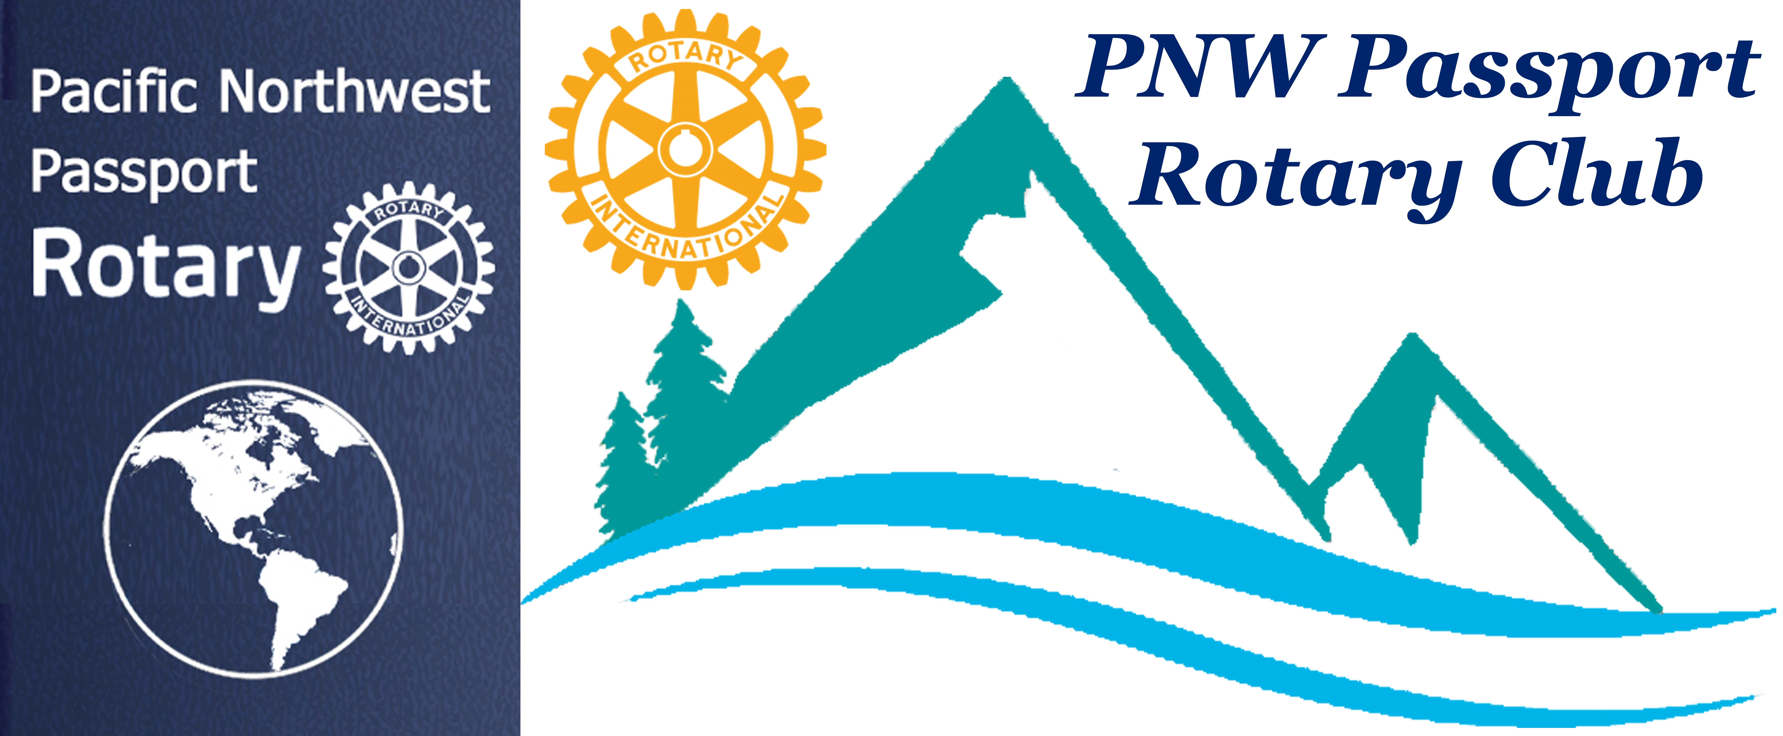 PNW Passport Rotary Club Meeting Notes

Date: February 9, 2019 Time: 4:15 pm

Place: Bob’s Burger & Brew, Birch Bay Square, WA

Club Attendance: 12 Members and 2 Guests

Presidents Report:

President Tim – called the meeting to order and opened with a reflection:

Hindu Upanishads
Lead me from death to life,
From falsehood to truth,
Lead me from despair to hope,
From fear to trust,
Lead me from hate to love,
From war to peace,
Let peace fill our heart, our world, our universe,
Peace, peace, peace

P Tim asked four different members for a line from the Rotary Four Way Test.

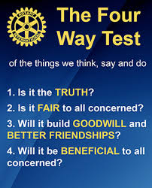

P-Tim asked Joy to introduce our visiting Rotarians. Joy introduced Bob Moles, Julie’s husband and a long time Rotarian. Bob is presently with the Bellingham Bay Club. Phoenix MacLaren, Rotaract Fraser Valley she was our guest speaker.

P-Tim asked for a short introduction of members present.
Below is a sampling of some of our Members present:

Ray Holman – he said who’s counting but in five months he’ll be retiring. He and his wife will be moving to Parksville on Vancouver Island. He is really looking forward to being a Snowbird and spending times at their place in Scottsdale.

Bob Moles, Visiting Rotarian – has been a Rotarian for 47 years. He is a charter member of Bellingham Bay Rotary Club.

Phoenix MacLaren – Our guest speaker, has been extremely involved with the Fraser Valley and the District 5050 Rotaract Clubs. She has helped new Rotaract Clubs get chartered and succeed.

Roy Holman – Has belonged to the Surrey Rotary Club, was president three times. Sadly he’s not retired yet but is getting closer.

Patrick Drum – wanted us to know that he started 2019 off right at noon New Years Day …. by jumping into Birch Bay like a true polar bear and survived. He said … ‘I simply jumped into the Bay!’
Terry Meyers – Started out her rotary life as a charter member of the East Grays Harbor County Centennial Rotary Club in Elma Washington, and I was their third president. However the last club that she belonged to was the Bellingham Bay Rotary club. Between those two clubs she also belonged to the Bainbridge Club, and the Sunrise Sequim Club. Her job as a Nursing Home Administrator took her to different location making it requiring her to join different Rotary Clubs.
Pati Vallhauer – daughter in her 30s was getting her drivers license for the first time.

Marrietta Ostenburg – experienced first hand Rotarians helping other Rotarians. Lindagene helped her downsize from a house to a motorhome. She is now a single woman trying out living in a motorhome. She was very appreciative of Lindagene’s help and guidance in this process.

P Tim asked all members to look at our Club’s six-month calendar and mark the dates in your Day-Timer (see below).

P Tim said there would be a meeting after the District Training Assembly on March 23rd it is to be a Club AGM. Each year RI wants Clubs to hold an AGM. At the AGM we will nominate members to the Executive Board for year 19/20 as well as look for a member to be P-Elect for year 20/21. It would be very nice if we had a Canadian member for the year 20/21. It would be nice if the Executive Board were a mix of Canadians and US Club members. The meeting will be held at Sean and Carol Hogan’s house at 3:30. Please come to the meeting even if you didn’t go to the District Training.

P Tim mentioned the Whatcom County Rotary Career Fair still needs speakers and volunteers to help the day of the Fair. He strongly urged Club members to come out on April 27th to help with the Rise Against Hunger. It is a very worthwhile hands-on project.

Secretary Report:

We have two new member proposals Terry and Jill Greer they are sponsored by Sean Hogan. An email has been sent out to each Club member asking if there is any reason why Terry and Jill should not become PNW Passport Rotary Club members, the member needs to contact or send an email to the Club President or Secretary by February 13th. If none were received a letter would be sent to Terry and Jill welcoming them to the PNW Passport Rotary Club. An induction date would be organized.

Engagement Committee: Pati Villhauer

Please see below a copy of the Club Calendar January to June 2019.
Please send any guest speaker suggestions to Pati.

Guest Speaker:
President Tim introduced our guest speaker Phoenix MacLaren, Fraser Valley Rotaract Club.

Phoenix gave us a wonderful overview of how District 5050 Rotaract (Rotary In Action) Clubs were progressing. There are now 10 Clubs 6 in Canada and 4 in the US. Their goal is to go from 32 members to 64 over the next year. The strategy is to continue adding new clubs.

Twenty-four Rotaracts were going to Guatemala August 16-24 to install clean air stoves. The trip was going to cost $15,000. Each of the Rotaracts going is fundraising through their Clubs.

They host a Presidents weekend for all Rotaract Club to give the clubs an opportunity to go over what is working within their Clubs, what wasn’t working, and where they can help each other.

Rotaracts are very involved with youth programs in Rotary:

R.Y.L.A. (Rotary Youth Leadership Awards) is a leadership development program for young people who want to learn new skills, build their confidence, and have fun. Events range from one-day seminars to weeklong camps. This year’s registration closes May 1st.
Y.A.I.L. (Youth Adventurers in Leadership) teaches participants 15-17 years old through a variety of exercises involving leadership and growth - to empower students to network, plan, and set goals. Participants are divided into groups with an experienced youth facilitator.
The program is led by youth, with guidance from adult Rotarians. Candidates are selected and sponsored by a local Rotary Club, with a mix of males & females, Canadians & Americans.

Rotary Clubs sponsor students or young adults for these programs. If our Club knows of someone we’d like to sponsor that would be great. If you’d like to volunteer for either program Phoenix would love to hear from you.

Rotaracts will be opening the District Training plenary session ‘Myth Busting of Rotaracts’. They will be organizing the Corn Hut for the Port Moody Rib Fest July 19-21, 2019. They will be in touch with our Club as the event gets closer looking for volunteers.

P- Tim thanked Phoenix very much for informative talk on District 5050 Rotaract Clubs.

Joy mentioned the Club has not yet spent the money they gave us last year for our help at the Corn Hut. It was said the funds needed to be spent locally. The PNW Passport Rotary Club was hoping we could help the District 5050 Rotaracts with a project in a locale of their choice.

Meeting adjourned at: 5:30 pm Notes taken by: Joy St. John, Secretary

Next Club Meeting: February 21, 2019
Location: The Roadhouse Grille, 1781 King George Blvd, South Surrey, BC
Time: 6:00 – 8:00 pm

Happy Bucks:

President Tim: Sadly one of their dogs died while they were vacationing in Mexico. They did have a wonderful time away it just wasn’t long enough. Thank you to all Board Members for doing an excellent job.

Lindagene: Her 57 year old sister had an operation to repair 99% blockage of her arteries. She was in fine spirits and doing well.

Marietta: Thanked Lindagene for all her help with her move.

Bob: It was good to see Allen Stockbridge

Phoenix: She had found a replacement for the DR position.

Patrick: January has come and gone with Global Bonds moving up again.

Terry: Thrilled she was able to make it to the meeting even though she had to leave early.

Pati: Welcome to our visitor and guest speaker.

Ray: Figuring out coinage Canadian and US.

Allen: Happy to be able to make the meeting he had just been volunteering at the Sundance Film Festival. He has been volunteering with them for 19 years. Spoke about the Bellingham Human Rights Film Festival February 21st – March 2nd. There would be 23 free international movies at different venues.

Joy: Thanked the Club members for their patience in particular the Board as she learns more and more about the duties of the Club Secretary.

PNW Passport Rotary Club Calendar for February – June 2019:
  - PNW Passport Rotary Club meeting February 9, 4:00 - 6:00 pm at Bob’s Burger & Brew, Birch Bay Square, WA
  - District Grants Management Seminar February 16, Ferndale WA (Julie and ? attending)
  - PNW Passport Rotary Club meeting February 21, 6:00 – 8:00 pm, The Roadhouse Grille, South Surrey, BC
  - RLI Rotary Leadership Institute Part 3, March 2, Everett WA
  - PNW Passport Rotary Club meeting March 9, 4:00 – 6:00 pm, The Roadhouse Grill, South Surrey, BC
  - Board Meeting March 13, Go to Meeting
  - District Training (assembly) March 23, Surrey, BC
  - PNW Passport Rotary Club meeting March 23, 3:30 – 5:00 pm, P-DG Sean Hogan’s residence, Surrey, BC
  - PNW Passport Rotary Club meeting March 28, 6:00 – 8:00 pm, Bob’s Burger & Brew, Birch Bay Square, WA
  - Board Meeting April 10, 2019, Go to Meeting
  - PNW Passport Rotary Club meeting TBA
  - District Conference April 11 -14, Tulalip Casino
  - PNW Passport Rotary Club meeting: April 25, 2019, 6:00 – 8:00 pm, The Roadhouse Grill, South Surrey, BC
  - Rotary Work Day, April 27th community meals packing day - Bellingham.
  - Board Meeting May 8, Go to Meeting
  - PNW Passport Rotary Club meeting May 11, The Roadhouse Grill, South Surrey, BC
  - PNW Passport Rotary Club meeting May 23, Bob’s Burger, Birch Bay Square, WA
  - PNW Passport Rotary Club meeting June 8, Bob’s Burger, Birch Bay Square, WA
  - Board Meeting June 12, Go to Meeting
  - RI Convention in Hamburg Germany 1 - 5 June
  - PNW Passport Rotary Club meeting June 27, The Roadhouse Grille, 1781 King George Blvd, South Surrey, BC

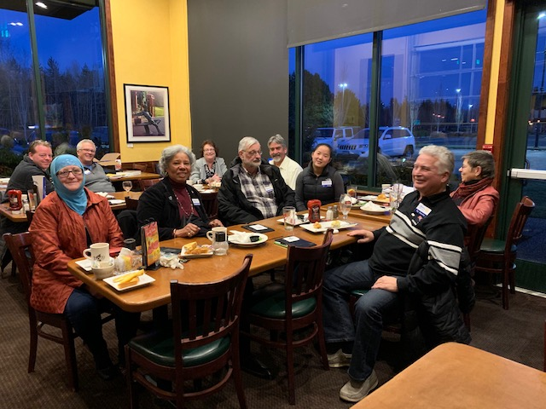
PNW Passport Rotary Club meeting at Bob’s Burger & Brew
February 9,2019
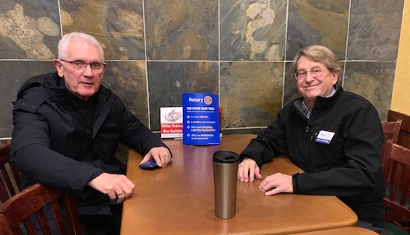

Bob Moles & Allen Stockbridge enjoying fellowship time

