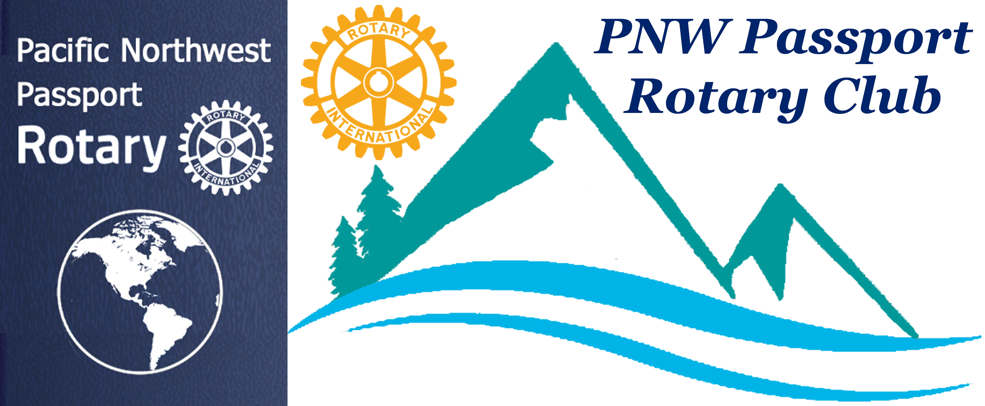

UPCOMING CALENDAR DATES TO NOTE:

June 27 PNW Rotary Club Meeting – Roadhouse Grille, Surrey, BC
Induction of Jill & Terry Greer
July 8 PNW Rotary Club Meeting – Roadhouse Grille, Surrey, BC
Induction of our new President Deb Wiggs
July 19 – 21st Port Moody Ribfest PLEASE volunteer for this event in particular the Rotaract Corn Hut.

PNW Passport Rotary Club Meeting Notes

Date: June 8, 2019 Time: 4:15 pm
Place: Bob’s Burger & Brew

President Tim called the meeting to order. He welcomed us all and reminded us that people in many countries including United States and Canada were remembering the horrors of D-Day June 6, 1944.

He asked those in attendance to give one unusual thing about them. A sampling of those interesting pieces of information from members:

Roger Kelley – is an ultra marathon runner.
Peter Kremen – Jesse Owens interviewed him.
Julie Johansen – 17 grandchildren and 2 great grandchildren
Deb Wiggs – is a half marathon runner and recently ran beside a 76-year old gentleman.
Lindagene Coyle – loves to go on cruises
Pres Tim – 18 years perfect attendance, drove his 54-dodge car to the meeting.

New Business:

President Tim asked the PNW members to sign up for the Port Moody Ribfest July 19-21. Please go to their website to register for volunteering in general or https://forms.gle/qxkFo14gqt7F5zHi7. to volunteer at the Corn Hut.

We will receive funds for our time spent volunteering with the Rotaracts at the Corn Hut!! With last years funds we sponsored two Rotaract members to go to RYLA. We still have funds we may want to use those funds to sponsor a Rotaract to go on their trip Rotary International Trip.

President Tim introduced our guest speaker Pam Brady, she is with External Affairs at BP Petroleum at Cherry Point, Washington State. BP no longer stands for British Petroleum but Beyond Petroleum.

Pam said she has been with BP for 18-years. The company has been a great one to work for she has found it to be very rewarding over the years. She particular likes the fact that the company is a very good community member. They bought over 3,000 acres next to their plant that a developer couldn’t build houses on the land. BP felt that having houses so close was not wise. They have made the acres into a conservation area for the community.

From the deep sea to the desert, from rigs to retail, BP delivers energy products and services to people around the world.

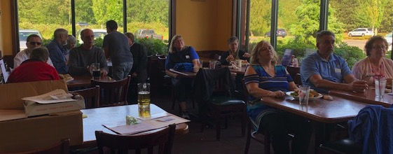
BP has 13 wind farms in the States. They have 7100 stations. They are continually looking at alternative sources of energy to produce power. They use solar panels where they can.

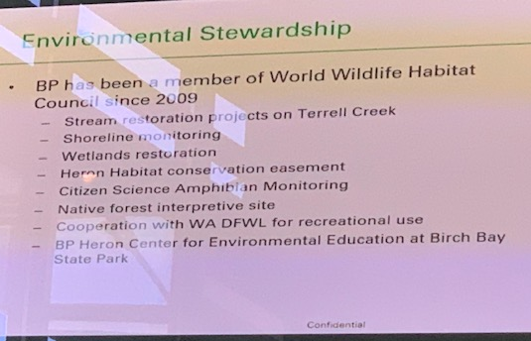
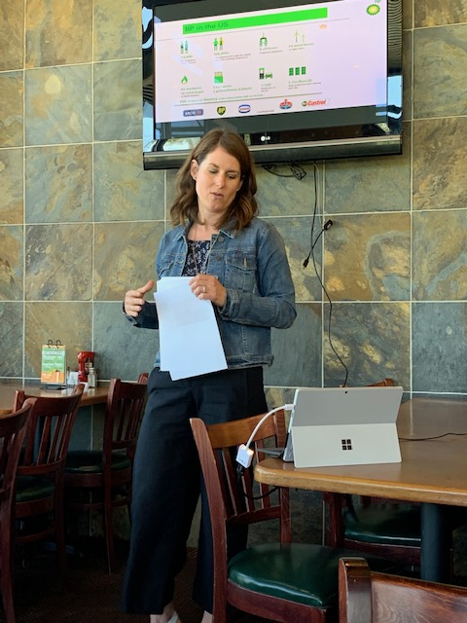
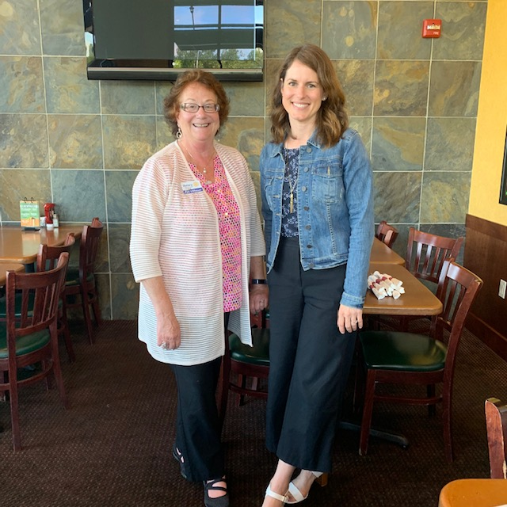

Pam informed us of so many great advancements happening at BP the company never stops looking at ways of improving.

One of their many projects right now is RIC – Reduce, Improve, Create!!

She mentioned that on September 27, 2019 there is to be an open house. You are required to RSVP for this event because they can only handle a certain number each year.

Pete said he’d like to say that BP is a great community partner and employer.
Julie said BP was a great Rotary Supporter.

President Tim thanked Pam for the very informative talk.

Pati informed us that she will be arranging for the PNW Passport Club to go to the open house if there is an interest.

Meeting adjourned at: 5:45 Notes taken by: Joy St. John, Secretary

Trivia
The D simply stands for "day." The designation was traditionally used for the date of any important military operation or invasion, according to the National World War II Museum. Thus, the day before June 6, 1944, was known as D-1 and the days after were D+1, D+2, D+ and so on.

