Please Note Upcoming Dates

May 18 – Rotary World Container Loading – 9:00 am – 12:00
400th Container!!
May 23 -- Rotary Meeting -- 6:00 pm – 8:00 pm
Bob’s Burger & Brew, Birch Bay Sq, WA

PNW Passport Rotary Club Meeting Notes

Date: May 11, 2019 Time: 4:10 pm
Place: Roadhouse Grill, Surrey, BC

Our President Nominee 2020/21 Roy Holman greeted all in attendance. He was feeling out the chair. He hasn’t run a Rotary meeting for some years but he was looking forward to his future position. He loves belonging to PNW Passport Rotary Club.

He mentioned that he had recently returned from Japan.

He reminded us of the Rotary World Help container loading on May 18th. He said we have been asked by the Port Moody Rotary Club to help with their Rib Fest again in July. This year we might be helping in the parking area. We will advise at late date where we’ll be needed.

He said Langley might need our help at their Rib Fest the executive will advise.

Upon the suggestion of Vice-Governor Lindagene that we should introduce ourselves Roy asked each of us to introduce ourselves. We always find this a fun and great way to find out about our members. It seems with each introduction there is a new fact or two to learn about our very interesting members. For examples:

We learnt that our Vice-Governor (see below) Lindagene and our soon to be DG Brad have been spending lots of time together over the past few years!! Brought to mind the song … Let's give them something to talk about, baby -- Kim his wife, a charter member of our Club, said ‘I know he’s in good company’ and smiled. It is amazing how many meetings these elected members have to attend to keep a District running smoothly. Thank you Lindagene, Brad and all elected executives of District 5050.
Patricia Sibley mentioned that she attended a Rotary meeting this past week where the Club still expects perfect attendance from its members. Where fines are given for so many things such as her attending the meeting even though she was there to inform the Club of a particular program. There truly is something to be said for the flexibility of our Rotary Club while continuing to adhere to the Object of Rotary to encourage and foster the ideal of service as a basis of worthy enterprise and, in particular, to encourage and foster the Rotary Four Way Test.

Our new member Terry Greer told us he and his wife Jill, also a new member, have a code when they travel. Jill, I’m dehydrated --- meaning he needs a beer NOW!! Jill, I’m anemic – meaning he needs a scotch NOW!! He got this good advise from a doctor so it can’t be wrong.

President-Nominee Roy said in Japan they love their beer but over the years due to the stricter road rules for drinking and driving the Japanese are turning to non-alcoholic beer. He also said they have vending machines for everything – underwear, beer, hamburgers, French fries you name it and they have it in a vending machine.

Our meeting went from introductions to questions about what is the Club doing about raising funds to pass along to other projects of our choice. We talked about many types of possible ways of raising funds. Each one will take a member grabbing onto that fundraising possibility and finding out how we can accomplish it. We talked about the gift cards again. We all agree this is a simple way to raise funds.

This brought forward the importance of having a visioning session for the PNW Passport Rotary Club. We hope to have one this Fall.

We talked about asking members to attend a meeting to pick up their name badge and welcome package. We talked about the possibility of every few months in the future we use FaceTime or skype as a means for members to join in their Club’s meeting. But members have to know that this is not an eRotary Club and attending meetings throughout the year is encouraged.

Joy talked about helping at the Rise Against Hunger event. It was so amazing to be part of this worthwhile project. It was so well organized and went so smoothly but still allowing for fellowship. Over 75,000 bags were packed that day!! Where those bags of sustainable food will end up we don’t know but where they are needed around the world!!

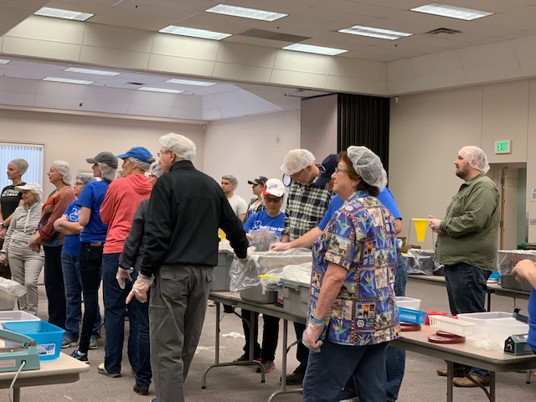
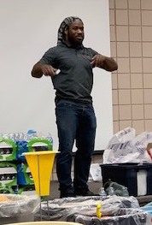

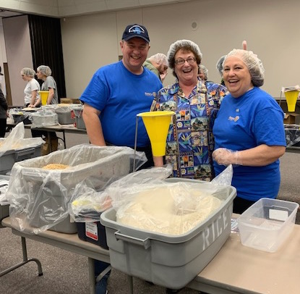

Getting our instructions
This young man was the main man from
Rise Against Hunger

Rotarians love to have fun while they help!!

President-Nominee Roy called the meeting to a close at 6:10 pm.

Wonderful fellowship at the PNW Passport Rotary Club Meeting

Thank you President Nominee Roy!!!
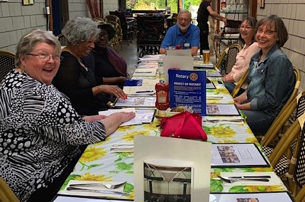

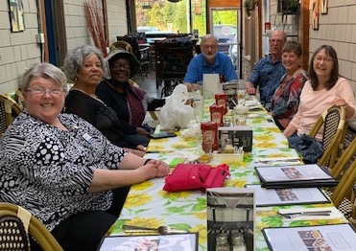
We welcomed our new members Terry and Jill Greer.
They will be attending the Rotary International Convention in Hamburg, Germany.
Upon their return they will give us a talk on the Convention.

ROTARY TRIVIA

Vice-Governor is a term I hadn’t heard before … a position our esteemed member Lindagene Coyle has accomplished!! She was District 5050 Governor, then Past-District Governor now Vice Governor Lindagene

VICE GOVERNOR -- The nominating committee for governor will select one past governor to serve as a vice governor. The role of the vice governor is to replace the governor in case of temporary or permanent inability to serve. (RIB 6.120.1.) It is a best practice for districts to use the regular governor election process to select the vice governor.

Thank you Lindagene for your continuing service to Rotary. We are so fortunate to have you help guide us through our formative years.

