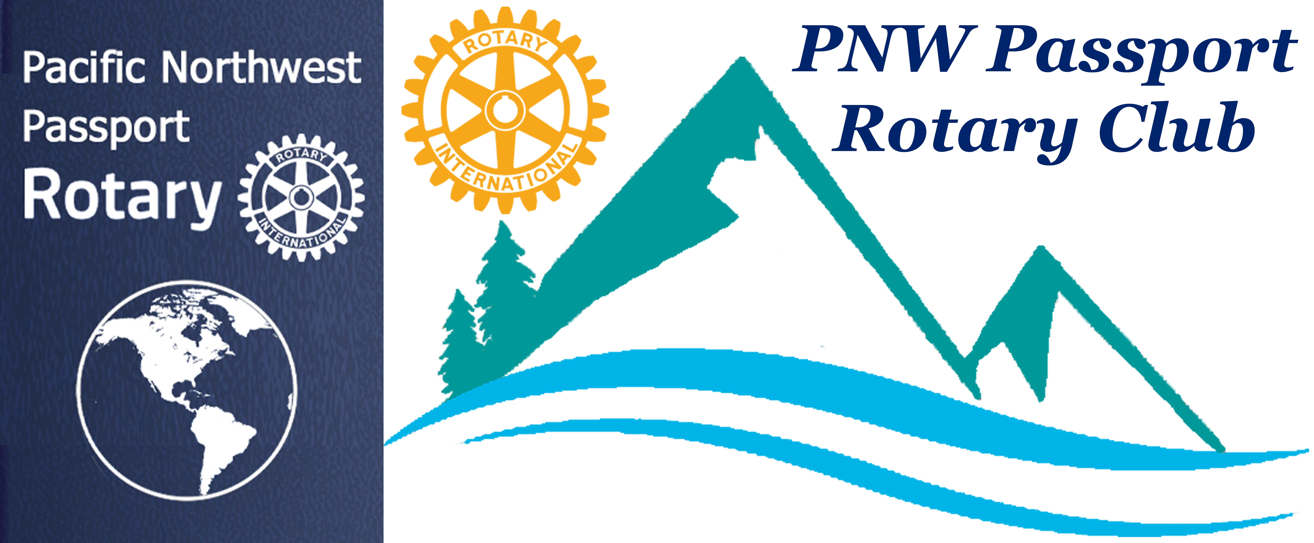

Please Note Upcoming Dates

May 25 – Rotary World Container Loading – 9:00 am – 12:00 Philippines, Manila Van /Rich Sun Clubs #401 -- RI reporter will be there from Head Office for Friendship Exchange Article.

June 8 -- Rotary Meeting – 4:00 pm – 6:00 pm
Bob’s Burger & Brew, Birch Bay, WA

June 12 -- PNW Passport Club executive meeting

June 15 -- Rotary World Container Loading – 9:00 am
Montevideo, Uruguay

May 23 -- Rotary Meeting -- 6:00 pm – 8:00 pm
Bob’s Burger & Brew, Birch Bay Sq, WA

July 19, 20, 21 – Port Moody RibFest please register to help the Club is helping at the Corn Hut

PNW Passport Rotary Club Meeting Notes

Date: May 23, 2019 Time: 6:15 pm
Place: Bob’s Burger & Brew, Birch Bay, WA

President Tim – Welcomed all in attendance. He mentioned that we have a speaker for our July 25 meeting at Bob’s Burger & Brew. They will be speaking about Sustainable Connection. We have a speaker from the Mercy Ships for an October meeting.

He asked Julie Johansen to introduce her guest. Her guest was her husband Bob Moles, from Bellingham Rotary Club.

President Tim gave Happy Happy Bucks tonight because he has 18-years perfect attendance with Rotary!!! This will become something of a rare happening as Rotary International changes it rules on attendance. Congratulations Tim and thank you.

President Tim asked those in attendance to talk about any travels they may have had over the past few months.

Peter Kremen: Said he has just returned from Puerto Vallarta after six months of sunshine oh and more sunshine. It was getting too hot there and our weather was getting nicer so he returned! He tried to attend a Rotary meeting while he was in Puerto Vallarta. It took some querying to find out when the meeting was because the sign outside where the meeting was to be held was totally wrong. Next year he hopes to attend and find out if they are in need of our help.

He presented our Club with a cheque from his sister. He and his sister do not exchange Christmas gifts but donate to each other’s favourite charity.

Hazel MacDonald: told us of her trip that her insisted she take which included visiting her in Dubia and going on other trips. Hazel went to Africia, India a few other destinations using her daughter’s place as home base.

Walt Jackson: went to Memphis recently. To see Elvis’s home?? He reassured us Elvis no longer lives there though he didn’t really go inside his house. There were just too many wanting to visit Elvis’s residence as he drove past!!

He also went to New Orleans where he enjoyed listening to music, sightseeing and eating ribs.

Pati Villhauer: went to Las Vegas recently with President Tim. They did many hikes and other sightseeing ventures. She came away having won money!! She informed us that she and President Tim lived there a few years back so it was like going home for them.

Julie Johansen: traveled to San Antonio and Galveston, Texas she did not take Bob on this trip. She raved about the Lost World Caverns at Galveston.

Bob Moles: said while Julie was away he went to British Columbia for fly-fishing. He got lots of fish at Lake Talapus near Merritt, BC. No he didn’t have pictures to prove the size of the fish.

V-Governor Lindagene: said she went to Canmore, Alberta for Easter to visit her daughter. If you haven’t been to Canmore you don’t know what you’re missing an awesome town with lovely scenery. It is the home of the Canmore Nordic Centre it was originally constructed for the 1988 Winter Olympic games cross-country skiing, biathlon, Nordic combined, and blind cross-country skiing events were held here. The Canmore Nordic Centre provides world-class trails for use by cross-country skiers, mountain bikers, unicyclists, trail runners, roller skiers, and hikers.

Patrick Drum: he has recently been to Dubia on business/pleasure trip, and then went on to Cairo. He had a tremendous guide in Cairo who a friend had suggested the sightseeing was all the better because of the guide. He was able to keep him safe while enjoying interesting sightseeing trips. He saw pyramids as well as other truly interesting sights of Cairo.

President Tim introduced our guest speaker for tonight – Roger Kelly a PNW Passport Rotary Club member. Roger is here to speak to us about Rotary’s YES program.

Roger told us he found out about the YES program at his wife’s Rotary Club – the Burlington Rotary Club. He thoroughly enjoys being part of this programme. What does YES stand for? Youth Engaged in Service. The mission is to provide leadership development opportunities while engaging youth in Rotary’s motto, Service Above Self, both locally and internationally. Where did YES begin the impetus for starting this program in 2007 by the Burlington Rotary Club was to provide a platform for local students to create an Interact Club in their high school. That has been quite successful, as Burlington Rotarians have continued to sponsor YES teams year after year.
In 2012 YES was recognized as a District 5050 youth program, which involves three avenues of service: youth, community, & international.

Students apply in their sophomore year (grade 10) go on a trip in their junior year (grade 11). The students selected to be part of YES need to make a nine-month commitment to the project be willing to attend once a meeting once a month at a Rotary Club. High school students throughout Rotary District 5050 are being offered the opportunity to experience the joy of serving others by volunteering in their local community and participating in an international humanitarian service project. Students attend monthly leadership training meetings and contribute 80 hours of local volunteer service. Each student is responsible for $1,500 of the program cost. If you know of anyone who might be suited or interested in finding new meaning and direction for their life by assisting local community organizations, improving the conditions of the poorest of the poor in remote regions of the world, have them apply to the YES programme. It would be great if they had a Rotary Club willing to sponsor them. Over and above the $1,500 from the student a Rotary Club needs to donate $2,000 to the programme. The programme is an expensive one to operate each year prices go up for flights, accommodation, food, and transportation to the village they will be helping.
As mentioned each student is responsible to log in 80 hours of volunteer community service from October to May. They must participate in a monthly team building meeting, attend a Rotary meeting every month, attend the weekend team building retreat Rotary Youth Adventures in Leadership weekend; assist with program fundraisers; obtain a passport and recommended immunizations at your own expense; bring enough money to pay for personal expenses such as some meals and souvenirs.
Like Rotary, the main objective of YES is Doing Good in the World…both locally and internationally. YES students and their adult mentors meet each month to develop leadership skills, share their local service experiences, learn about Rotary, prepare for an international humanitarian project, and raise support for both their program fee and the project materials. If needed students will get help with fundraising for their portion.
Some of the places they have taken students are Agua Escondida, Guatemala, Chipoxlac, Guatemala, and villages outside Copan, Honduras. While there they have helped on many projects in the villages such as a kindergarten school, playground, and housing projects.
Over the years the International Phalaenopsis Alliance IPA has helped immensely with getting the YES projects organized. YES gets help from local Rotary Clubs in area of their trip. Roger has become friends with many of these people over the many trips he has been on this makes it easier when needing information on the new project.
Roger said it is very rewarding for the students who go they come back changed and wanting to continue with Service Above Self attitude. It is also rewarding for him to see how the programme helps students and communities in need.
He would like our Club to speak about YES to other Rotary Clubs, to local High Schools, speak to young people who would be good candidates.
President Tim thanked Roger for speaking to us about this worthwhile project and for his involvement in it.
There was great fellowship at our meeting with some good stories being told by many. Such as one from our President on how he became known as a Caballero after a horseback ride while visiting the ruins in Copan.

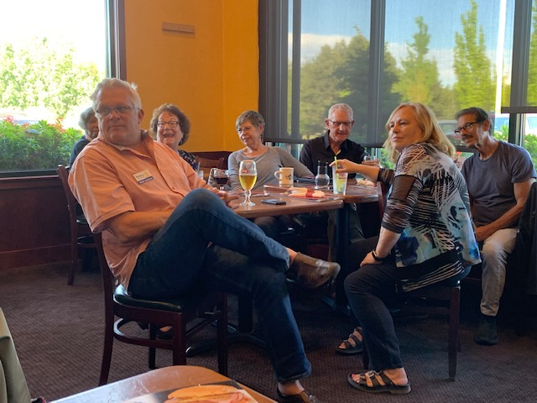
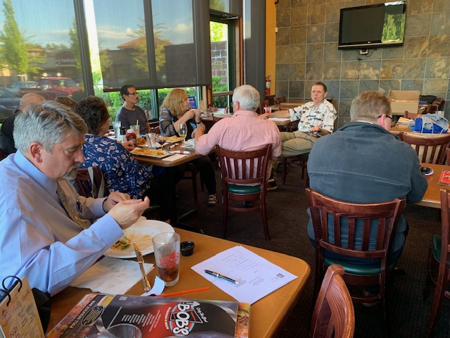

President Tim adjourned our meeting.

