PNW Passport Rotary Board Meeting
Date: August 14, 20191 Meeting start time: Fellowship 5:30 pm
Meeting time: 6:00 pm

Location: President Deb Wigg’s Home

Attending: | Absent:
Deb Wiggs, President  Tim Villhauer, Past-President  Jim Smart, Treasurer  Lindagene Coyle, Co-Treasurer  Julie Johansen, Service Comm  Pati Villhauer, Engagement Comm | Sean Hogan, Founder of PNW Rotary Club  Patricia Sibley, Rotary Foundation Chair  Guests: Pete Kremen  Marlene Sexton

President Deb: Welcomed those in attendance. She had high expectations for tonight’s meeting and there was a lot to cover. She thanked both Pete and Marlene for joining us tonight.

President Deb: Asked for approval of the Board Minutes for the meeting held on:
July 13, 2019
Tim Villhauer motioned approved
Julie Johansen 2nd the motion
APPROVED

President Deb: called on our treasurer to speak to the financial statements for the Club. There was a small discussion over some items.

P-Elect Roy motioned approval of the financial statements
P-President Tim 2nd the motion
APPROVED

President Deb: asked about Club insurance.
Co-Treasuer Lindagene: was able to answer this question she said the Club was covered both in Canada and the States. The Club is covered not the members of the Club. RI states the coverage differently for Americans then Canadians and we pay differently.

The U.S. Rotary Club & District Liability Insurance Program ("Program") provides general liability (GL) and directors' & officers'/employment practices liability (D&O/EPL) insurance coverage automatically to active U.S. Rotary Clubs & Districts (subject to policy terms and conditions).

American Rotary clubs are all covered by an insurance policy taken out by Rotary International and the fee is included in the annual RI dues. For further information, please contact US District Insurance Chair, Don Whitfield don-whitfield@leavitt.com 425-258-2300.

District 5050 Canadian Rotary Clubs take out a separate policy and dues pay it for the insurance of our Club. I’ve attached two documents for you to look at if you wish more detailed information.

President Deb: asked Pati Villhauer, Engagement Chair to speak about upcoming meetings. The Mt Vernon meetings were going to be at Max Dale’s Restaurant. She was planning some with the Days for Girls on August 23rd.

Discussion arose about our meetings and the schedule. Members felt more clarity was needed as to when the meetings were – members wanted to mark their calendars and have a mind-set as to when the meetings were without even really thinking about it. It was stated that the meetings are every 2nd Saturday and every 4th Thursday. To give equal time on either side of the border there is always two meetings on each side of a Saturday and Thursday that are back to back.
Example: Thursday, August 22nd time 6:00 pm and Saturday, September 14 time 4:00 pm are at Roadhouse, Surrey, BC. -- Thursday September 26 time 6:00 pm and Saturday, October 12 time 4:00 pm Bob’s.
The executive felt because we have a number of members who live on the southern end of District 5050 we should have a meeting in their area once a quarter – Dale Max Restaurant was chosen for those two meetings.

It was noted that December 19, 2019 meeting was holiday meeting. April 11, 2020 was changed to April 4, 2020 because of Easter.

President Deb was going to send Joy a corrected copy of the Meeting Calendar for distribution with minutes.

Business part of meeting ended: 6:50 pm

President Deb: Informed us the rest of meeting would be devoted to a Vision Session:
Leadership is the capacity to influence others through inspiration, motivated by passion, generated by vision, produced by conviction, ignited by a purpose.
(M. Munroe)

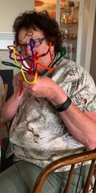
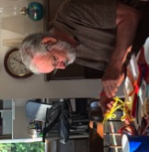
She offered us some chenille strips (pipe-cleaners) to make something that represents Rotary to us.
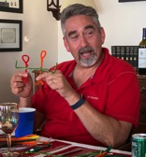
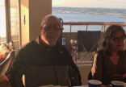
Tim - Working together
Jim - Glasses help with Clarity of vision to make things better
Roy - Power of One to affect the World

Pati - Circle of Friends

Others said:
Lindagene – world / people working together making an impact

Marlene – working together to make changes to a community, nationally & internationally

Julie – peace

Pete – Exemplify the common bond of our Canadian and American members in our efforts to serve and enjoy fellowship.

President Deb: Said this was a good process to get us into the right mind set for setting out a vision for the PNW Rotary Club. Goals for tonight were:
- Refine Purposes of the PNW Passport Club
- Participation expectations
- Pursue purpose
- Set operational strategy to meet Rotary Citation Goals for 2019-2020
- Operational challenges

With these topics in mind Deb set out the following for us with questions on how we can improve our Club, what are some of the challenges we face.
Club Members:
- want their investment of time commitment to count
- sense of a service project

Club members need to recognize:
- The terminology will be different in a Passport Rotary Club.
- Fellowship makes a Rotary Club cohesive

Are these things necessary?
- Participation by members – should they try to attend a meeting a quarter
- Do we need a local service project and an international one

How can we make the above points happen within the PNW Rotary Club? Deb asked what do we think the PNW Club needs to STOP:
- Can’t keep saying we always have done it that way
- Rid the Club of old Rotary expectations
- Get out of traditional framework of Rotary
- Stop worrying about members attendance
- Stop the frustration of service projects still not being set out – we’re a new Club service projects lots of time. We need to have a fundraiser to get money for projects.
- The Club was helping other Clubs within District 5050; this gives our members a sense of purpose. We need to set-up fellowship with those commitments.

Some things we need to start immediately:
- Establishing Clubs expectations and making them happen.
- Get to know our members – possibly establish Whose Who chat from a member these didn’t have to be long.
- Try to get those members who have never attended a meeting or only one to come out. Deb is planning on chatting with PNW members to get a feel for why they aren’t attending. Past President Tim, Pati and Julie offered to help with this project.
- We need to make the meetings more appealing. Pati can really only do so much other members need to provide suggestions of speakers or activity for the meetings.
- It was suggested we get the folks who drove Miss Vicky back to speak about their trip.
- President Deb – asked Pete if he would write a paragraph on why he belongs to the Pacific NW Rotary Club
- It was suggested we offer members to attend meetings electronically.

It was suggested that we send out Birthday cards to members. Lindagene said she was doing this.

The Executive members in attendance and our two guests felt the visionary things were doable. It is just now assigning people tasks to make the suggestions happen.

Thank you Deb for a wonderful dinner and my goodness the view was amazing we were blessed with a wonderful sunset. Thank you for all the effort you put into making the Visionary meeting happen.

On a personal note – I came away with a new mindset to our Club.

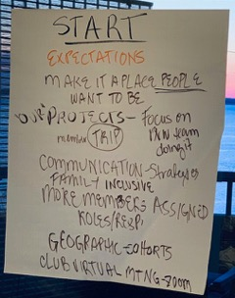
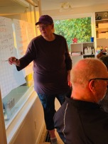

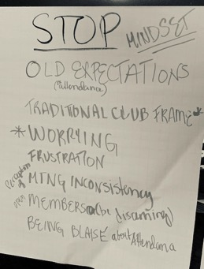
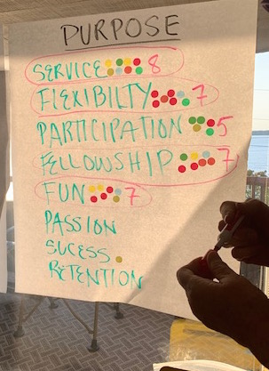

Meeting adjourned at: 8:40 pm
Next Meeting:
Date: September 14, 2019Location: Roadhouse Grill, Surrey, BC
Minutes Submitted by: Joy St. John, Secretary PNW Rotary Club

