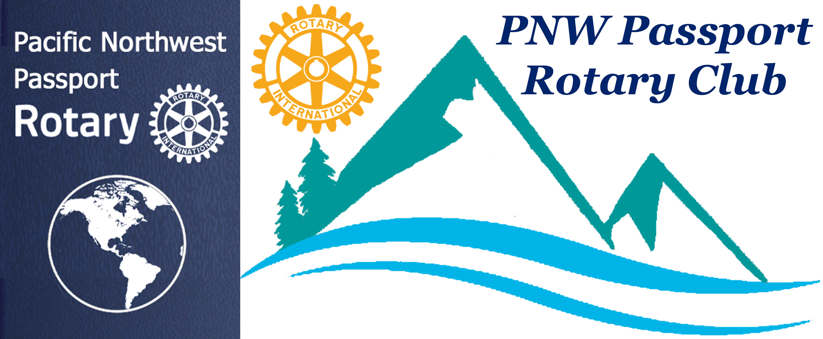

PNW Passport Rotary Special Board Meeting
Date: August 22, 2019 Meeting start time: 8:16 pm
Location: Roadhouse Grille, Surrey, BC

Attending:
Brad Whittaker, DG District 5050
Deb Wiggs, President
Julie Johansen, Service Comm. Chair
Pati Villhauer, Engagement Comm. Chair
Patricia Sibley, Rotary Foundation Chair
Lindagene Coyle, Co-Treasurer
Joy St John, Secretary

Absent:
Roy Holman, President-Elect
Tim Villhauer, Past President
Jim Smart, Treasurer

President Deb: Thanked DG Brad for taking the time to sit and discuss our Club and Rotary’s vision for the coming year. P-Deb restated the comments that the RI President remarked to her – he knew things were different with Passport Clubs so maybe not asking permission just doing it was the way to go as long as it pasted the Four Way Test.

DG Brad: Asked about Club concerns.

Julie: Mentioned that not getting members out even though they had paid their dues.

DG Brad: Suggested reaching out to members by:
- Increasing personal communication not electronic but phoning or meeting with a member or members and asking why they may not be attending at least one or two meetings.
- The Club doesn’t need to be big to be a great Club having member participation is important no matter the size.
- Having a specific project might bring them out.
- Giving other members tasks to be completed.

DG Brad: Suggested that a question to ask might be:
- Rotary Above Self and how does each member see this within our Club.
- What are they passionate about
- Seek former Rotarians with this new concept of a Rotary Club – it may appeal to them

DG Brad: Suggested going to other Clubs and while there talk about availability to help them with their projects. Let them know we are not interested in taking any of their members BUT to help, as this is what the PNW Passport Rotary Club wants to do.

DG Brad: Suggested that it might help to get the word out about our Club by putting an article in the Peace Arch News – James Munroe.
- Letting them know how we’ve helped
- Where we’ve helped
- What we’d like to do
- Advising that we were looking to partner with another Club on an International project
There are many different methods of reaching out to District 5050 Rotary Clubs.

President Deb: Stated that we were trying to do a better job of connecting. Some of the ways are:
- Our member Pete Kremen is going to be writing a paragraph on why he likes being a member of the PNW Rotary Club.
- Having more socialization at our meetings
- Figuring out our own service project
- We will be helping with the Green Food Bank Bag project. Tim Villhauer is heading this up for us.

Joy: Stated we were planning on looking at having members attend meetings electronically – there are several different methods. We just need to get this organized over the next few months.

DG Brad: Mentioned that District had go-to-meeting we could use that.

President Deb: Thanked DG Brad for his advice on how we can improve. We look forward to seeing him in November.

Meeting adjourned at: 8:
Location: Roadhouse Grill
Minutes Submitted by: Joy St. John, Secretary

