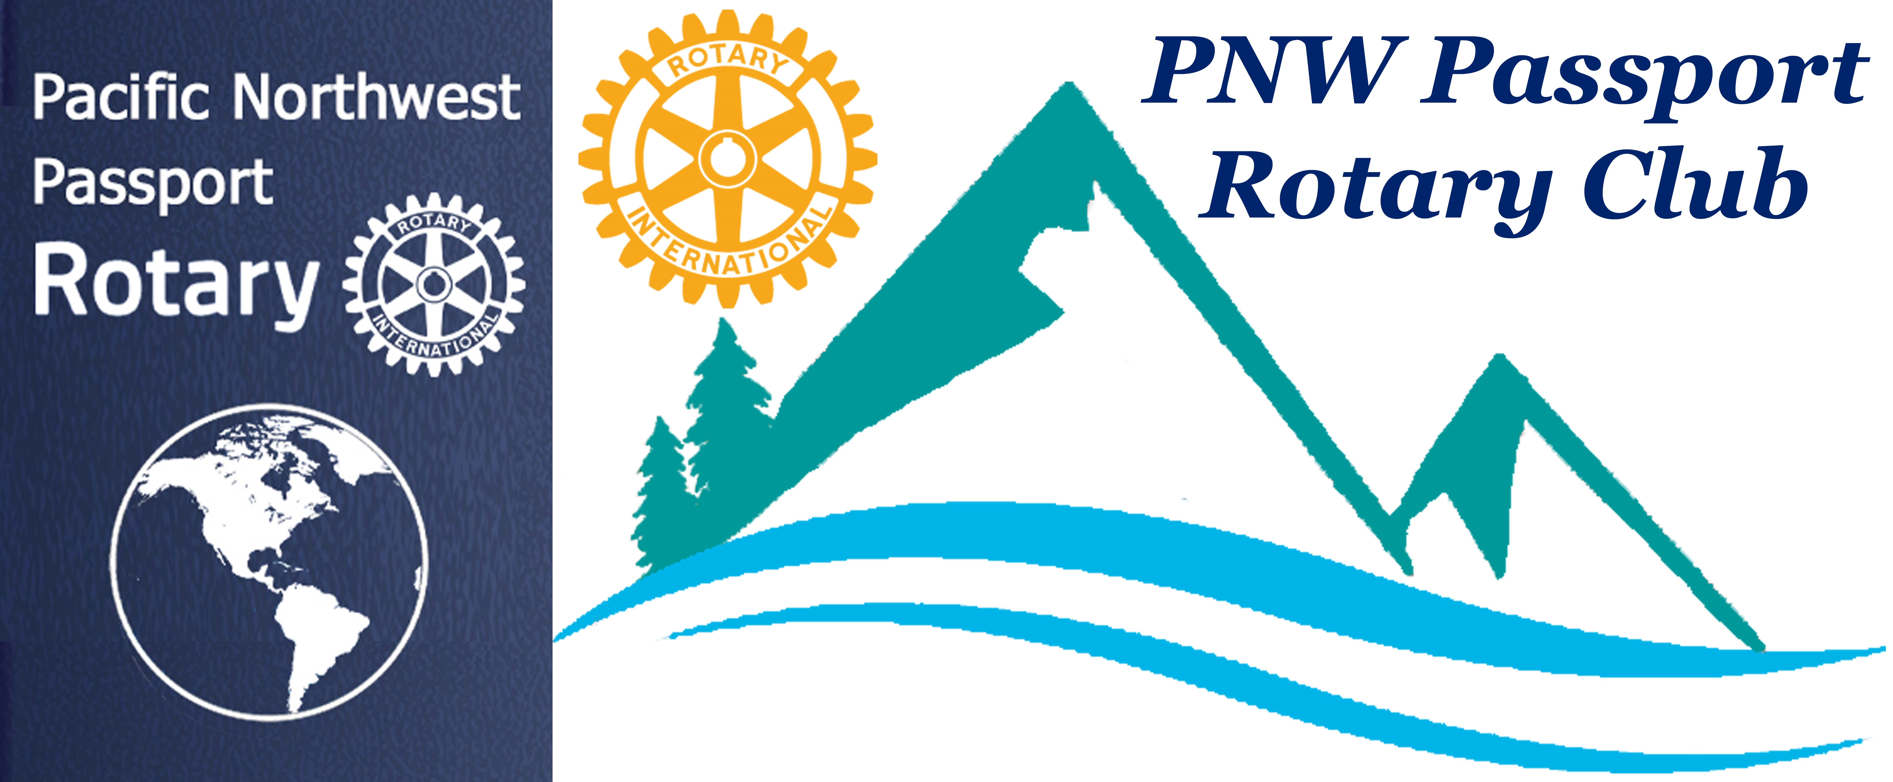

PNW Passport Rotary Club Meeting Notes

Date: August 22, 2019 Time: Socializing 6:00 – 6:40 pm
Meeting 6:41 -
Place: Roadhouse Grill, Surrey, BC

President Deb: Welcomed the members to the meeting. She was happy to see such a large attendance to welcome DG Brad to our Club meeting. She asked us to recite the Rotary 4-Way Test. P-Deb said that when she goggled Beneficial to all concerned the following came up…. favorable or advantageous; resulting in good.
Synonyms: advantageous, favorable, helpful, useful, of us, of benefit, of assistance, serviceable, of service and more.

President Deb: asked members with guests to introduce them:
Sean Hogan introduced his wife ‘Poor’ Carol
Lindagene introduced Assistant Governor for Area F Joan Appal
Pat Bond introduced her husband Al
President Deb: Recognized our newest member Sheri Brown who was inducted into Rotary by RI President Mark Maloney

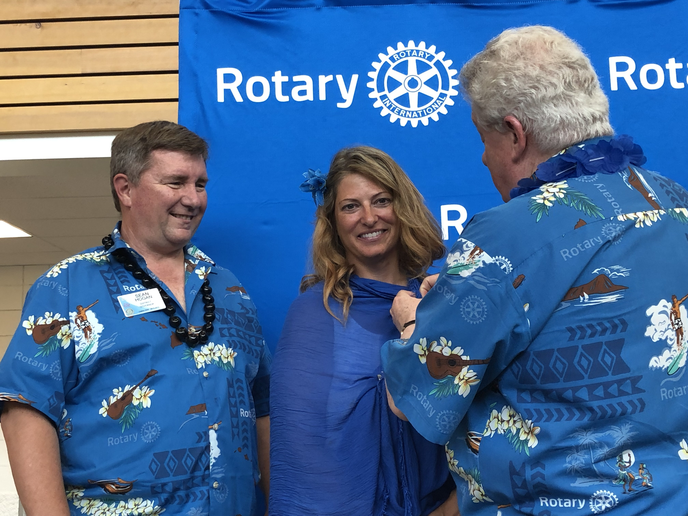

President Deb: reminded members she had started Loonie (for Canadians) / Buck (for Americans) DG Brad had asked that the funds raised tonight go to Rotary Foundation. Here are but a few thoughts given as money was put into the basket:
Sean Hogan: Said last Rotary meeting he was sharing the happy occasion of his 35th Wedding Anniversary and this week he was celebrating his son being married 35-days.
Sherri Brown: Happy to be back in Rotary.
Pat Bond: Was delighted to have her husband attending tonight’s meeting with her.
Terry Gallant: Happy that this year saw each Ribfest successful.
Steve Gable: Welcomed his Club PNW Passport Rotary Club as the newest member of Rotary World Help.
Jim Smart: He and his wife are going to be celebrating 50 years of marriage in September.
Patricia Sibley: Joked saying she had invited three people to tonight’s meeting when they heard DG Brad was the speaker they said catch me another time.
Others gave Happy Bucks & Loonies – thank you all for contributing to Rotary Foundation. Thank you to the members in attendance we are able to donate to the Rotary Foundation
President Deb: Told the membership that the Executive meeting on August 14th had not only been a executive meeting but a small visionary meeting. There were two guests Marlene Sexton and Pete Kremen they provided some very important insight for the Club. Pete will be writing a short paragraph on why he is a member of the PNW Passport Rotary Club. His paragraph will be attached to the next meeting’s minutes as well as on the web page, home page of Club Runner. There were three main headings that folks were directed to by President Deb: Stop, Start and Purpose. P-Deb said some important thoughts from the comments were: a mindset – we’re not a traditional club. That our members were lacking in attendance yes we are flexible but it would be welcomed if each member tried to attend a meeting once a quarter. That fun, fellowship and service were important to this Club we will work on more innovative ways of accomplishing these things. She spoke to RI President Mark Maloney about our Passport Club he gave her permission to be creative and realized Passport Clubs were new to Rotary and were not normal Clubs. P-Deb feels that this Club can accomplish the requirements to obtain a Rotary Citation this year it will be a jewel in the Club’s Crown.
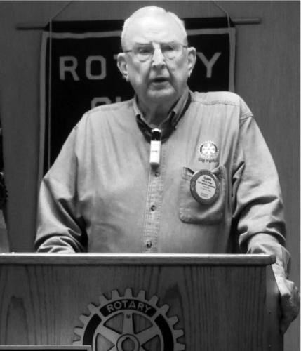
President Deb: said there seemed to be some confusion over our meeting dates and that members would prefer not to have to think or go to look back at documents to find out when and where our meetings were. She stated our meetings are every 2nd Saturday, 4-6:00 pm and every 4th Thursday 6:00 pm. Two meetings are at Roadhouse Grill, Surrey or Bob’s Burger & Brew, Birch Bay Square, WA. There would be an occasional exception as it was determined that we needed to go further south in our district to accommodate our member located there. There will be two meetings there in our calendar year and they will be at the Max restaurant. Joy will be attaching to the minutes a Pacific North West Passport Rotary Club 2019-2020 Calendar. Please mark the dates on any of the calendars you look at whether it be electronic or paper or both.
President Deb: It was 30 years ago that her Dad was District Governor. She presented DG Brad with the pin for that year’s theme, which was Enjoy Rotary. (DG Brad was honoured to receive such a wonderful meaningful gift).
DG Eldon Wiggs

President Deb: asked District Assistant Governor Area F Joan Apel to introduce our District Governor Brad Whittaker.
Joan Apel: District 5050 Governor for 2019 – 2020 is Brad Whittaker. He is married to one of your Club Charter Member’s Kim Isaac. He has four stepsons, has a dog-named Rosie and three rescued cats. He recently retired from University of the Fraser Valley where he served as Director of Research Services and Industry Liaison. He has been a Rotarian since 2002 during that time he has held many positions and has served the District well. I’m pleased to introduce DG Brad Whittaker.
DG Brad: Thank you for the opportunity to speak to the PNW Passport Rotary Club. Thank you again President Deb for the honour of giving me your father’s DG theme year pin. I will keep it safe and I do Enjoy Rotary.
I’d like to bring to you now some of my thoughts and visions over the next year.
Rotary Vision Statement:
Together, we see a world where people unite and take action to create long lasting change – across the globe, in our communities, and in ourselves.
RI Strategic Action Plan Priorities:
- Increase our impact
- Expand our reach
- Enhance participant engagement
- Increase our ability to adapt
Theme this year for Rotary is – Rotary Connects the World
- Grow Rotary - Rotary lost more Rotarians last year then in the history of Rotary.
- Membership / foundation / public image
- Create new membership models – such as the Passport Clubs
- Build new Rotary and Rotaract Clubs
- Bring Families into Rotary
- Viable path to Rotary Leadership
- United Nations – 75th Anniversary of partnership
Getting the Most out of Rotary:
- Put more into Rotary
- Learn more about Rotary
- Become involved beyond the Club
Rotary Events:
- Golfun – Friday August 23 for Foundation
- Foundation Dinner – Abbotsford – November 15
- District Assembly – Surrey, April 4
- District Conference – Harrison Hot Springs April 30 – May 3
- Peace Conference – California – January 17 & 18
- International Convention – Honolulu – June 6 to 10th
Getting the Most out of Rotary
Rotary Action Groups:
- Literacy • Peace
- Hearing • Endangered Species
- Malaria • Multiple Sclerosis
- Microfinance • Polio Survivors
- Water & Sanitation • Health Education
Rotary Fellowship Groups:
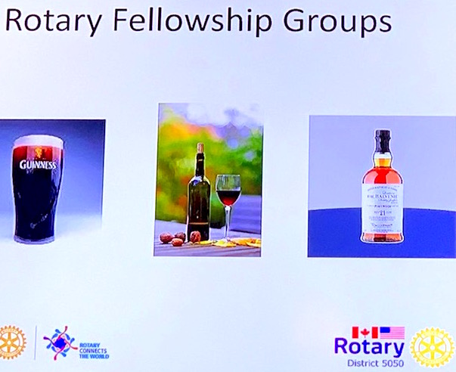
These are some of our DG’s favourite Fellowship Groups. There are many others and they are formed by Rotarians around the world sharing same interests. You can always check on line if there is one you’d like to join.

DG Brad left us with these inspirational words:
Let’s get our hands dirty. Let’s get involved.

DG Brad: Said he now had the pleasure of awarding a Paul Harris Foundation Fellow to one of our members who has upheld the Rotary Motto of: Service Above Self. She has also contributed substantially to the Rotary Foundation. He called Pati Villhauer up to thank her personally for all she does for Rotary.
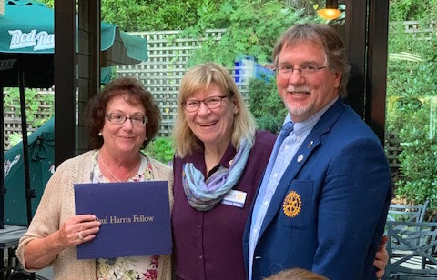
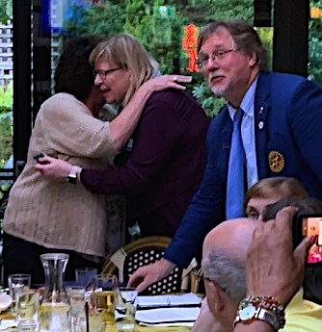
Congratulations Pati from all the members of PNW Passport Rotary Club.

DG Brad: Also called another member of the Club up for recognition that person was none other than your Club Secretary (Joy) he presented her with the Rotary pin People in Action.
Thank you to the membership for this recognition.
President Deb: Thanked DG Brad for a great talk. We have lots to go away and ponder as a Club and as individuals. P-Deb is excited at the growth of the Rotaract Clubs in District 5050. Sean Hogan said there are many changes coming within Rotary International. She asked if anyone had questions for DG Brad. There were none forthcoming.
Pati Villhauer: Reminded the Club of the BP Tour & luncheon on September 27th. She will need people to advise quickly if they are going to be attending. Spouses were welcome to attend. Pati was going to see want the ages for children were to attend the tour.
President Deb: Thanked everyone for coming out to the meeting. There will be an executive meeting with DG Brad following the meeting and members were welcome to attend.
Meeting adjourned at: 8:00 pm Notes taken by: Joy St John, Club Secretary
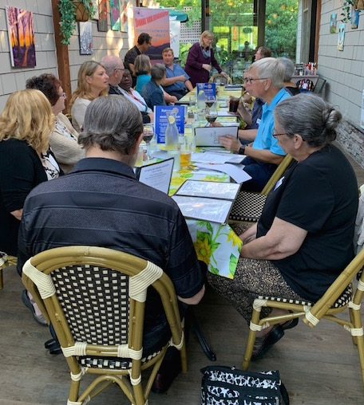
Next Club Meeting: Date: September 14, 2019 Location: Roadhouse Grill, Surrey, BC
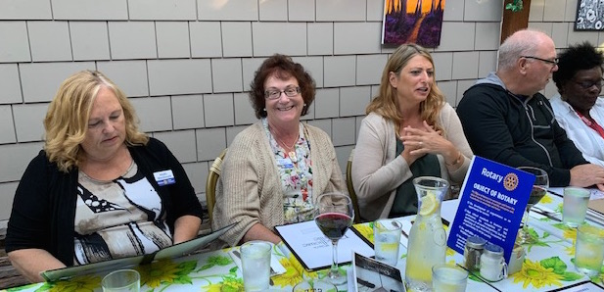
True Rotary Fellowship sitting around a dining table!!

