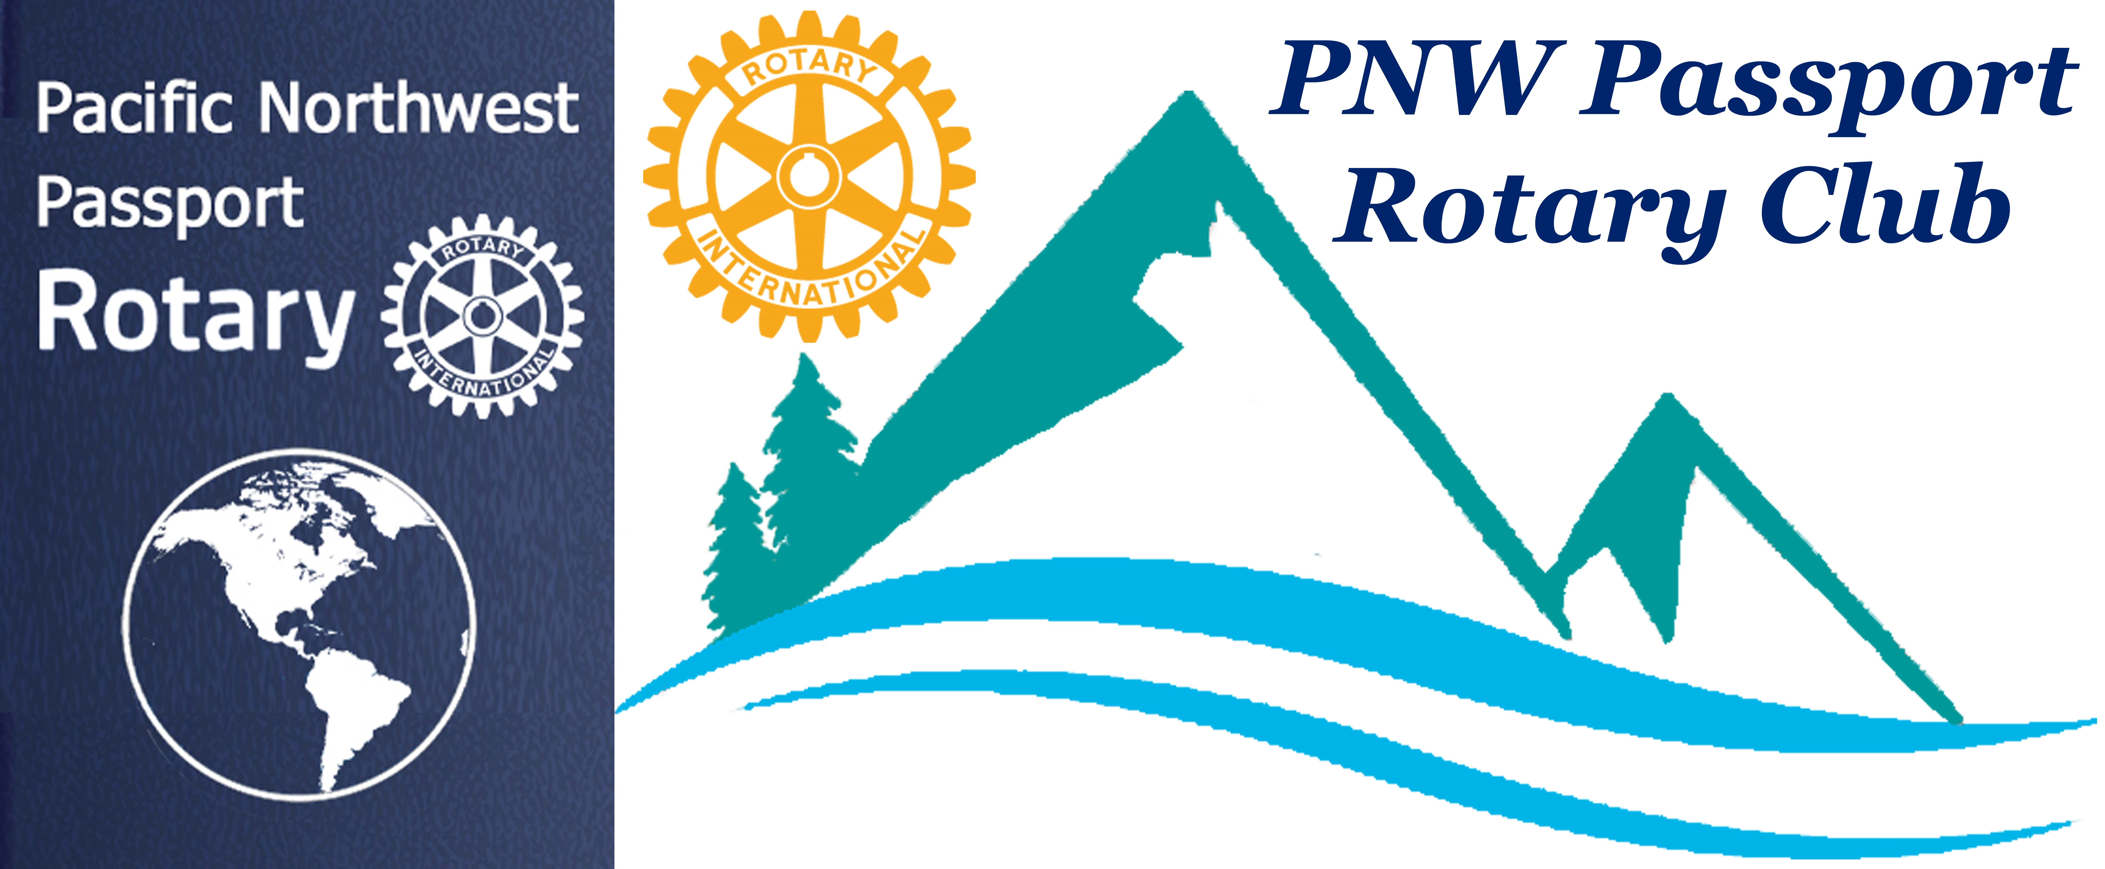

PNW Passport Rotary Club Meeting Notes

IMPORTANT UPCOMING DATES:
July 19-21 - Port Moody Ribfest
July 21 - DG Brad Whittaker’s Installation
July 25 - PNW Rotary Club meeting -- Come and Celebrate the Pacific NW Rotary’s 1st Anniversary at Bob’s Burger & Brew, Birch Bay Square
July 27 - District 5050 Rotaract Installation of their new Board.
Rotaractor Dakota White of the Bellingham Club is their 2019 Rotaractor of the Year and is our very own Julie Johansen’s grandson.
Aug 15-19 - Langley RibFest – PLEASE SIGN UP this is a fundraiser for our Club
Aug 17-18 - Mark Daniel Maloney is coming to Surrey, BC
Aug 23 - Rotary Golfun
come out for a fun filled event whether it be to - play golf, volunteer or come only for dinner with members

Date: July 13, 2019 Time: 4:00 pm
Place: Roadhouse Grill, Surrey, BC

President-Elect Deb: welcomed all to the meeting. Mentioning we had several guests with us today thanking them for joining us. We have 45-minutes to socialize and order our food.

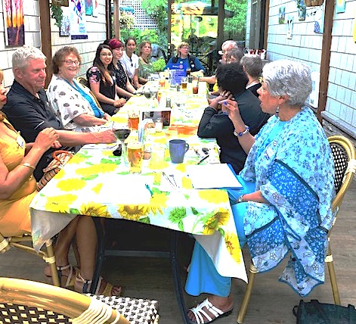
The noise level was high with everyone meeting, reconnecting and getting to know PNW members & guests next or across from them.

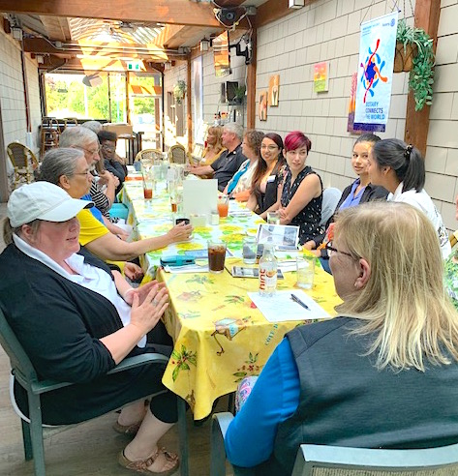

P-E Deb: Brought the meeting to order saying it was hard seeing so much fellowship going on but we needed to get on with Rotary business. She had chocolates for each of us in attendance saying she brought silver and gold chocolate coinage stamped with the euro on very fitting as the Rotary International Conference was in Europe this year. She recognized Pati Villhauer for her efforts for organizing speakers for Club meetings. She also recognized Julie Johansen for her continued support to the Club in her efforts of finding projects we might participate in. P-E Deb said during her presidency she would be to caring the torch that her Dad set out for her family, she was a third generation Rotarian. She grew up with the Rotary 4-Way Test always in sight at their family house. Her goal is to always keep strong to that Test as her Dad did.

P-E Deb: hoped during her tenure as President to possibly add extra money to our Club funds with Club members sharing special moments with the membership these special moments don’t always have to be attached with funds.

P-E Deb: Called our Charter member Lindagene Coyle who has held so many titles over her years as a Rotarian to her present title Vice Governor to preside over the Installation of the 2019/2020 Pacific NW Board of Directors.

Thank you Vice Governor Lindagene – Wow -- I’m now President of the Pacific NW Passport Rotary Club 2019-2020

The Pacific NW Passport Rotary Club 2019-2020 Board members President-Elect Roy Holman
and Secretary Joy St. John. There will be more celebrations to come at our next meeting.

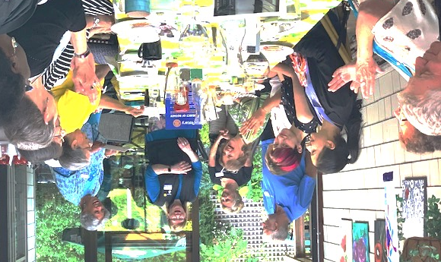

President Deb – Brought us back to a serious moment the installation of our newest member Pat Bond who has had many titles within District 5050 her latest title is District Governor’s Aide.
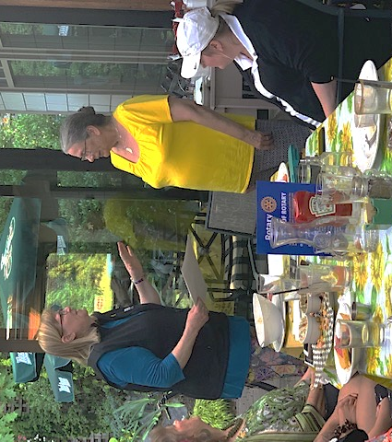

Welcome Pat!!

President Deb – introduced our guest speakers who the Club sponsored for the 2019 RYLA Manpreet and Stephanie.
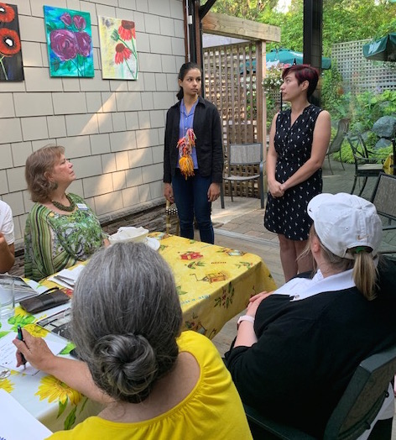
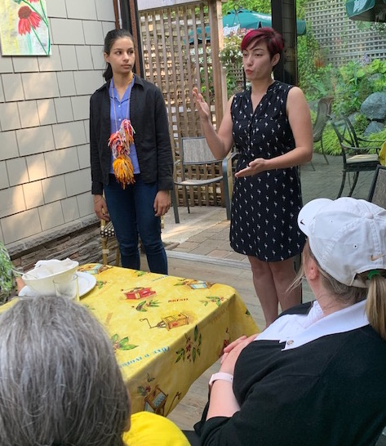

Manpreet and Stephanie: Sung the praises of the opportunity to go to RYLA. Some of the highlights they pointed out to us were:

- Your journey starts immediately upon arrival with the presentation of a necklace with yarn attached to it. You were given the instructions that each person you hugged each of you could take a piece of yarn from each others necklace. Some people did fist bumps or hand hugs which was also a warm way of saying hello
- Valuable speakers
- Took away some of their shyness of speaking up in front of a room with very large personalities
- Their day started out early 8:00 am but was packed full of awesome things to participate in
- Cell phones were off but really there was no reception. Was this intentional?
- Yes, RYLA was life changing for them and they knew they had made life long friendships
- Left knowing they wanted to be a Rotaract with the hopes of someday being a Rotarian putting service before self!

President Deb – Thanked Manpreet and Stephanie for the excellent report of their time at RYLA it’ll inspire the Club to keep sponsoring young people to go to RYLA.

Pati Villhauer: said she had a speakers lined up for
August 10 from Northwest Straights:
The Northwest Straits Commission is a regional coordinating body comprised of people who care about the marine areas where they live, and who work together to protect and restore marine resources.
The Northwest Straits Commission carries out regional conservation projects and supports the work of seven Marine Resources Committees through funding, technical support, training and regional coordination.
October 12 a speaker from Mercy Ships.
Julie Johansen: reminded us of volunteer opportunities that would bring funds to our Club:
July 19, 20, 21 Port Moody RibFest
August 16, 17, 18 Langley RibFest

President Deb: challenged club members to go to Club Runner and say hi to a member you don’t know. Please send notice of your meeting to Club Secretary Joy.
She also said her inbox would always welcome comments about the PNW Rotary Club especially if a member had a complaint with a solution to their complaint. Observations by members for Club improvement would be great.
P Deb also wanted members to know there were no boundaries in this Club.
Our guest Dave Rogers wanted to know if our Club gets global grants the same as other Rotary Club. Yes we do get the global grants but we first need the funds to be matched.

Meeting ended with:
President Deb saying:
It is OUR Rotary Club please speak up with your vision of YOUR Club!!

Meeting adjourned at: 6:10 pm
Notes taken by: Joy St. John, Club Secretary

Next Club Meeting: July 25 at Bob’s Burger & Brew, Birch Bay Square, WA

