PNW Passport Rotary Club Meeting Notes

Date: July 25, 2019 Time: 6:00 – 7:00 pm fellowship
7:00 pm meeting called to order
Place: Bob’s Burger & Brew, Birch Bay Square, WA

President-Elect Roy: Called the meeting to order. He informed us that President Deb was not able to attend tonight. He asked Secretary Joy to introduce our guests.

Secretary Joy: Introduced the guests of Jill & Terry Greer
Oliver & Marion Sweeney
From Sligo, Ireland

Club members enjoyed chatting with our guests learning about their travels, Ireland and their upcoming travels.

P-Elect Roy: Thanked President Tim on behalf of the PNW Passport Rotary Club for a job well done. It hasn’t been easy being the 2nd President to a Club that is still trying to understand the direction that best suits this Club with a membership on both sides of the border. You have guided the Club helped the membership make important decisions this past year. We look forward to your continued guidance as Past-President.

Thank you Past-President Tim we are truly appreciative of your leadership.

Past- President Tim: Said he enjoyed his tenure as President and thanked his executive members by honouring them with a donation to Polio Plus.
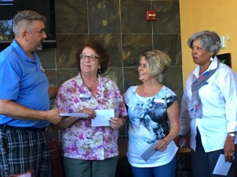

Absent Executive members: President Deb Wiggs, P-President Sean Hogan, Treasurer Jim Smart, Service Chair Julie Johansen, Foundation Chair Patricia Sibley

P-Elect Roy: Reflected on the great time those that volunteered at the Port Moody Ribfest in particular the Rotaract Corn Hut had.
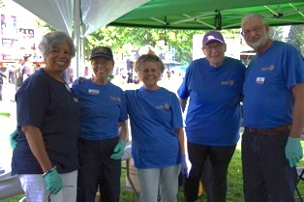
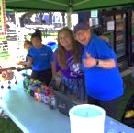

He

He reminded us if we missed the Port Moody RibFest we have another opportunity to volunteer and enjoy a ribfest and Rotary Fellowship --- at the Langley Ribfest August 16, 17 & 18. Please register at: www.ribfestlangley.com Volunteering helps bring money into our Club for future endeavours.

Our RI President Mark Maloney will be attending the Langley RibFest on Sunday August 18. He has a very full schedule but has requested to visit a community Rotary Fundraising project.

You are invited to a Meet and Greet with RI President Mark Maloney on Saturday August 17th from 4-6 pm at Kwantlen Polytechnic University in Surrey, BC. To reserve your spot CLICK HERE.

Induction: Vice-Governor Lindagene was asked to induct Jill and Terry Greer.
V-G Lindagene: reminded us of the importance of Rotary in the World. Terry you’re not new to Rotary you have been a Rotarian for 26 years. You were twice President of the Stanwood Rotary Club; it is still important to remind you about your Rotarian duties and the importance of Rotary. We know you will continue to be an active dedicated Rotarian.
Welcome Terry to the Pacific NW Passport Rotary Club we are pleased and privileged to have you as a new member.
Jill, as a new member to Rotary it is important that you read your welcome package and continue to learn about Rotary locally and international. We know that you have been a very supportive Rotarian spouse over the years; we are so pleased that you have decided to become a Rotarian yourself. Rotary will benefit greatly from your membership.
Welcome Jill to the Pacific NW Passport Rotary Club we are pleased and privileged to have you as a new member.
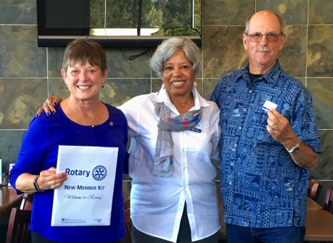

P-Elect Roy: Invited P-P Tim to come up and explain a very worthwhile project for our Club to get involved in:
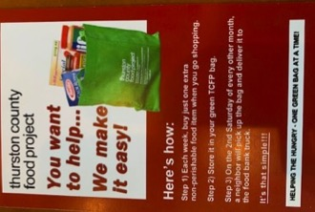
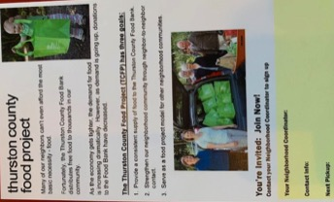
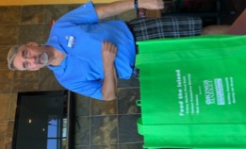

P-P Tim: Explained that this would be a very rewarding project for us as Rotarians. He is presently working with his other Rotary Club Whatcom North. He is going to do a trial run explaining the premise of the drop off of an empty bag and pick up a bag with food in it at the Ferndale Fair. He has personally put $500.00 US towards obtaining the bags to start the project off. It would be a matter of one Saturday a month to collect the bags and dropping off an empty bag to participants of the project. For now he is planning on keeping the project within the Ferndale area. He hopes to get Rotaracts involved. The food taken in would go to the local Food Bank. This project has done very well in other states and he hopes with Whatcom North and the PNW Passport Club to make this a successful venture.

P-P Tim will keep us informed on this project and when he wants us to step in to help.

Engagement Chair Pati: Said she is continuing to work on speakers for the club. She would like Club members to help her by giving her suggestions of speakers. Right now she is working on BP Tour and luncheon on September 27. Watch for speakers to come. Some suggestions were:
Rotary Fellowships are international groups that share a common passion. Being part of a fellowship is a fun way to make friends around the world, explore a hobby or profession, and enhance your Rotary experience.
V-G Lindagene said she belongs to Fellowship of Wine lovers.
Invite someone to talk on Rotary Wheelchair Foundation.
P-Elect Roy: Talked about the Rotary Presidential Citation Criteria that President Deb would like us to obtain. There is no reason why we can’t make it happen with all of us working toward the goals. We will be discussing these goals over the coming months:
(1) Unite People – we need to achieve 5 out of 10 goals. We discussed this is as very doable.
(2) Take Action – we need to achieve 5 out of 8 goals mentioned. We can do this easily.
(3) With Presidential Distinction – out of four goals we need to achieve one for silver, two for gold, three for platinum.
As NIKE would say lets just DO IT!!
P-Elect Roy: Said our meeting on August 22 is the day before the GolFun Tournament on August 23.
V-G Lindagene: motioned that we change our meeting date of August 22 to August 23. There are opportunities for non-golfers to volunteer. Those not golfing can come for dinner only. To register for dinner only, CLICK HERE.
The date change was passed. Our meeting will be August 23, at Homestead Golf & Country Club -- 115 E Homestead Boulevard, Lynden, WA 98264, United States of America.

Meeting adjourned at: 8:00 pm Notes taken by: Club Secretary Joy St. John

Next Club Meeting:

Date: August 10, 2019 Location: Bob’s Burger & Brew, Birch Bay Square, WA

