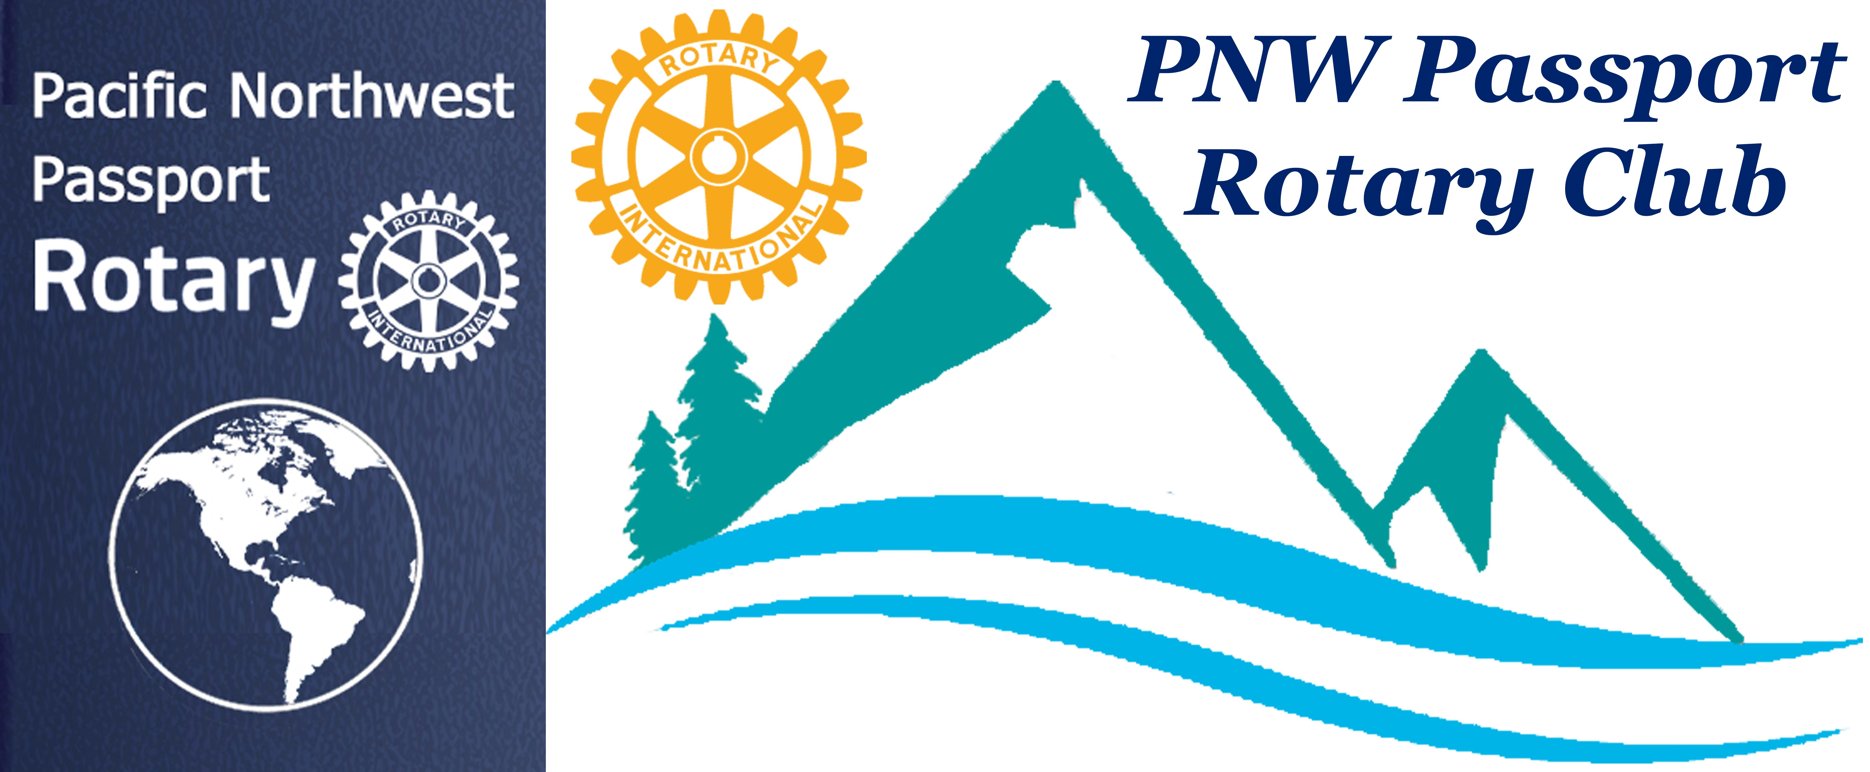

News: Newton Rotary Club in Surrey is having a food drive Sunday (11/10) 10:00 am – 4:00 PM, donations to go to Foodbank (Starfish Park Project)
End of January: the Rotaract Club of Surrey will hold RotarX for 200 people and profits will go to SOS.
Next meeting: November 21st 6:00 – 8:00 PM
LOCATION: Max Dales, Mt Vernon,
Guest: District 5050 Governor Brad Whittaker

November 9th, 2019
PNW PASSPORT ROTARY CLUB MEMBER MEETING

Roadhouse Grill, Surrey, B.C. 6-6:45 Socializing and Food 6:45-8PM Meeting

Reflections on Gratitude

Pres. Deb: Grateful for friends allowing her to “borrow” their children. Jill: Grateful for family/friends and good health.
Terry: Read President Maloney’s message in the July “Rotarian” about being stuck in an airport and passing the time walking the airport and observing all the pockets of humanity clustered by the different gates going to international destinations, totally separate from each other, causing him to reflect on how Rotary brings people from all over the world together to meet and share ideas!
Grateful for Rotary!
Pati: Grateful for family, both 2-yr-old grandson and Rotary family
Ann: Grateful for being able to share with cousin from England her passion for Orcas!

Nav: Grateful for 3 generations and lots of cousins gathered for a wedding and knowledge of Rotary Clubs in India that she might visit.
Roy: Gratitude for family gathering for youngest daughter’s wedding, plus that all 4 children have grown up without issues and are all entertaining and healthy people.
Mary: Gratitude for family (siblings) and their children who have all grown up outspoken and independent people, plus she loves dogs.
Irma: Gratitude for family! Daughter has met a special man, and his mom came for a visit and they “hit it off.” The grandchildren range from 3-16 yrs in age and are a joy. She was just on a Cruise and met many Rotarians at an impromptu meeting.
Rosemary: Grateful for her health even tho she is experiencing knee pain. And thankful that her daughter delivered a healthy grandson for her.
Rose: Grandfather had 68 perfect years of attendance in Rotary. She learned Rotary values from dad who was raised in interracial Kentucky. Her dad grew up playing with the kids in his neighborhood and then wanted to bring them to the “white” Y. Grandfather said “yes” and by the time dad graduated from high school, the Y was integrated, and Frankfurt, Ky, did not have race riots. Thankful for growing up with Rotary values as presented by the 4-way test.
Four Way Test recited together! Foundation History
The mission of The Rotary Foundation of Rotary International is to enable Rotarians to advance world understanding, goodwill, and peace through the improvement of health, the support of education, and the alleviation of poverty.
Foundation dinner: November 15th at Quality Hotel
36035 N. Parallel Road, Abbotsford, BC, 5:30PM Miss Vicky there for Polio Plus.
(1 of 26 crossing the finish line under their own steam out of over 350 applicants)
Motion by: Terry to donate $100 from the club to Foundation per the Foundation Dinner request.
Seconded by: Nav Passed by unanimous vote (show of hands)
Next meeting: Nov. 21st, 6-8PM at Max Dales, Mt Vernon, with DG Brad Whittaker
Loony bucks: Deb found her Canadian coin wallet, Terry thought RLI was great, Pati is happy for her new kitchen, Rob is looking forward to next trip, Mary

is excited about granddaughter’s play, Irma is proud of 16-yr-old granddaughter’s “distinction” in school, Ann and Rose just happy to be here.
Service: Days For Girls sew day in Stanwood, 11-2PM, Fri. Nov. 15th.
Program: SOS Children’s Village https://www.sosbc.org/people/rose-hamilton
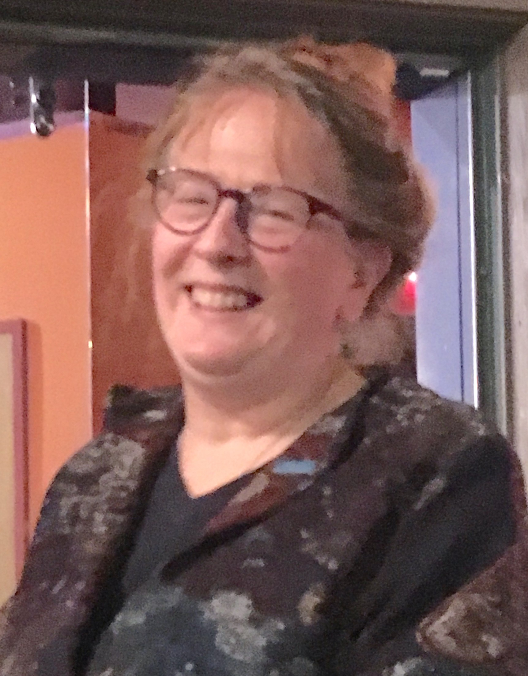
SOS program started about 70 years ago by a young medical student in Austria who saw millions of children abandoned after WWII with no system to deal with them other than putting them in “warehouses” or allowing them to live in the woods as “wolf children” and continue to be marginalized, when the deepest human need is “to belong.” Catholic foundations were expanded upon for “Family Homes” with four radical “pillars”: 1) Professional “Mom”; 2) Siblings stay together; 3) Family home; 4) Village (“It takes a village….) Went to National Governments and to UN, asking “Who speaks for the children?” Lobbied and received one seat in UN, and now have 600 villages and 200 training institutes. Nobody
“ages out” from 2 weeks to 29 years! In Surrey, 20 years ago, we got the first village and now have 7 homes in the community with 6% budget from government, some from Thrift Stores, and some private donations. An 8th home is a pilot program with ministry, training caregivers with continuing care orders because these are not “easy kids.”
Questions/answers:
2/3 in BC are aboriginal kids. 49 out of 49 up for adoption had been abused in foster care or own homes. Kids courage to heal from abuse is amazing.
“Its not just the one child, it is all the children that come afterwards.”
Now working on the first 5 of 26 villages so first nations can work to get guardianship of their children.
There is no emergency placements, or “coming and going”, as change is upsetting for the children. They need consistency.
The program is non-governmental and non-denominational and has the psychological testing and continuity of care lacking in foster care.
Usually, 24-43% would graduate from High School, but in last 5 years 100%!
Suggestion of designating a “Rotary House” for donations to be funneled for repairs, etc. by 5040.
December 1st, 3-7PM having an “Un-Gala” called “Home for the Holidays” with Ugly Sweater Contest, prizes, etc. February is “I heart SOS” month

There are 2 villages in Chicago and one in Florida that Rose knows about and they have a government contract, but are SOS style, with highest accreditation.
Respectfully submitted: Jill Greer

