PNW Passport Rotary Club Meeting Notes

Date: October 24, 2019 Social Time: 6:00 pm
Meeting Time: 6:45 pm

Place: Roadhouse Grill, Surrey, BC

Upcoming Dates to mark on your Calendars

October 30th, 2019
Days for Girls
Surrey, BC
9:30 am – 2:30 pm
For more details please contact: Hazel MacDonald
hazmacdonald@gmail.com

November 1, 2019
Days for Girls
Stanwood, WA
For more details please contact: Pati Villhauer
plvillhauer@yahoo.com

November 2, 2019
Rotary Learning Institute (RLI)
Register NOW for Part 1, Part 2 or Part 3
We need to pay our own way.

November 9th, 2019
PNW Passport Rotary Club Meetng
Roadhouse Grill, Surrey BD
4:00 – 6:00 pm

November 12th, 2019
Port Moody, BC
6:00 pm – 9:00 pm
For more details please contact: Hazel MacDonald
hazmacdonald@gmail.com

November 15, 2019
Foundation Dinner
Register on-line
Guest Speaker: Rotarian Lee Harman, Peking to Paris
The story of how Lee, Bill & Miss Vicky Crossed the Finish Line.

It was exactly a year ago that Lee Harman was our guest speaker at Burger Bob’s. We all got to see Miss Vicky we heard about the year ahead and learnt that he and his friend were doing it to help raise awareness of Rotary’s fight to End Polio, all funds raised went directly to Polio Plus. You won’t want to miss hearing about his adventures.

November 15, 2019
Days for Girls
Stanwood, WA
For more details please contact: Pati Villhauer
plvillhauer@yahoo.com

President Deb: Welcomed all those in attendance. She was very happy to see the socializing part of the meeting continues to work well in helping us get to know our fellow members. She was so happy to see our member Celeste Mergens, as well as our newly nominated member Rhian Piprell.

President Deb: Reflection was on Rotary History it is Rotary World Day October 24, 2019 in particular Rotary’s two official mottos. Arthur Frederick Sheldon inspired our second motto: One Profits Most Who Serves Best. Ben Collins spoke about Service, Not Self.

1911 – He Profits Most Who Serves Best was approved at the second Rotary Convention. At that time another motto was talked about Service, Not Self.

1950 – two mottos were formally approved:
- He Profits Most Who Serves Best
- Service Above Self
1989 -- Council on Legislation established the following as the principal:
- Service Above Self
2004 – modification to He Profits Most Who Serves Best to read:
- They Profit Most Who Serve Best
2010 – modification was established to read:
- One Profits Most Who Serves Best

We followed this with reciting the Rotary 4 Way Test then reminded to think, say & do it in our daily lives.

President Deb: Said with Thanksgiving having past for Canadian members and about to happen for our American members we should also reflect on all we have to be grateful for in our lives.

The Club is now officially a member of Rotary World Help and what does this mean:

By 1997, Bill Richwa and Ralph Towsley realized the project was becoming too big for one club, and needed to evolve to survive. As a result, the Rotary clubs of the Lower Mainland of British Columbia World Help Network was sanctioned by Rotary International, incorporated as a society in BC and received their registered charity status from Revenue Canada.

Operating as Rotary World Help Network, its membership was made up not by Rotarians, but by Rotary clubs. There were seven Rotary clubs who originally joined and each club paid $10 in fees per club member to Rotary World Help Network to help cover the administration costs.

Originally, we mainly gathered and sent medical supplies to hospitals, which had been built but couldn’t fully operate because of a lack of supplies or equipment. Today, medical supplies and equipment are still our main focus, but we have expanded to include dental and optical, education, and sports equipment and disaster relief supplies.
President Deb: called upon our member Nav to speak about the Rotaract Big West Convention October 25-27 at Vancouver, BC.

Navjit Singh: There are approximately 188 members attending from California to northern BC. They have great speakers lined up for the event. There is going to be lots of networking opportunities for the members. She thanked the Club for sponsoring two Rotaract members enabling them to go to the conference. She also thanked our member Dave Boulton for his personal contribution to sponsor one Rotaract to attend the conference.

President Deb: Said that because it was Rotary World Day she would ask our Foundation Chair, Patricia to talk about Foundation.

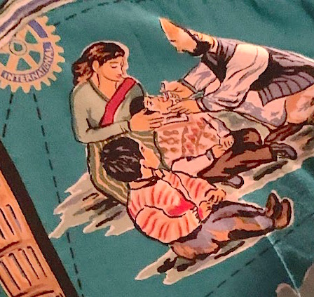
F-Chair Patricia: Said as she put on her End Polio shirt today she pulled out of the pocket a message she had passed along previously. It was meant to be that she should once again put the shirt on and be required to say a few words.

‘I’m from a generation who has witnessed the devastating effects of polio. It is so rare we can accomplish something so spectacular.’

I slept and I dreamed that life is all joy; I woke and saw that life is all service. I served and I saw that service is joy. Kahill Gibram

Emerson said, “Our chief want is someone who will inspire us to be what we know we could be.”

Today we’re thankful for the leaders of Rotary. We’re thankful they’re willing to give their time and their talent, willing to risk, and willing to inspire each of us to become the best we can be.

F-Chair Patricia: Asked our member Hazel who went to India on a End Polio mission to tell us again what it meant to her.

Hazel said it was five years ago that she went on this aw inspiring trip to help the betterment of children it was very meaningful indeed – it brought her back to Rotary to continue the work of Service Above Self.

F-Chair Patricia: Said we’re thankful that Rotary brings together these opportunities to improve our community and our world.
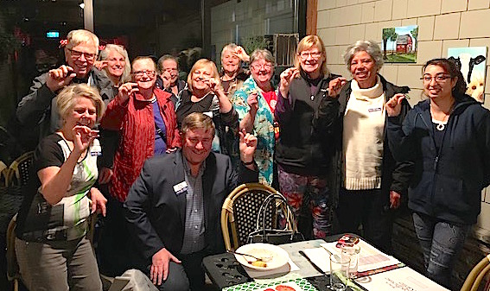

President Deb: Brought out our Loonie/Buck Basket saying it’s through our offerings and sharing that we are able to raise funds to keep our Rotary fees low.
Members shared with us moments of sadness and of great happiness. With our member Sean always throwing in humour!!

Thank you members.

President Deb: noted that we didn’t have a speaker tonight. She called upon Celeste to talk about Days for Girls.

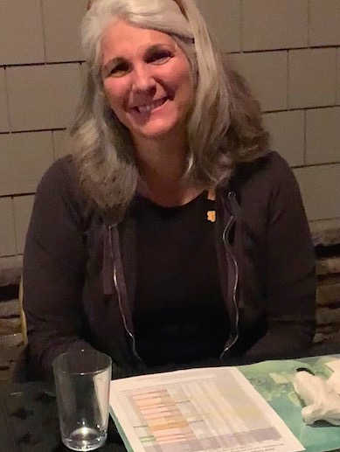

Celeste: told us that Days for Girls now is in 144 nations. Menstrual packages are sewn and packaged totally by volunteers they allow females to go to school or work and not miss a day. When women would miss because they weren’t able to take care of their personal hygiene they were shamed, called unworthy, asked to sit somewhere other then beside another person. Celeste had stories that brought tears to our eyes and disappointment in the world. With the help of people like herself spreading the word regarding this problem women are able to achieve the goal much faster of no woman hiding in shame about something, which is a natural part of being a woman.
She was extremely excited to say that she had just been informed that Cambodia would be including knowledge of the menstrual cycle into their school curriculum.

Celeste doesn’t spend much time at home there is so much travel happening to do with this project. Thankfully she has a very understanding husband who sees the changes she has made and continues to make in the world. He supports her when things aren’t going as well as they should and celebrates her accomplishments.

Celeste told us about a new campaign happening soon called IT STOPS NOW -The Red Line!!

She told us about her desire to have a traveling van – she sees it as being called the Minstra Mobile. This van would allow women of rural villages to sew their own packages. Packages sewn in the very rural areas see the ladies having trouble dealing with the material so it stays off the ground. She envisions the van with a Rotary decal on it!! We see this as an opportunity to help her achieve this goal to do this we would need to raise funds. If any of our members know of a possible fundraising opportunity or would like to take on this project for PNW Passport Rotary Club please advise my self or our President.

Member Sean: told us that the team with the ARES Project will be going again in January 2020.

President Deb: Thanked Celeste for all the work she has done and continues to do for women around the world.

To all members a safe drive home.

Meeting ended: 8:00 pm

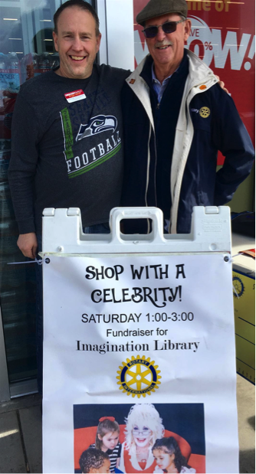
Terry Greer and Shayne Stoddard.
Volunteering to raise money for
Imagination Library.
Next 'Shop w/a Celebrity'
will be on Nov 2nd 1-3pm

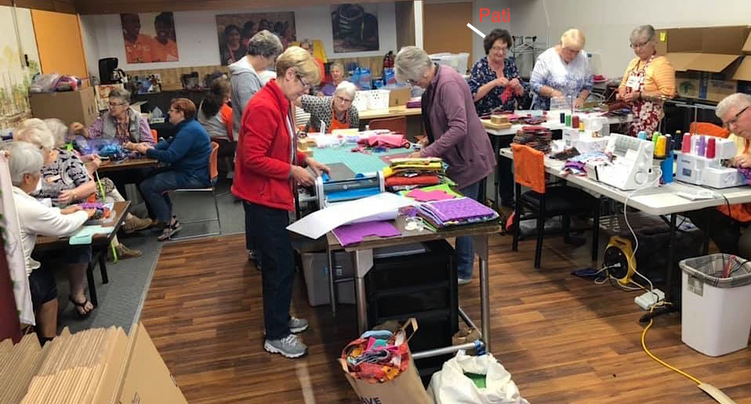
Days for Girls – Stanwood
Pati Villhauer was able to attend

