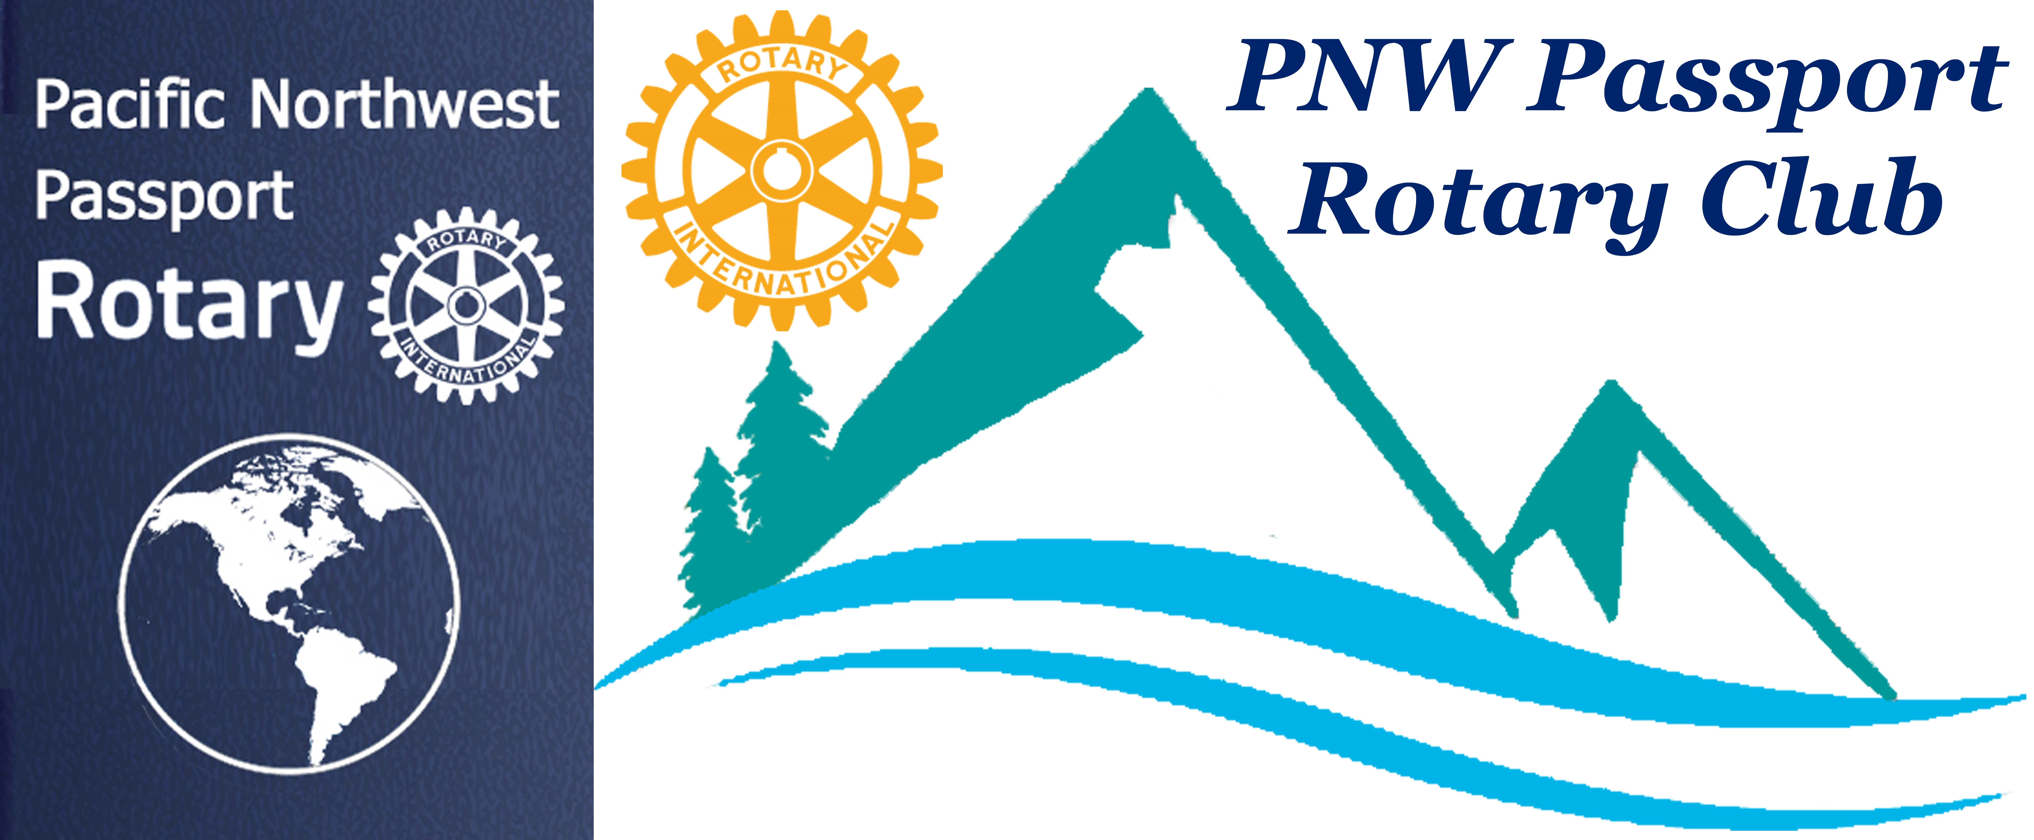

PNW Passport Rotary Club Meeting Notes

Date: September 14, 2019 Social Time: 4:00 pm
Meeting Time: 4:45 pm

Place: Roadhouse Grill, Surrey, BC

Upcoming Dates to mark on your Calendars
October 6th, 2019 – 9:00 am
Rotary Club of White Rock
Great Turkey Run/Walk
For Details & Registration go to -- Whiterockrotary.org

November 2, 2019
Rotary Learning Institute (RLI)
Register NOW for Part 1, Part 2 or Part 3

November 15, 2019
Foundation Dinner
Register on-line
Guest Speaker:
Rotarian Lee Harman, Peking to Paris
The story of how Lee, Bill & Miss Vicky Crossed the Finish Line.

President Deb: Welcomed all those in attendance. She was very happy to see the socializing part of the meeting is working well in helping know fellow members.

Her reflection for this meeting:
“It is easy to sit up and take notice,
What is difficult is getting up and taking action.”
Honore de Balzac

That is what the PNW Rotary Club is going to be doing this year is the difficult part of taking action. We have done some visioning for our future and I President Deb plan on making it doable.

President Deb: noted that there were no guests today other than our Guest Speaker Karen.
President Deb: asked us to recite the Rotary 4-Way Test.
President Deb: #3: Will it build goodwill and better friendships?
Meaning – besides -- friendly, helpful, or cooperative feelings or attitude
It means -- the established reputation of a business regarded as a quantifiable asset, e.g., as represented by the excess of the price paid at a takeover for a company over its fair market value.
President Deb: informed us she would be away for the next two meetings President-Elect Roy will be doing the honours for her.
President Deb: told us on a recent flight she was sitting beside a young businessperson, who was sixth generation to be in the families box company. As they talked she wanted to learn about Rotary. She became very interested in knowing even more. President Deb was able to connect her to a Rotaract who will be inviting her to a meeting from this conversation possibly another future Rotarian.
Secretary Joy: Reminded people of the upcoming District events. It was clarified that we will need to pay our own way to attend RLI. She stated that she has taken Part 1 and 2 they were both beneficial to her knowledge of Rotary and meeting other District Club members. She spoke about an email the Club had received talking about an opportunity to join a Guatemala Literacy Project going to Guatemala in 2020. It will be an added attachment to the minutes.
Foundation Chair Patricia: Informed us about the upcoming District 5050 Foundation Dinner and the opportunity to hear about Lee Harmon’s Peking to Paris adventure.
Patricia dashed out of the meeting because a grandbaby was about to be born!! We later found out that in her excitement Patricia went to the Vancouver General Hospital but should have gone to Langley Hospital --- oh dear
President Deb: passed around the Buck/Loonie basket.
Sean – oops went to Bob’s but realized his mistake in enough time to come to the Roadhouse Grille
Marietta – was going to be attending her aunt’s 100th Birthday. She was a researcher for NASA – she developed the food required for astronauts going into space.
President Deb: said she recently took a friend to Harrison Hot Springs, she found there had been a lot of changes since she last was there. She also informed us September 13th she joined the U.S. medicare system!! She was going to be doing lots of running at Disney in Paris, France attending their Disney Run Weekend September 19-21, lots of stories upon her return.
Member Navjit: told us about two opportunities to help support District 5050 Rotaracts:
- Approximately 10 Rotoracts from District 5050 are looking to be sponsored for the upcoming very important Rotaracts Big West Meeting in Vancouver. Rotaracts from the up and down the West Coast will be attending this meeting. They are having great speakers. We’re all welcome to attend October 25, 26, 27 at SFU Harbour Centre Campus, Vancouver.
- Lindagene motioned: That the PNW Rotary Club sponsor two Rotaracts from Canada but only their conference portion not their accommodations.
- Marietta seconded: PASSED
Our member Dave Bolton is kindly donating separately towards sponsorship of a Rotaract.
- September 26, 5:30 to 6:30 Tree planting at Elgin Park, South Surrey. We’re all welcome to come out to this event.
Vice-Governor Lindagene: Informed the Club we had received two cheques for our help:
- Rotaracts Corn Hut -- Port Moody Ribfest -- $1,960.00
- Langley Ribfest -- $1,027.50
President Deb: Introduced our guest speaker Karen McDiarmid, she is Co-President of the Rotary Club of Vancouver-Yaletown, she was speaking to us about Persons With Disabilities Accessibility (PWD) to Technical Occupations.
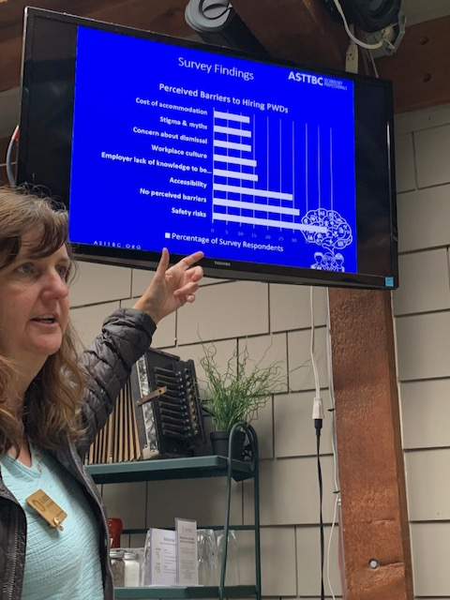
Karen: Thanked the Club for inviting her to speak about this very important subject and project.
The project was designed by the Applied Science Technologists and Technicians of BC (ASTTBC) it is to help support employers in developing diverse and inclusive workplaces. Karen explained engineers design the equipment, trades install the equipment, and technologists keep the equipment up and working.
Some highlights from Karen’s very informative talk on this important subject:
- Purpose: Labour Market Partnership study.
- LMP Findings: 65.6% reported less than 1% of employees were PWD.
- Survey Findings as to why this is: Safety risks, No perceived barriers, Accessibility, Employer lack of knowledge, Concern about dismissal, Stigma & Myths, Cost of accommodations.
- What’s the Next Step? TechAbility Initiative understanding of what’s available to employers.
- TechAbility Success – they are finding certain tech jobs are well suited to PAD ie Fire Protection, Web Development, QA testing, Underground Utility Location, Technical Administrative Support and TIC welding. They are find more and more placements with great success. Each PAD may have particular disabilities but the team is able to have them Job Shadow a person to find out if the particular job works for them.
- TechAbility Partcipants: one class was all students with Autism Spectrum Disorder. Another class had students with physical disabilities.
How can you be of service?
    - Do you know someone who has a disability and might participate in the project?
    - An industry speaker for our training sessions?
    - A company that can provide a volunteer for a week of job shadowing?
To sum it up from a participant with a disability about the programme:
“This wonderful project saved my life, because it was hard to find a project similar to this one, and all staffs I met were very friendly, enthusiastic, patient and responsible like you. Maybe since this was a research project, rather than working like a routine, students and all of you were discovering together and looking for solution together, so that the communication between students and staffs was very important and rewarding. I like this project and I wish that it will have more in future.”
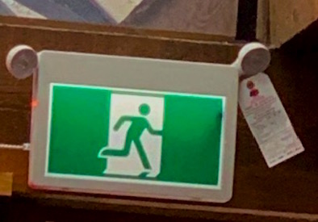
Even this little guy needs to be tested once a year. With guidance a PWD is very capable of doing this.
Our member Marietta gave her company’s information to Karen they might be able to help with job shadowing for a week. Marietta is the owner/operator of an Underground Utility Location company.

President Deb: thanked Karen for coming and speaking to us today. She adjourned the meeting.

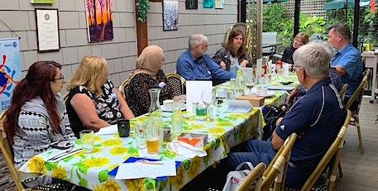

PNW Rotary Club members enjoying fellowship and sharing of their thoughts.

Meeting adjourned at: 6:00 pm Notes taken by: Joy St John

Next Club Meeting: Date: September 26, 2019
Location: Bob’s Burger & Brew, Birch Bay Sq, WA

