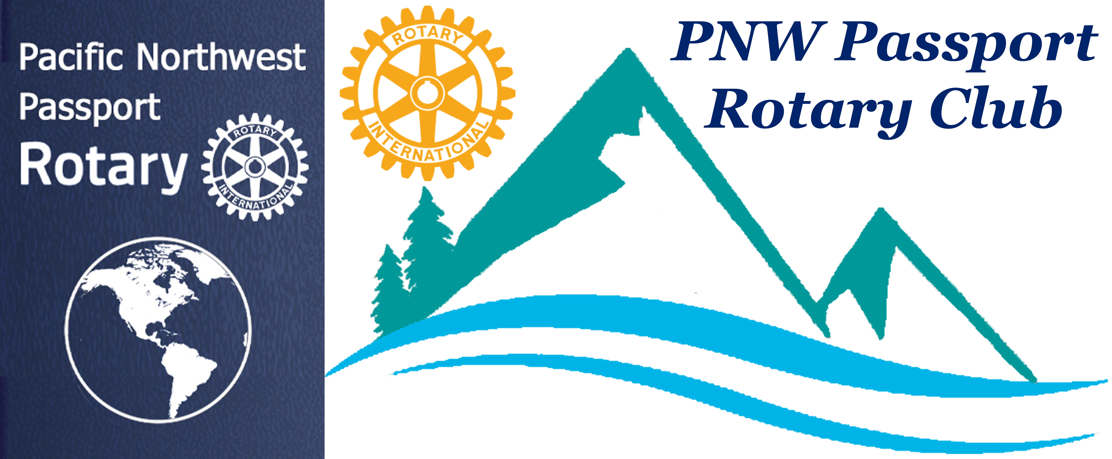

PNW Passport Rotary Club Meeting Notes

Date: September 26, 2019 Social Time: 6:00 pm
Meeting Time: 6:30 pm

Place: Bob’s Burger & Brew, Birch Bay Square, WA

Upcoming Dates to mark on your Calendars

September 30 – October 6, 2019
Rotary Club of Surrey Book Sale
Please sign up to help

October 12, 2019
Next meeting with guest speaker from Mercy Ship
Bob’s Burger & Brew, Birch Bay Square, WA
4:00 pm – 6:00 pm

November 2, 2019
Rotary Learning Institute (RLI)
Register NOW for Part 1, Part 2 or Part 3

November 15, 2019
Foundation Dinner
Register on-line
Guest Speaker:
Rotarian Lee Harman, Peking to Paris
The story of how Lee, Bill & Miss Vicky Crossed the Finish Line.

November 21, 2019 meeting – 6:00 pm
DG Brad Whittaker will be attending this meeting
Mt Vernon, WA

President-Elect Roy: Welcomed all those in attendance. He said it was always hard to break up the social time of the Club members. He mentioned that Rhian is soon to be a new member in the NWP Rotary Club. Rhian will be meeting with executive members at our October 12th meeting.
P-E asked Sec Joy: to introduce our guests:
Our guests tonight were our speaker Mark Peterson, Sustainable Business Manager and Brandi Hutton, Sustainable Business Development Program Assistant
Joy also said a warm hello to Jill & Terry who have been traveling as well as entertaining many guests to their home over the summer months. Their sunny smiles are always welcomed at our meetings.
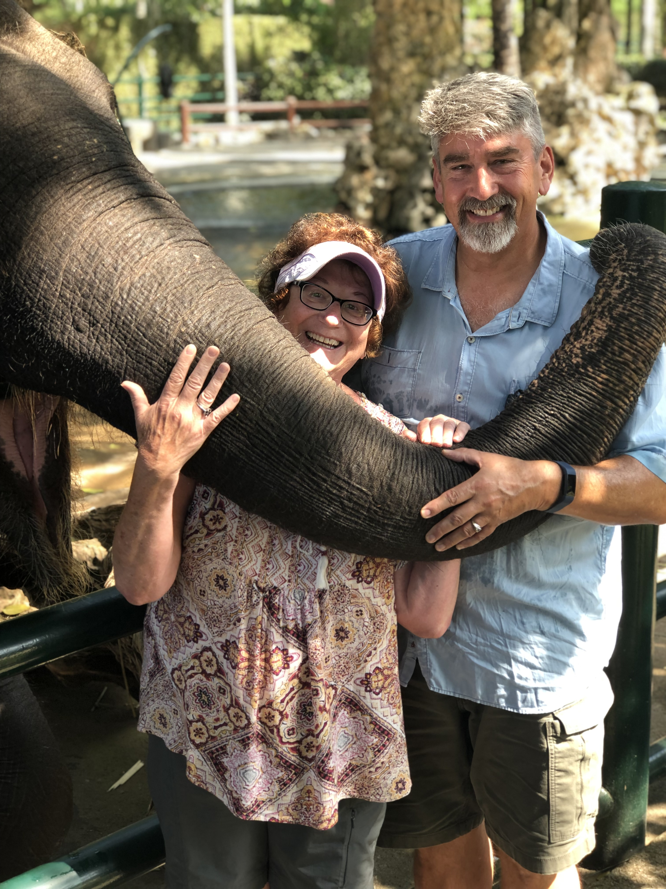
Our members Pati & Tim joined us still suffering from jet lag having enjoyed a wonderful trip to Bali, Indonesia.
P-E Roy: Reminded us November 21st meeting DG Brad’s would be joining our Club at Mt Vernon
Patricia Sibley, told us that September 28 there was going to be a container loading for Rotary World Help at Riverview, Coquitlam, BC.
Julie Johansen, reminded us to sign up for the Rotary Club of Surrey’s Book Sale.
October 12th meeting we will have a very interesting speaker from the Mercy Ships. It would be great to have a good club turn out.
P-E Roy: Introduced our guest speaker Mark Petersen, he is their Business Manager at Sustainable Connections.

Mark Petersen: Sustainable Connections

Sustainable Connections:

Mission: We create thriving communities through innovative ideas, collaboration, and action.

VISION: A world of thriving communities.

Sustainable Connections are working towards zero waste!!

With INNOVATIVE IDEAS:
The best ideas are often generated from within the communities where we work. We take stock of community needs and opportunities in the Pacific Northwest, create leading edge strategies, and build impactful plans with our partners that can be replicated in other regions.

Through cOLLABORATION:
Lasting results are achieved by working with a variety of partners who share our vision of thriving communities. We maximize our impact by working with:
• Local businesses
• Government agencies
• Non-profits
• Community members
• Civic leaders

Through Action: Innovative ideas are meant to be implemented, these ideas, plans, and partners come together to produce lasting results for happier, healthier people. More quality jobs, growing businesses, clean environments, and reduced pollution provide communities the opportunity to thrive.

Mark informed us that one (1) apple takes 40 gal of water on an average to produce!!
He suggested that we look at a video call Life & Times Of A Strawberry.
Mark said that one of Sustainable Connections missions is to go to local restaurants to observe their daily table waste. After determining a restaurants waste they make suggestions for improvement. Sometimes it is as simple as serving smaller portions or having a smaller menu or staff knowing which bin each waste product belongs. This is very important as the wrong waste in the wrong bin could make that bin have to go to garbage!!
Things we can do:
      - Shop wisely
      - Buy Funny-looking fruit
      - Learn when food goes bad – by law baby food is the only one that needs a Best Before date
      - Use our freezers
- Request smaller portions at restaurants
- Eat leftovers - whether they be from home cooked meals or restaurants.
- Compost food scraps
- Donate food – if you find you’re not eating a particular can of food you brought home or you bought too much donate it
IMPORTANT: Mark said – when you are looking at the different bins in a mall or wherever if you can’t decide then its garbage!!!
How can we help: Volunteer with their programs, donate funds in particular to their driver fund. Drivers pick up food, deliver food and very rarely receive funds for gas for this worthwhile project.
Mark’s talk was full of passion for what he & his company are doing for the well being of the community, state and beyond. This type of innovative thinking is extremely important today with climate change.
P-E Roy: Thanked our guest speaker for his very informative information.
P-E Roy: Passed around the Happy Buck/Loonie Basket:
Member Terry: Motioned that $250. US should be donated toward the Sustainable Connections driver program.
Pati, Engagement Chair: seconded Passed
It will now go before the Executive Board for final approval.

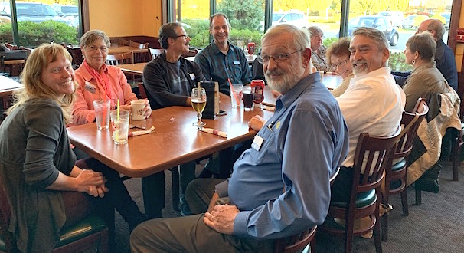Guest speaker
Assistant

Meeting adjourned at: 7:30pm Notes taken by: Joy St John

Next Club Meeting: Date: October 12, 2019
Location: Bob’s Burger & Brew, Birch Bay Sq, WA

