

***Wine Fundraiser!***



*North Balwyn Rotary Club is part of a 1.2 million strong global organisation that gives service throughout local, national and international communities. The Club was chartered on 8 May 1980 and since that date has become one of the most vibrant and active Clubs within the District.*

*The coronavirus pandemic has put on hold on much of our fundraising activities for the year, so this wine fundraiser is a good opportunity to raise some funds and continue to support our many and varied projects. And we even get to taste the fruits of our efforts!*

*Most people we know enjoy a nice glass of wine! Ask your family and friends if they would like to buy some quality wine and help raise monies for our wonderful club. Wine also makes an excellent gift for birthdays and other special occasions, and Christmas is just around the corner. All bottles have a specially designed label with tasting notes, just like the one below.*

*The minimum order is 6 bottles and can be a mix n' match selection of the different styles if so desired. For orders of 12 or more bottles a further 10% discount will apply (use promo code ‘ROTARY12’ in the online cart just before you checkout or the second column on the paper based order form).*

*Orders can be placed directly online at the below link*

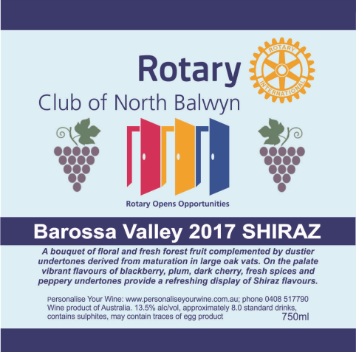

[North Balwyn Rotary Club Wine Fundraiser](tba)

*Alternatively complete the order form below and email to: Darren O’Hara at* [*darren@personaliseyourwine.com.au*](mailto:darren@personaliseyourwine.com.au)

*All Melbourne metro orders will be dispatched within 5-10 working days of receipt. Delivery is free.*

*For all regional Victoria and interstate orders please email or call for a quote on freight before placing your order.*

*For any enquiries please contact Nino Sofra (Rotary Club of North Balwyn)*

*mobile: 0409 506226 or email:* [*nsofra@bigpond.net.au*](mailto:nsofra@bigpond.net.au)

*The* ***Rotary Club of North Balwyn*** *thank you for your support of this wine fundraising drive!*

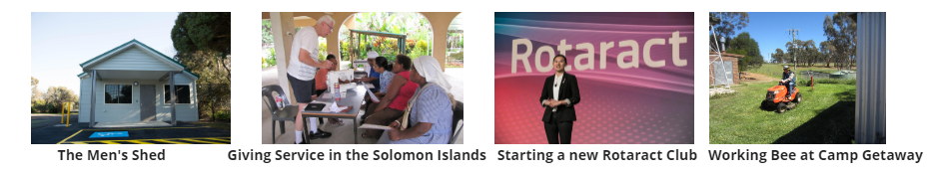

**Rotary Club of North Balwyn – Wine Order Form**

To assist in packing and distribution please ensure that your order form is completed in full and clearly legible

|  |  |  |  |  |  |  |
| --- | --- | --- | --- | --- | --- | --- |
| * **The minimum order is 6 bottles in total and can be a mixed selection** * **Free Melbourne metro delivery otherwise call or email for a quote on freight** * **If ordering 12 or more bottles use the pricing the second column which is inclusive of the 10% discount, otherwise use pricing in the first column** | | | **Bottle Price** | **Price in a mixed 12 bottle buy** | **No. of**  **Bottles** | **Total $** |
| **S113 King Valley PROSECCO**  Vibrant aromas of citrus, apple and pear lead to a fresh, crisp palate with clean delicate bubbles. Finishes off both light and refreshing, leaving you wanting more. A fine example of Prosecco and true to its ancestral style in northern Italy. | | | $18.00 | $16.20 |  | $ |
| **W108 Adelaide Hills SAUVIGNON BLANC 2019**  The cool climate of the Adelaide Hills is perfect for ripening Sauvignon Blanc. This wine shows excellent varietal definition with soft tropical fruit aromas and a palate of ripe fruit with subtle grassy notes. A delightful lively and flavoursome Savvy that is sure to please. | | | $16.00 | $14.40 |  | **$** |
| **W117 Clare Valley RIESLING 2018**  A dry style of Riesling from the renowned Clare Valley in South Australia. It opens with fresh zingy lime and floral aromas. The palate has some flinty tones, blending beautifully with intense lemon and citrus flavours. The dry lingering finish has refreshing crisp acidity. | | | $17.00 | $15.30 |  | **$** |
| **W147**  **King Valley PINOT GRIGIO 2019**  Aromas of nectarine, pear and green apple fruit with a floral lift. Stone fruit and pear flavours with some citrus amongst bright crisp acidity driving good length and flavour persistence. This wine makes a delightful aperitif or the perfect match to prawn and scallop risotto. | | | $16.00 | $14.40 |  | **$** |
| **R178 Sunraysia SHIRAZ SANGIOVESE ROSE 2019**  Made from a luscious blend of Shiraz and Sangiovese grapes, this rosé has the best of both worlds and isn’t afraid to show it. Delicious flavours of strawberries and cream, balanced by a zesty acidity and gorgeous length make this wine blossom before you! | | | $15.00 | $13.50 |  | **$** |
| **R181 Barossa Valley SHIRAZ 2017**  A bouquet of floral and fresh forest fruit complemented by dustier undertones derived from maturation in large oak vats. On the palate vibrant flavours of blackberry, plum, dark cherry, fresh spices and peppery undertones provide a refreshing display of Shiraz flavours. | | | $16.00 | $14.40 |  | **$** |
| **R107 Coonawarra CABERNET SAUVIGNON 2018**  Classic varietal Cabernet characteristics of cassis, mint and blackcurrant on the nose. The palate is rich and full bodied with sweet berry/plum flavours, mild oak and grape tannins. It will develop well with bottle age and soften, giving the wine a silky smoother texture. | | | $19.00 | $17.10 |  |  |
| **F101 South Australia 5 YEAR OLD TAWNY (PORT)**  Produced from a blend of premium grapes grown around Reynella in SA. Aromas of caramel and rancio, dried fruits and nut. Luscious with generous caramel, chocolate and raisin flavours; developed characters from the time spent maturing contribute complexity and depth. | | | $16.00 | $14.40 |  | **$** |
| **DELIVERY FEE (if applicable)**  The minimum order for delivery is 6 x bottles of wine. Free Melbourne metro delivery.  For all regional Victoria and interstate orders please email or call for a quote on freight before placing your order. | | |  |  |  | **$** |
| Payment details:  🞏 Credit Card  🞏 Cheque (must be payable to Personalise Your Wine)  🞏 EFT (payment to Personalise Your Wine, BSB 063-155 Acct no 1029 4439) | | | **TOTAL** |  |  | **$** |
|  |  | 🞏 **YES**, I would like to be included on your mailing list | | | | |

**Credit card details for Rotary Club of North Balwyn Wine Fundraiser:**

Name on card: _______________________________________________ Card type: Visa / MasterCard

Card no.: _______________________________________________________________ Expiry date: _____/_____ Total amount: $ ________________

I authorize Personalise Your Wine to charge the above amount to my credit card. Signed: ______________________________ Date: ___ /___ /___

**Delivery order form to Personalise Your Wine**

Please accept my order for the following Rotary Club of North Balwyn wines.

I declare that I am over 18 years of age and agree with the following conditions:

1. That I am placing an order on Personalise Your Wine, holder of Victorian Packaged Liquor Licence No 36128911.

2. No obligation to sell or supply the goods will arise until the order is received and accepted at the licensed premises.

3. The applicable law for transactions for the purchase of wine from Personalise Your Wine is the law of the State of Victoria.

4. By placing an order with Personalise Your Wine I accept that the ownership of and risk to the goods passes to the customer upon payment for the goods and when the goods have been picked up by the customer from Personalise Your Wine, or delivered to the nominated address.

5. If a wine/s is not available, we reserve the right to make a substitution of another wine of equal or greater quality and price.

Name: ___________________________________________ Telephone: _____________________ Email: ______________________________

Address: _________________________________________________________________________________________________________________

Delivery instructions: _________________________________________________________________________________ Postcode: __________

Signed: ________________________