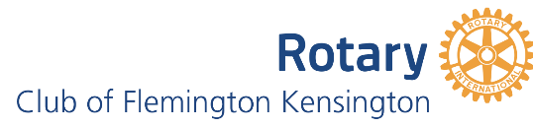
Let's Talk About Mental Health

- Lifeline: 13 11 14 or lifeline.org.au
- Kids Helpline 1800 55 1800
- SANE Australia Helpline: 1800 18 SANE (7236) or sane.org
- Beyond Blue: 1300 22 46 36 or https://www.beyondblue.org.au/
- Black Dog Institute: blackdoginstitute.com.au
- Headspace: 1800 650 850 or headspace.org.au Headspace is the National Youth Mental Health Foundation
- Head to Health https://www.headtohealth.gov.au/crisis-links

‍Embrace Multicultural Mental Health
provides a national focus on mental health and suicide prevention for people from culturally and linguistically diverse (CALD) backgrounds.
Choose your language https://embracementalhealth.org.au/

13YARN
13YARN is an Aboriginal & Torres Strait Islander crisis support line funded by the Australian Government with the support of Lifeline and developed in collaboration with Gayaa Dhuwi (Proud Spirit) Australia. It is run by Aboriginal and Torres Strait Islander people.
13yarn.org.au
Butterfly Foundation
Butterfly provides support for Australians who suffer from eating disorders and negative body image issues and their carers. Phone: 1800 33 4673 thebutterflyfoundation.org.au/
ReachOut.com
ReachOut.com is Australia’s leading online youth mental health service. ReachOut.com is an initiative of the Inspire Foundation, an Australian non-profit with a mission to help young people lead happier lives. au.reachout.com
Mental Health First Aid
Provides high quality, evidence-based mental health first aid education to everyone – courses run face-to-face and online and teach mental health literacy. https://mhfa.com.au

Raising Children's Network – resources for parents
https://raisingchildren.net.au/pre-teens/mental-health-physical-health/pre-teens-practical-mental-health-wellbeing-strategies/positive-thinking
Emerging Minds – advancing infant, child and adolescent mental health
Supporting parents of pre-teen children with mild-moderate anxiety (emergingminds.com.au)
Smiling Minds Meditation APP and Feeling It!
https://www.smilingmind.com.au/smiling-mind-app

Centre for Multicultural Youth:
https://www.cmy.net.au/organisations-businesses/policy-research/
Child mental health in CALD communities – Australian Institute of Family Studies
Approaches to support child mental health in culturally and linguistically diverse communities | Child Family Community Australia (aifs.gov.au)
Thank you for attending the Let's Talk About Mental Health forum.
Having a strong social network with activity and exercise are protective factors.
Rotary provides such a network for many people in our community: through regular events and activities, volunteering in the Op Shop and getting together socially each month.
Our goals are to work together to help make communities stronger through supporting families, children and organisations.
Our focus areas are education, health, the environment, stronger economies, water and sanitation and peace and conflict resolution.
In recent years our members have:
- supported over 20 students with scholarships and education programs,
- provided picture story books for children through the Maternal & Child Health nurses,
- Sponsored a PhD scholar to research mental health in teenagers,
- funded the shipment of containers of hospital beds to Sri Lanka and playground equipment to Nepal,
Sri Lanka and Timor Leste,
- planted over 500 trees to develop a wildlife habitat along the Maribyrnong River
- sponsored the Kensington Women's Soccer Club
- funded a homework program at Farnham Street Neighbourhood Learning Centre
- funded playground equipment at The Venny
And so much more . . . .
If you would like to be part of this amazing group of ordinary people, contact Lesley on 0417 532 259
or join us for breakfast at Mama Bear Café, Wednesday 1 June, 7.45am.
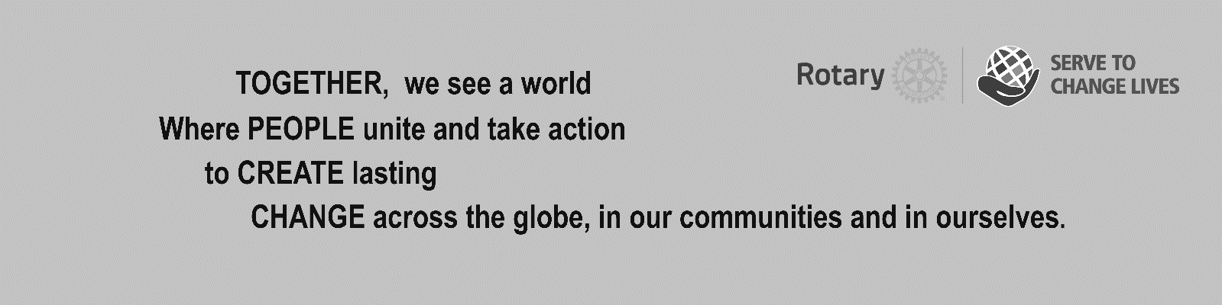

Bring this voucher to the Op Shop at 444 Racecourse Road {next to the GoodStart Early Learning Centre} for 20% discount off the purchase of purchases over $25. Tuesday 11-4, Saturday 10-2
We always need volunteers to work in the shop. If you are interested chat with Mel, the Manager!

