

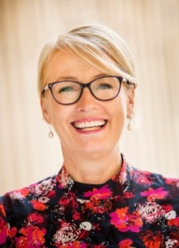

**MESSAGE FROM THE LORD MAYOR OF MELBOURNE**

The City of Melbourne is proud to support the 2019 Rotary Club of Flemington Kensington Art Show.

The Kensington Town Hall will showcase talented artists displaying over 400 amazing items of specialised art work; from paintings to garden art, there’s something for everyone.

Bring the family and enjoy the Krafty Kids program which is packed with all kinds of hands-on arts and craft activities, there’s the adult “come and try craft session” and learn about how to create your own masterpiece.

I invite you to come and meet the artists and find that special piece to take home.

Congratulations to the organisers – well done.

