**MAC Student selected for prestigious National Youth Science Forum**

Aziza Sawiz, a year 12 student and former Afghani refugee, at Mount Alexander College in Flemington has returned from attending the prestigious National Youth Science Forum in Brisbane full of ideas and possibilities for a future in science.

She was the first student from MAC to be accepted into this 2 week long residential science and leadership program which is held during January each year at universities in Canberra, Brisbane and Perth. The program is sponsored by Rotary and in Aziza’s case, fully funded by the Flemington Kensington Rotary Club.

Aziza was nominated by Science Coordinator Nicole Dobson who praised Aziza’s work ethic, leadership skills and love for science. She submitted an application and attended an interview in August last year. The interview panel of experience Rotarians and educators were impressed with her attitude, experience and ability to speak about science and the opportunities for helping others.

Aziza is the only female student in the Physics class at MAC although the Chemistry class is closer to even. She was unsure of what her future in science might be, possibly medicine, but after attending NYSF is aiming for Neuropsychology.

During the 2-week program held at the University of Queensland, Aziza experienced Laboratory and site visits to Cochlear and Lockheed Martin, Keynote addresses and lectures, workshops, a Science Dinner and lots of networking. She has met people and made friends from all states.

The program has opened her eyes to opportunities in STEM which are traditionally thought of but which could be the future for students today.

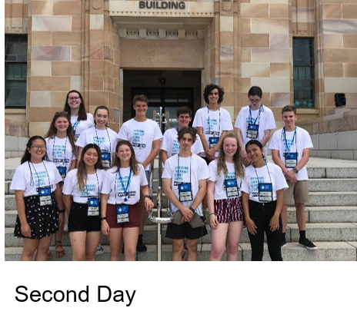She was very appreciative of the sponsorship from Flemington Kensington Rotary Club and her school and has been promoting the program to her fellow students, encouraging them to take the opportunity and apply.