Gabriella Griffiths
I am incredibly thankful to Rotary for providing me and other students with the opportunity to attend the National Youth Science Forum. The experience has fundamentally changed how I approach life and science, for the better.

It is incredibly important in science to have a variety of viewpoints. Science in essence is the pursuit of knowledge for the benefit and improvement of all humanity. To be able to understand how we can apply
science best to help the world we need real people and their ideas – a wide range of people from all walks of life who can shed light on the real problems facing our race. Toyota’s initiative to fund students in places and circumstances where science may be more inaccessible is a step to ensuring science continues to serve humanity well.

Personally, the NYSF has had a major impact on my life. I found that the atmosphere of the Forum has made me a more positive and happier person, with an excitement for life and the opportunities available to me. I formed lifelong friendships with other students from across Australia, creating a network of people I can call on throughout my Year 12 and university studies, and into the rest of my career. Not only that, their lives, experiences and personalities have shaped me in ways that words cannot describe and I will forever be thankful for.

Science-wise, my eyes have been opened to a whole new world. There were sciences and disciplines that I did not know even existed before I went on the NYSF. I now have an appreciation for optical engineering (and the background sciences that enable it), environmental robotics, hypersonics and urban planning. Before I went I thought I knew what I wanted to do and I was really unsure of the opportunities in engineering. I have now rethought everything I want to do, and know that I love both engineering and science; however I do not truly know what I want to do. But the NYSF has helped me realise that that’s alright too.

The opportunity to go to a university outside of my home state has also helped me realise that there are good universities and options outside of Victoria. Whilst I may not know what I want to do, I know that whatever it is I want to do it at the University of Queensland after discovering its amazing facilities and cheery atmosphere.

Overall, the NYSF has shaped me into an entirely new person, that I am truly happy to be. It could not have happened without the aid of Rotary and the Toyota Community Trust and I will forever be thankful for their belief in me and their contribution to the scientific community.

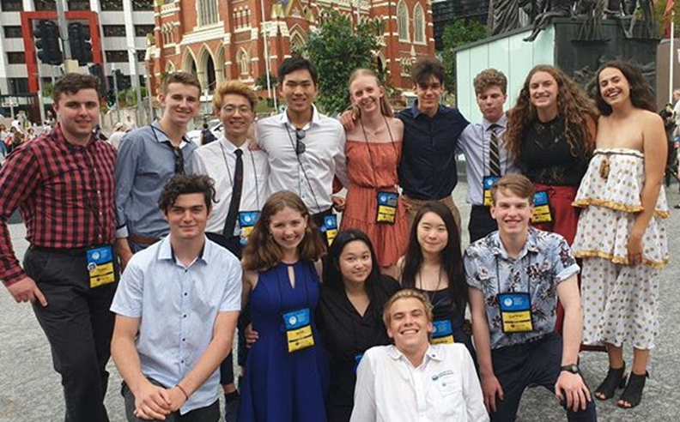

Emma Merritt
NYSF was an experience that I will never forget, and will never take for granted. I could never have anticipated the things I saw and the friends I made, which will remain life long memories. The absolute passion and enthusiasm among the group of students, staff and NYSF partners has not only encouraged me to pursue STEM further, but has given me a sense of hope for the future and what we will do to change it.
The core purpose of NYSF was to show us the world of STEM, and they went above and beyond. As part of the Mirzakhani engineering and manufacturing group I gained an insight into careers at places such as the Boeing Test Centre, QUT Centre for Hypersonics, the AUS Antarctic Division and QUT Research and Engineering
acilities in specific STEM visits. Being given the opportunity to see facilities and machinery while observing and talking to scientists and engineers who researched and created these things was eye opening and inspiring. We got to use flight simulators, see biofuels and batteries being made, watch as the tensile strength of specific materials were tested and observe the effects of a magnetic field to name a few. These experiences left me in awe of people working in STEM, and has made me excited for what the future may hold.
Additionally, we participated in workshops and discussions in critical thinking, robotics, drones, engineers without borders and much more. These hands on experiences made STEM feel so much more tangible, and made me realise how much we will be able to achieve in future to make the world a better place.
The thing I found most surprising about NYSF was the support from the staff and students around me. The environment was always comfortable and relaxed, and I felt I had friends everywhere. The staff members looked after us, embarrassed themselves constantly to entertain us, and cheered us up and motivated us when we were tired. We all felt like family after NYSF, events like the Disco, Swing Dancing, the NYSF Olympics and passion pitches ensured this. Despite not being STEM related, these activities are what made sure I got the most out of NYSF, as I felt like part of a community and was always beyond enthused to be there.
After a hectic week, the program closed by making sure we felt prepared to go into our futures. With workshops like Beyond Year 12, and StemPowerment I can only say I feel an immense sense of hope for our futures. NYSF helped us make connections with STEM companies and people working in the field through Speed Date a Scientist, Partners Day, and the Science Dinner so we will never feel like we have to go out on a limb. NYSF opened up a plethora of opportunities for everyone who attended, it is only up to us to use them.
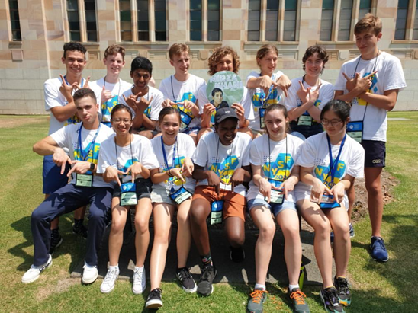
I mentioned before I was in the interest group named after Miriam Mirzakhani. Miriam was an Iranian mathematician who died at the age of 40. She is applauded for her work on many theories, and as a professor at Stanford. Mirzakhani is someone I didn’t know existed before NYSF, and is now a significant role model for me. I think this sums up NYSF perfectly, it has opened my eyes to a whole new world.
And I am very excited for its future.
I cannot thank the Rotary Club of Flemington Kensington, the Toyota Foundation and the Federal Government enough for the financial support and encouragement which has allowed me to attend NYSF.

Alex Langley Brisbane 8th to 18th January Brisbane.
On the 8th of January 2020, myself and around 200 other lucky year 12s arrived at the University of
Queensland in Brisbane for session B of the National Youth Science Forum. I was extremely excited for the event, but I had no idea just how much my time there would change my life.
At the NYSF, I had the privilege to go on four ‘STEM Visits’, which were half-day long tours and interactive activities at various research labs, institutes and companies across the Brisbane area.
The most notable was a trip to Boeing’s training facility, where myself and others were able to use one of their multi-million dollar, fully fledged flight simulators they routinely use to train new pilots. I was also given the privilege to attend a ‘Specialist Lecture’ of my choosing, so I attended one on Biomedical Engineering, a career path I have a unique interest in. Being able to hear first hand from an expert in the field about the qualifications needed, challenges and employment opportunities was an invaluable experience.
On session 3, I got to meet the thirteen other people in my ‘Interest Group’, along with a multitude of other people, including many of the amazing ‘staffies’. The friendships I formed and the connections I made will last with me for years into the future and are ones I will forever cherish.
Staying in dormitories at Emmanuel College with my peers and spending the majority of my time on campus gave me a unique insight into the university lifestyle, which is priceless knowledge heading into starting a course in 2021.
The 10 days I spent on the NSYF was, without a doubt, the most eye opening and simultaneously enjoyable experience of my life. The person who left Brisbane is more confident, passionate and educated than the one who arrived, by far.I can’t say thank you enough to Rotary and Toyota for sponsoring me and giving me the privilege to
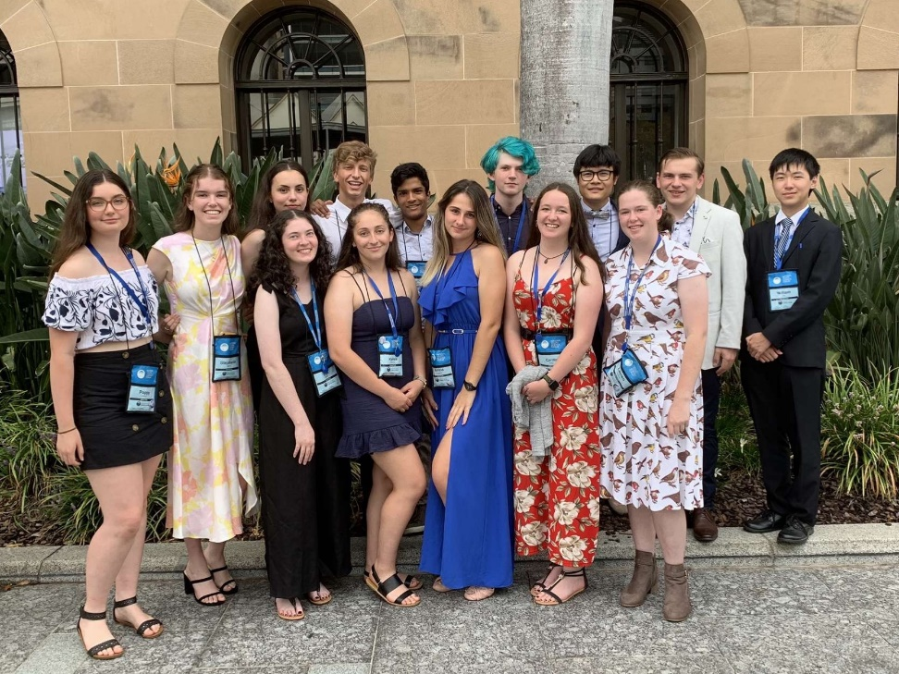
experience such an incredible and invaluable experience. Your support of the National Youth Science Forum demonstrates a commitment to helping support the upcoming scientists of my generation and future ones to come. I greatly appreciate such efforts and I feel comforted knowing myself and others my age have the
support provided.
Thank you so much.

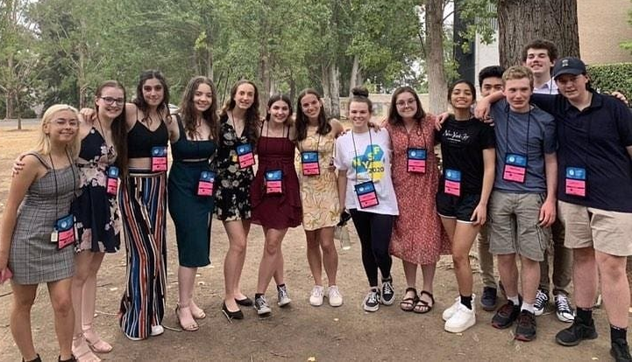
Ella Klassen, Canberra, January 1st to 6th
On January 1st 2020,
I was lucky enough to
have the privilege to go
to Canberra for the
National Youth Science
Forum session A at the
Australian National
University.
The NYSF program was
originally supposed to last
for eleven days but
unfortunately, our trip
had to be cut short due to
the heavy smoke and low
air quality due to the bushfires.
Despite the fact that I didn’t get to spend the full time at the NYSF, I still had an amazing experience that has changed my life. Unfortunately, many of the STEM visits that I was looking forward to ended up being cancelled due to the smoke but I still went to Questacon, which is a science museum in Canberra that ended up being one of my favourite experiences. In addition to this, I also got to attend heaps of lectures and talks from scientists around Australia and around the world which included a video conference with someone who visits Antarctica regularly for microbe research and a talk from the CEO on critical thinking.
One of my favourite lectures was one that was done by a scientist who was doing research on bushfires across the world but mainly focused on Australia. I think research like that is extremely important, especially now due to the fact the fire season has lasted much longer than usual this year and last year and the fact that climate change is still a massive issue that we as a society need to do more about.
As well as learning heaps about careers in science, the NYSF also gave an insight on what it's like to be a university student. At the session, past students acted as staffies (the people who looked after us and took us around Canberra) which gave me a great insight into what options I have for after school. As well as this, we stayed in the dormitories at Burgmann college which was a look into what it would be like to live in a dorm full time (I have decided that I do not want to live in a dorm).
Meeting scientists, going to STEM visits and attending lectures were all amazing opportunities but my favourite thing about the entire National Youth Science Forum experience was the people that I met there. The entire time I was in Canberra I was surrounded by 200 other like-minded year 12s that all were all as interested in science and the future as I was. At the NYSF, everyone was split into groups of around fourteen people that were called interest groups based on our choice science. I was in the chemistry group called Cornforth, named after John Cornforth, an Australian scientist who focused on organic chemistry. Everyday our interest groups would meet and do activities together and by the end we were all super close and we’re already planning to meet up sometime during this year.
NYSF is something I don’t know if I would have had the opportunity to go to if I wasn’t supported financially. Thank you so much for this amazing opportunity to learn more about and pursue something that I love. It's so important for young people, particularly young women to be supported in pursuing a career in science especially due to the issues currently in the world today that can only be helped or stopped by science, like bushfires, global warming and the prevention of various diseases. Experiencing the National Youth Science Forum has totally changed the trajectory of my life and I will never forget the experiences I had, the people I met and the generosity of Rotary, Toyota. and the Australian Government. Thank you so much!

