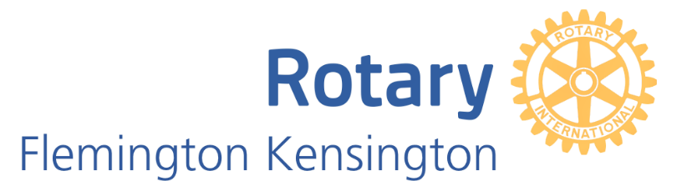

The Flemington-Kensington Rotary Art Show 2020
Gold Sponsorship package - $2,500

I invite you to consider sponsorship of this 3rd Flemington-Kensington Rotary Art Show. The last 2 years have seen an amazing connection within the community and a celebration of the creativity amongst our residents.
Past sponsors have seen their organisation logos and name publicised widely in printed and digital formats within the club, across the Rotary District and on the Gallery247 website for artists and art lovers.
Specific benefits include

- Naming rights for one of the art prize categories: Oil – Watercolour – Photography or Other Medium.
- Your Company name and logo on all print and online promotional material – Posters, Advertising Boards, Catalogue, Website and social media. Company highlighted as sponsor of a category award and Art Show.
- A Company representative to present award to the winning artist of their selected category at the Gala Opening – promotional photographs to appear on web site/ news and social media posts and promotion.
- The Company logo and message to appear on banner and selected participating artists pages of Gallery 247 website, reaching over 10,000 subscribers – artists, art lovers and patrons.
- Acknowledged as “Gold Sponsor” in promotional in lead up to and during Art Show, on all social media channels and opportunity to link Company’s website and social media platforms Facebook and Instagram.
- Company banners prominently displayed at Arts Hub - Kensington Town Hall for duration of the Art Show.
- Two complementary tickets to Gala Opening on Thursday 24th September.
- Listed as a permanent sponsor on the club website.
- The opportunity to include a Company Show Bag for Art Show audience over the weekend.
- Other promotional opportunities as negotiated.

For further information please contact:
Lesley McCarthy
E: Lillico2009@gmail.com
Mob: 0417 532 259

