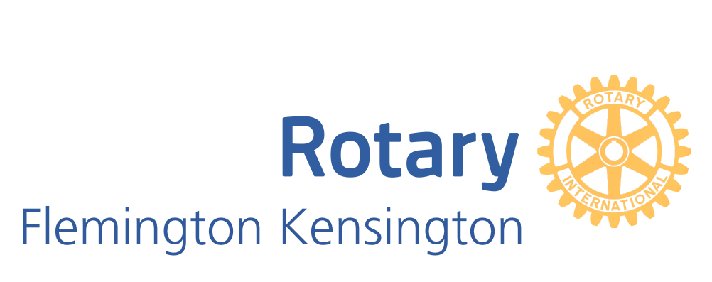

The Flemington-Kensington Rotary Art Show 2020
Naming Rights Sponsorship Package - $5000

2020 sees the third running of the Rotary Arts Show by the Flemington Kensington Rotary at Kensington Town Hall. As was the case in 2018, this year we are providing not just an Art Show, but a combined Arts Festival incorporating music, dance and literary events and craft opportunities for participants. We will also be utilising 18 Anthony street and the Crown Street Stables for activities.

As the Naming Rights Sponsor, your business will be promoted as the major sponsor and have naming rights to the major painting award.

- Your Company representative to present the Award to the winning artist of First Prize (your choice of oil, watercolour or other media) at the Gala Opening with promotional photographs to appear on the Art Show and Club web sites

- Company name and logo displayed throughout Kensington Town Hall and on the Rotary marquee during the Gala and all Art Show weekend events.

- Company banners displayed at Kensington Town Hall and 18 Anthony Street Kensington during the event.

- Company name and logo displayed on catalogues, posters and all promotional material, social media posts, and the opportunity to link to the company’s website, Facebook and Instagram pages during and leading up to the Art Show via Gallery 247 website.
https://www.rotaryflemington.org.au/sitepage/2019-art-show/welcome
- Company name and logo included in our club's advertising in Flem-Ken News, in the What's On Sections of the Moonee Valley Leader, What's On in Melbourne and the Rotary District Monthly Magazine.

- Company logo and message to appear on the website banner as Major Sponsor and on over 50% of participating artists display pages, reaching over 10,000 subscribers – artists, art lovers and patrons.

- Four tickets to Gala Opening on Thursday 24th September 2020.
- Our gratitude and continued support of your organisation in any way we can assist you
For further information please contact:
Lesley McCarthy
Lillico2009@gmail.com
Mob: 0417 532 259

