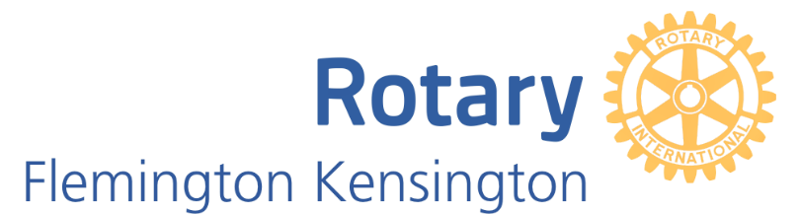

The Flemington-Kensington Rotary Art Show 2020
Silver Sponsorship package - $1,500

I invite you to consider sponsorship of this 3rd Flemington-Kensington Rotary Art Show.
The last 2 years have seen an amazing connection within the community and a celebration of the creativity amongst our residents.
Past sponsors have seen their organisation logos and name publicised widely in printed and digital formats within the club, across the Rotary District and on the Gallery247 website for artists and art lovers.

Specific sponsorship benefits include:

- Naming rights for one of the art prize categories: Oil – Watercolour – Photography or Other Medium.
- Company name and logo on all print and online promotional material – Posters, Advertising Boards, Catalogue, Website and social media. Company highlighted as Silver Sponsor of chosen category award and Art Show.
- Your Company representative to present the prize to the winning artist of the selected category at the Gala Opening – promotional photographs to appear on web site/ news and social media posts and promotion.
- Company logo and message selected participating artists pages of Gallery 247 website, reaching over 10,000 subscribers – artists, art lovers and patrons.
- Acknowledged as “Silver Sponsor” in promotional in lead up to and during Art Show, on all social media channels and opportunity to link Company’s website and social media platforms Facebook and Instagram.
- Company banners prominently displayed at Kensington Town Hall for the duration of
the Art Show.
- Two complementary tickets to Gala Opening on Thursday 24th September.

For further information please contact:
Lesley McCarthy
E: Lillico2009@gmail.com
Mob: 0417 532 259

