Many local people and heroes go unnoticed. Here’s your chance to do something nice. Summit the name of a person who you feel should be recognized for his or her outstanding contributions to the community with their “Giving Spirit”.
Nominate that person for the “Giving Spirits Award” by filling out the form and returning it to club President Kathy Collingsworth at Kathy@joshthteotter.org or mail to 8445 Executive Woods Drive Lincoln NE 68512
Our committee will select the winner from the submissions forms received. The winner will be announced and awarded at the Lincoln Giving Spirits Evening Club bi-weekly meeting.
Thanks for helping us recognize outstanding citizens in our community, with someone that inspires, connects and makes a difference, with SERVICE ABOVE SELF.

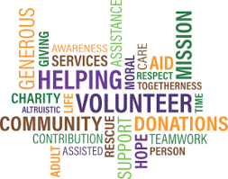

“Giving Spirits Award”
Nomination Form:
Nominees
Name______________________________________________________
Business___________________________________________________
Address____________________________________________________
Phone_______________________________
E-Mail_______________________________
Nominator’s Name____________________________________________
Address____________________________________________________
City__________________State_______Zip________________________
Phone___________________________________________________
E-Mail___________________________________________________

In 4-5 sentences, please give a brief description with specific examples of how the nominee has positively contributed to community:

