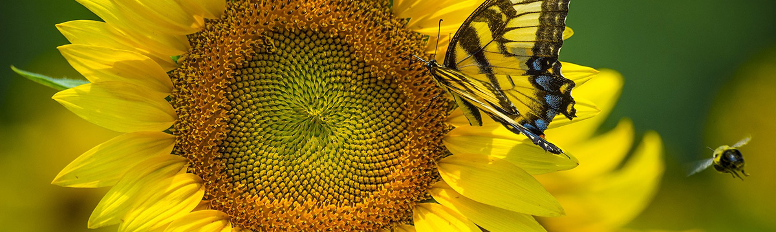

POLLINATOR
PLEDGE

Rotary Club: ___________________________________________

Main Contact Name: _____________________________________

Street Address: __________________________________________

City: ________________________ State: ___ Zip Code: _______

Email Address: __________________________________________
Which best describes you?

Nonprofit organization School/College Government/Public Entity Business
Individual
Rotary Club

Website: _______________________________________________
No. of Club Members: ________

Phone Number: ________________________________________

~~~~~~~~~~~~~~~~~~~~~~~~~~~~~~~~~~~~~~~~~~~~~~~~~~~~~~~~~~~~~~~~~~~~~~~~~~~~
We commit to the following activities in support of the Pollinator Pledge:
We recognize the critical importance of pollinator habitat both restored and maintained on public and private lands. Through collaboration and outreach our club makes a commitment to annual service and education opportunities to impact pollinator habitat to increase pollinator species. Potential options for our club to consider are supporting regional partners in pollinator planning, planting pollinator gardens, avoiding or limiting pesticides, creating meadows and diversified lawns, implementing pollinator-friendly mowing practices, participating in prairie restoration, presentations at club meetings, and pollinator education outreach.
Additional ideas include: __________________________________________________________________
_______________________________________________________________________________________
_______________________________________________________________________________________

My signature represents my organization’s consideration of and commitment to the Pollinator Pledge.

Name: __________________________________________________ Date: _________________:

Signature: _______________________________________________ Title: _________________

Please Return to:
Steve Solbrack
District Environment Action Team Chair
Email to steve@solbrack.com

