Stallholders Trading Beyond the Merimbula Market
Name | Business name | Products | Where | When
John |  | Fruit & Veg | Corner Sapphire Coast Road & Tathra Road Kalaru | Fri Sat
Barbara Moore | Puzzleme | Customised Jigsaw Puzzles | https://puzzleme.com.au/ | any time
Rodney & Carolyn Potter | Somethin Cushy | Soft Furnishings & Soy Candles | https://www.facebook.com/groups/646476768859629/ | any time | 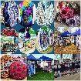
Jackie Marshall |  | Fresh Fruit Apples & Citrus | 553 Tathra Road Kalaru | Fri Sat Sun | 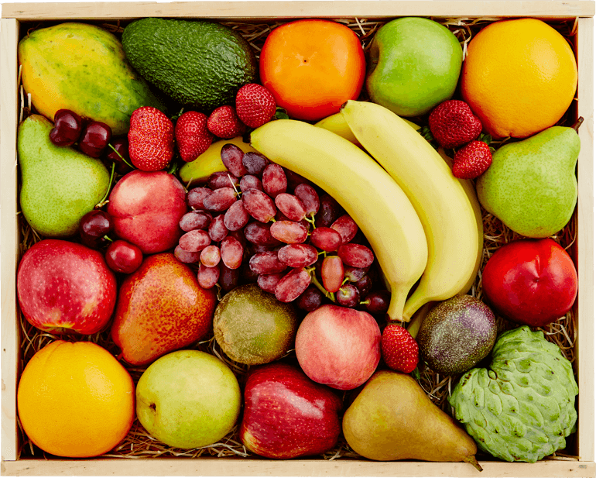
 |  |  | Bermagui Market | Thurs 2.15 - 4pm
Alana Nichols | The Mill & Co | Candles, Reed Diffusers, Bows, Jewellery | https://themillandcolifestyle.square.site/ | any time | 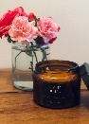
Margaret Cuzner | Homestead Horseshoes | Decorated Horseshoes | https://www.facebook.com/Homestead-Horseshoes-628157694230134/ | any time | 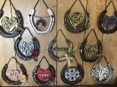
Lisa Rikken | Claudie George | Handmade Toys | https://www.etsy.com/au/shop/ClaudieGeorge | any time | 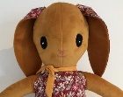
Bryan Willie | Happy woofers | Pet supplies | https://www.facebook.com/pg/HappyWoofersLE/shop | any time
Chris Winchester | Pet Products | Pet Essentials, Toys & Luxury | https://petproducts-online.com.au/ | any time
Jacqueline Beever | Ochiltree Designs | Handmade Jewellery | www.etsy.com/shop/OchiltreeDesigns | any time | 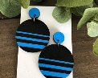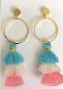
 |  |  | Black Daisy Trading Pambula | shop times
 |  |  | Tathra Beach General Store | shop times
Steve Ryan | Bournda Farmgate | Seedlings | https://www.facebook.com/Bourndafarmgate/ | contact Steve | 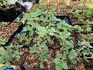
Ann Mawhinney | Maloola natural skincare | Skincare | www.maloolanaturalskincare.com.au | any time
 |  |  | Mi T Nutrition 184 Carp Street Bega | shop times
Alison Baker | Esther Jane | Unique Handmade Timber Earrings | https://estherjane.com.au/ | any time | 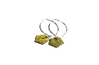
Ian Ritchie | Za's mobile coffee | Coffee | Coffee shack at 479 Sapphire Coast Drive | 6.30 - 11 am daily
Johanna Weiss | Stairwell Studio | Art printed tea towels | https://www.instagram.com/stairwellstudio/ | any time | 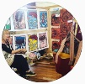
Maike Quellenberg | Bally Park goats milk soap | Goats milk soap | www.ballyparkgoatsmilksoap.com.au | any time | 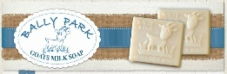
Reiko Healy | Japanese Creations | Kimono, Obi, Fabric, Dolls, Prints, Antiques & Collectables. | https://www.japanesecreations.online/ | any time | 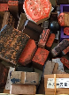
Melissa Meeks | Surya | Ethical clothing from Nepal | www.surya.com.au  www.facebook.com/SuryaEthical | any time | 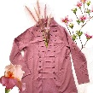
Phillip Kennedy | Guyedy Hydrosols | Hand crafted Peppermint Eucalyptus products | www.guyedy.com | any time | 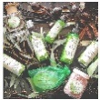
Kay Saarinen | Saarinen Organics | Eco skin care, sustainable & local | www.saarinenorganics.com  https://www.facebook.com/saarinenorganics | any time | 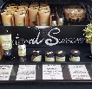
Patricia Pena | Asai Arte | Bags,Hats,Shoes,  Jewellery,Clothing | https://asai-art.com/  https://www.facebook.com/aartecolombia/ | any time | 