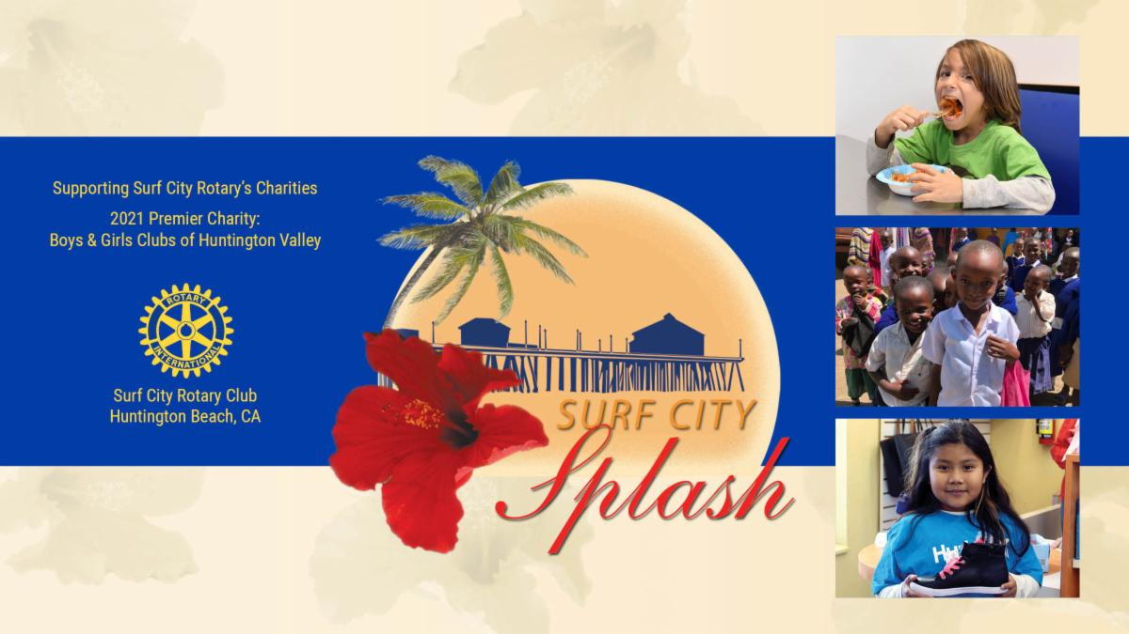

|  |  |
| --- | --- |
| |  | | --- | | **Thank you for Supporting**  **Surf City Rotary Club's**  **Surf City SPLASH**  **VIRTUAL EVENT**  **Thanks to you, the event was a big success!**  You helped raise more than ***$100,000*** for Surf City Rotary to support the good work of charities around the world and right here in our community, like the Boys & Girls Clubs of Huntington Valley. | |

|  |
| --- |
|  |