RI President: R Gordon R McInally |  | The HUB  The weekly bulletin of  The Rotary Club of Kingaroy  22 January 2024  Chartered 8 December 1948  Proud sponsor of the Rotary Satellite Club of Kingaroy Sunrise  Chartered 30 July 2022  “RI President R. Gordon R. McInally calls for Rotary to create hope in the world by working for peace and mental wellbeing. He urges members to engage in tough conversations and earn the trust that’s necessary to realize these values.” | 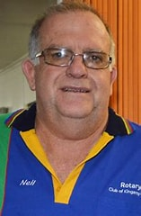  Club President: Neil Black
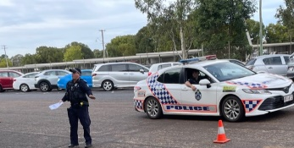
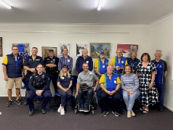
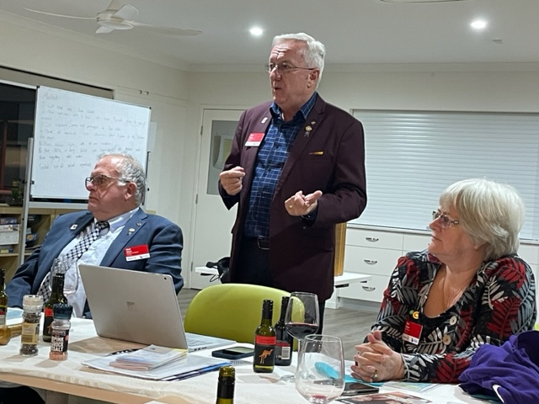

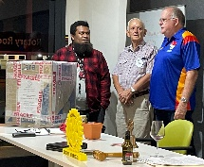
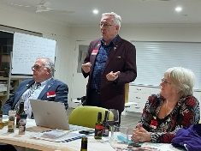
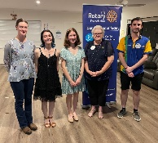
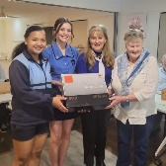

We give thanks to Rotary for good fellowship, the opportunity to serve our community and to do good in the world.

The General meeting was opened by President Neil Black at 6.36 pm. All members and guests were warmly welcomed.

Attendance: Neil Black, Kerry Heit, Ray Pitt, Geoff Hosking, Murray Johnston, Deb Hails, Ian Hall, Carmel McKeering, Ron Roberts
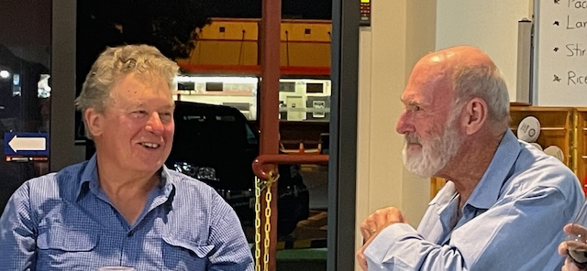
Guests: Dennis Cupitt, Helen Waugh, Brian Tessmann

Members on Leave: Lex Petersen
Apologies: Anna Faunt, Brett Otto, Bev Watter, David Black, Gus Napier
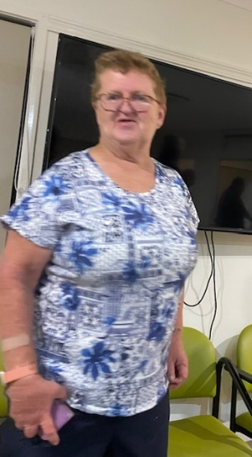
Birthday:
16 January Brett Faunt

Wedding Anniversary:
14 January Carmel & Allan McKeering

Club Anniversary:
Nil

Rotary Information: Ron Roberts
Step right up: In Rotary’s membership game, everyone’s a winner
By Geoffrey Johnson
When it comes to finding new members for his Minnesota Rotary club, Tom Gump doesn’t just walk the walk, he trots the trot: the turkey trot. Gump is a former president of the Rotary Club of Edina/Morningside, which makes boosting membership a priority. In fact, that’s the fourth item on a list of 10 tips to attract and retain members which has been prepared – and practiced – by the club. It’s tip No. 10 that finds Gump clad in a turkey suit. More on that shortly.
The tips work: During Gump’s 2016-17 stint as club president, Edina/Morningside added 31 members. Eleven of them were women; 10 were under 40 years old. With 94 members, the club “went from being classified as a medium-size club to being one of District 5950’s large clubs,” says Gump, who will be the 2020-21 district governor. “There were 13 clubs larger than our club in our district, and now there are only four.”
The tips have proven so effective that Gump has taken the Edina/Morningside show on the road, using a PowerPoint presentation to coach other clubs on specific ways they can expand their membership. “I have been called a good salesman,” says Gump (who, for the record, is a real estate lawyer and a developer). “But to me, recruiting new Rotary members is not really selling. It’s matching up potential members with what he or she wants in a club.”
So if you’re looking to add members to your club, consider taking a page from the Edina/Morningside playbook. Read on for the club’s 10 tips, as well as five suggestions for increasing membership from other Rotarians and Rotary clubs.
International Toast:
Deb proposed an International Toast prepared by Bev Watter. The toast was to the RC of Monrovia – Liberia – West Africa.

The RC of Monrovia meets bi-weekly on Fridays, 12.30pm – 2pm at Fuzion D’Afrique, Sinkor, Monrovia. According to their website they have 53 members.
The RC of Monrovia was initially chartered by RI on January 24,1964 as the first RC in Liberia with 29 members from business and professional classifications that ranged from engineering, medicine, insurance, transportation, law and many others. The club meetings were held on Fridays at 7pm at the Ducor Hotel. Rotarians continued to meet and serve during the civil conflict, though infrequently. This resulted in a five year lapse in the official relationship with RI. Remaining committed to the object of Rotary, the RC of Monrovia was re-chartered in 2000 to formally continue its service to the people of Liberia.
Following its initial charter in 1964, the RC of Monrovia sought others who were committed to Service Above Self and sponsored the RC of Yekepa in 1970, the RC of St Paul River and Buchanan in 1985, the RC of Gbarnga in 1987 and the RC of Sinkor in 2008. The RC of Monrovia was instrumental in supporting the chartering of the RC of Harper in 2007.
Rotary Clubs of Monrovia district administration is District 9101, which includes 9 other countries.
Areas of Focus:-
They write-the causes we target to maximize our impact are called our areas of focus. Our most successful and sustainable projects and activities fall within these areas. Through global grants and other resources, we help clubs focus their service efforts in the following areas:-
Peace building & Conflict Prevention, Supporting Environment, Basic Education & Literacy, Water Sanitation & Hygiene, Maternal & Child Health, Community Economic Development, Disease Prevention Treatment.

They have 13 members on their Board – apart from the usual they have New Generation, and one I’m sure we can use, although it may be a bit of a problem to fill the position depending on how it is categorized. The position is Trainer, for what you may ask????

Next meeting’s toast will be proposed by Murray Johnston

President: Neil Black
- Board Meeting report
  - Swimming Club food stall – thanked members & volunteer Helen. Should clear $500
  - Swickers bar – very good night. Thanked members for their work. $400 donation to us + Cash for Cans income
  - Satellite Club is running their Pride of Workmanship event on 24 March. All members invited
  - 24 March Western PETS to be held in Kingaroy. Venues - SB Care & KSHS Assembly Hall
  - Dinner Meeting dates – sorted until June. See Calendar below
    - All dinner meetings will be 6.00 for 6.30pm. Meals to start at 6.45pm
    - Dates are- 5 Feb, 4 March, 8 April (due to Easter), 13 May (due to Labour Day), 3 June
    - Changeover will be 15 June and will combine with the club’s 75th birthday
  - Club’s 75th celebrations to be held on Changeover night
  - Ham Wheel 2024 – only going to raffle 20 hams Tickets $2
  - Bunnings price increase - drinks now $2 & sausages still $3
- District Conference 8 – 10 March at SeaWorld. Please consider going. Some members already booked in

Secretary: Kat
- Minutes of the previous meeting were accepted as a true & correct record. Moved: Ian & Seconded: Kat
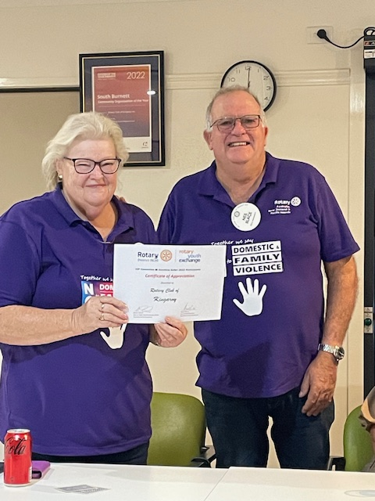
Kat thanked everyone for their well-wishes. It really meant a lot to her knowing that so many people were supporting her. Going very well.
- Bank Statement received
- Non – profit food licence approved
- Certificate from Exchange program received – presented to Deb by Neil

Treasurer: Mark Huston
- December Financial report sent out
- Spreadsheet discussions with Auditor Bill Ewen to account for special projects. $5000 to be allocated for Rotary Park project
- Membership invoices out. Membership is subsidised. Members are asked to bring in their cans & bottles to help with this

Directors Reports

Community Projects: Bev Watter:
- Once again thank you to the crew who worked the bar on Jan 13 for Swickers, and also the crew who worked the bbq at the swimming carnival.
- A text has gone out asking for workers at Bunnings on Sunday 28 January. I would like a yay or nay sooner rather than later. Possible starters – Ray, Bev, Kerry, Murray + ………..
- Would like all to pencil in May 4 this year as that is the date we are doing a bbq at Tarong for approx. 1000 people, so we are going to need all hands on deck plus many more. May have to call on friends and relations. Take care.
- Looking for someone to take BBQ to Nanango IGA Feb 10. Possibly - Geoff (drive van), Ian, Ray
- Nanango Races 10 Feb - Bev, David, Neil, + ………….
- 25 Feb Bunnings BBQ

Youth: Deb Hails
- Text received from recent Bursary recipient Charlotte Landherr – accepted into B of Med & B of Surgery at JCU. Used bursary to purchase a laptop for her studies. Highest ATAR score means top 100 in state
- Supported Mia De Guzman from St Mary’s CC to attend NYFS this year. Awarded Young Australian of the Year award at Australia Day Awards at Kumbia. Possible guest speaker at our next meeting.
- Training Awards information sent to all local schools

Rotary Foundation: Kerry Heit
Nil

Interact: Carmel
Nil

Membership: Ray Pitt
- Encouraging possible members – Brian, Harvey Norman & Salvation Army Captain
General Business:
- Ian Hall – Bowls Day to raise funds for the local Autism Support Group. Like to re-start this event as an annual event. Ian would be happy to run the event & would like someone attend the 9 Feb Autism Group meeting.
  - Mark suggested we honour John Bastable in some way to remember his efforts in this event previously – The John Bastable Memorial day. Members agreed

- Deb – received email from SB Saints AFL Club 4 Feb requesting support for their Family Fun Day. Deb will contact them
- RYDA – will need someone to coordinate this year’s event April 30 - 1 May as Murray will be moving early April

Card Draw:
4 HEARTS Ian Hall

Fines:
Nil

Meeting closed: 7.30 pm

Next meeting 5 Feb Dinner meeting

Cheers

Murray

Members need to let Kat know if not attending.
Reminders
• If you cannot attend a meeting, you MUST contact Kat by NOON on Monday!
• If you don’t cancel by noon you will be billed for a meal.
• New Bank account details
o Account Name: Rotary Club of Kingaroy Inc.
o BSB: 084 961
o Account Number: 254 905 213

Got recycling to drop off - Containers For Change Rotary Club of Kingaroy Account C10071454
(Please get a receipt and hand to Treasurer Mark)

• Make sure you wear your badge at every meeting. Makes it easier for guests.

Useful Rotary Websites
Club website www.kingaroyrotary.org.au
Rotary Foundation
- International www.rotary.org
- Australia www.rotaryfoundationaustralia.org.au

BIRTHDAYS – MEMBERS AND PARTNERS  16 January Brett Faunt  ANNIVERSARIES  14 January Carmel & Allan McKeering  CLUB ANNIVERSARY |  | Attendance at each meeting is presumed unless you notify your absence to:  Kat – South Burnett Podiatry  Phone: 07 41627633 or 0417 627 316  Email: reception@southburnettpodiatry.com.au  Numbers need to be in by 12 noon.  The Four-Way Test  OF THE THINGS we think, say or do:  - Is it the TRUTH?  - Is it FAIR to all concerned?  - Will it build GOODWILL and BETTER FRIENDSHIPS?  - Will it be BENEFICIAL to all concerned?

C A L E N D A R

Date | Event | Time
28 Jan | Bunnings BBQ | 7.00am – 2.00pm
5 Feb | Dinner meeting | 6.00 for 6.30pm
10 Feb | Nanango Races
10 Feb | Nanango IGA BBQ
25 Feb | Bunnings BBQ | 7.00am – 2.00pm
4 March | Dinner meeting | 6.00 for 6.30pm
8 April | Dinner meeting | 6.00 for 6.30pm
30 Ap & 1 May | RYDA @ Kingaroy SHS SB High schools
4 May 2024 | Stanwell | Catering event for 1000
13 May | Dinner meeting
3 June | Dinner meeting | 6.00 for 6.30pm
15 June | Changeover meeting + 75th celebrations | 6.00 for 6.30pm

Legend

Bunnings
IGA
Nanango Races
Multiple Events on same day
Other events
Dinner Meetings

