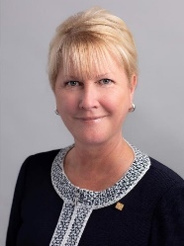  Proud sponsor of the Rotary Satellite Club of Kingaroy Sunrise  Chartered 30 July 2022  “We all have dreams, but acting on them is a choice. Imagine a world that deserves our best, where we get up each day knowing that we can make a difference.” |  | The HUB  The weekly bulletin of  The Rotary Club of Kingaroy  Chartered 8 December 1948  10 October 2022 | Club President: Kerry Heit
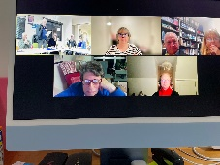
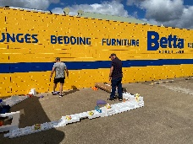
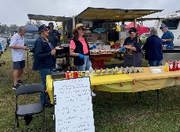
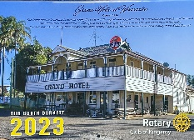
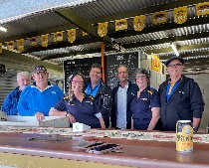
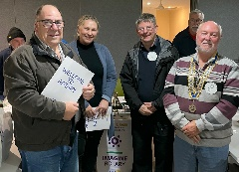
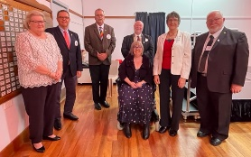
RI President: Jennifer E Jones

We give thanks to Rotary for good fellowship, the opportunity to serve our community and to do good in the world

The General meeting was opened by Neil Black at 7.08 pm and welcomed all members.

Attendance: Gus Napier, David Black, Vince Evans, Geoff Hosking, Lex Peterson, Ray Pitt, Mark Huston, Bev Watter, Neil Black, Murray Johnston, Ron Roberts, Abigail Andersson, Jerem Hinchliff(NSHS Active Citizen)
Kath Butcher, Sandy Hoffmann, Anne Faunt, Carmel McKeering, Allan McKeering

Guests: Nil

Apologies: President Kerry Heit, Deb Hails, Brett Otto, Ray Pitt

Birthdays: Nil

Wedding Anniversary: Nil

Club Anniversaries: Nil

International Toast: Nil

Next meeting’s toast: Murray Johnston
Rotary Information: Ron informed members about Who We Are.
Rotary is a global network of 1.4 million neighbours, friends, leaders and problem-solvers who see a world where people unite and take action to create lasting change – across the globe, in our communities and in ourselves.
Our mission – is to provide service to others, promote integrity and advance world understanding, goodwill and peace through our fellowship of business, professional and community leaders.
Guest Speaker: Nil

Secretary: Bev
- Letter from St Mary’s Catholic College thanking the club for its $250 donation towards its Speech Night program
- Rotary magazine received
- Slip Jervis (from Satellite club) is going really well following his recent health scare

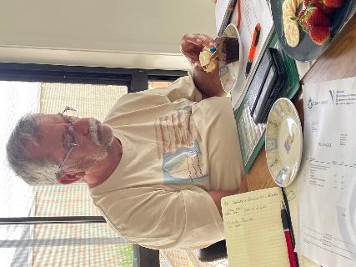
Treasurer: Mark
- Current Financial Report should have been received by members
- NAB Education Support Fund term deposit matures 13 October. It was moved by Vince and seconded by Geoff that we increase the Ed Support Fund to $30 000. Agreed
- BBQ trailer rego has been paid

Mark in action at the board meeting

Chairperson & Service Projects: Neil
- Moved by Bev & seconded by Vince that the minutes of the previous meeting be confirmed. Agreed

- No business arising

- List sent to all members by Bev of the Calendar of Events for the rest of the year. It is a very busy time ahead. Please help whenever you can
- SMILE bar this Friday. Workers are Bev, Neil, Jerem, Anna, Dave Abby Dave & Mellisa (tickets). White shirt required. 5.30 – 11.00pm
- 24 October – club guests are the winner & runner-up of the District Primary Schools Persuasive Speech competition

Satellite Club: Mark
- Slip Jervis is going really well. He and Sue have appreciated people’s care and concern
- Pride of Workmanship to be held in February 2023. KCCI is keen to assist. Idea – apprentice & trainee inclusion every year

Vocation:Dave
- 31 Oct Guest speaker is Dave Arnold
- CPR & defibrillator training. Suggested to devote a club meeting to this. Abby can assist with this as she is a member of the Local Ambulance Committee. Members agreed to hold the training on Monday 7 November 6.30. Finger food. Satellite club to join us

VP Kat
- Thanked board members for a great board meeting yesterday. Succession planning is a really positive action.
- A very busy calendar of events for the rest of the year. Please help everyone. We need to work as a team.

Youth: Kat for Deb
- Mum’s Packs to be distributed. We have 104 kits. To be divided between St Marys CC, NSHS, KSHS, MSHS, CTC & Women’s Shelter
- Plan to meet at shed on Sunday to organise. Leonie has made bags to use to hold items. Helpers are Kat, Deb, Bev, Murray & Sue

Administration: Ray/Neil/Gus
- Gus – met a person who is interested in finding out more about Rotary. Has been invited

Rotary Foundation: Murray
- Movie Night RF fund raiser. Planning event for Monday 5 December. Waiting confirmation from Cinema.
- Considering social RF fund raiser – Painting session at Crawford - 2 Sisters
- 24 October World Polio Day

General Business:
- Vince
  - IGA BBQ - $312 profit including $15 donations. 5 calendars sold. Thanked Geoff & Bev for their help
- Kat
  - AGM 14 Nov. Important that all members attend. Executive positions must be filled. Can you help?
- Mark
  - Succession planning – providore. Would like to see how we can standardise lots of things we do eg IGA account. Would make the life of providore easier. We also need a recycle bin for the BBQ trailer. Lex to do
- Mark
  - Microphone replacement. We need to get it done for zoom meetings. Need a ‘conference’ microphone. Gus happy to work with Geoff to investigate. Moved Gus & seconded Mark that a limit of $200 be spent on purchasing a microphone locally. Agreed
- Mark
  - Raffle – painting by Kathleen Gogerly (1st Bursary student) + minor prizes. To do this year. Proceeds to go to the Education Support Fund. Mark & Vince to follow up
- Mark
  - Club vests – Mark has ironed them & are now all on hangers. Keep them tidy please
  - Attended SB Regional Council small grant info night. There are 3 types of grants available. Mark is keen to see if one of them suits us to upgrade Rotary Park. More info to come. 1st round closes 22 November. Other rounds to come
- Geoff
  - Encouraged club to continue using Bill Ewen’s accounting package. Bill will continue to be our auditor if we use it
  - Bill has not been well recently, but is on the mend.
- Gus
  - There is a proposal being developed for the possible use of the old prenatal building in Glendon St as a drop-in centre which could include things like the Community Meals project. Discussion stage only

Interact:Carmel
- The club has been slow to get started this year. No meeting held yet. There are some keen students. May not reach fund raising target of $1000. The defibrillator has been ordered & received by our club. Interact will ask Yarraman Bowls Club to come & accept at a club meeting. Date to be set

Card Draw: 6 clubs no winner

Meeting closed 8:12pm

Cheers,
Murray

Members need to let Vince know if not attending.

Reminders
• If you cannot attend a meeting, you MUST contact Vince by NOON on Monday!
• If you don’t cancel by noon you will be billed for a meal.
• New Bank account details
o Account Name: Rotary Club of Kingaroy Inc.
o BSB: 084 961
o Account Number: 254 905 213

Got recycling to drop off - Containers For Change Rotary Club of Kingaroy Account C10071454
(Please get a receipt and hand to Treasurer Mark)

• Make sure you wear your badge at every meeting. Makes it easier for guests.

Useful Rotary Websites
Club website www.kingaroyrotary.org.au
Rotary Foundation
- International www.rotary.org
- Australia www.rotaryfouMurrayndationaustralia.org.au
- International Convention 2023 Melbourne https://rotarymelbourne2023.org

BIRTHDAYS – MEMBERS AND PARTNERS  Nil  ANNIVERSARIES  Nil  CLUB ANNIVERSARY  Nil |  | Attendance at each meeting is presumed unless you notify your absence to:  Vince Evans  Phone: 0499 366 007  Email: evansvlj@bigpond.com.au  The Four-Way Test  OF THE THINGS we think, say or do:  - Is it the TRUTH?  - Is it FAIR to all concerned?  - Will it build GOODWILL and BETTER FRIENDSHIPS?  - Will it be BENEFICIAL to all concerned?

Calendar of Events
Date | Event
14 October | SMILE bar at Town Hall
24 October | Guest speakers – Primary Schools Speech Competition winner & runner-up
24 October | World Polio Day focus
29 October | Betta Electrical BBQ
31 October | Guest speaker - IMPACT
3 November | SB Health & Community Expo catering
7 November | CPR / Defibrillator training
12 November | Nanango IGA Sausage Sizzle
14 November | AGM
28 November | Guest speaker - Jerem Hinchliff NSHS Active Citizen
2 December | Dalby Stock Horse sale - BBQ
3 December | Nanango Races pm
3 December | Nanango Markets Calendar sales am
4 December | Nanango Music Recital
5 December | Rotary Foundation Movie Night
8 December | Kingaroy Christmas Carnival
10 December | Nanango IGA Sausage Sizzle
12 December | Guest speakers - 3 Bursary students
17 December | Christmas Party
9 January 2023 | First meeting for 2023 – BBQ at Rotary Park
18 February | Strategic Planning workshop

