President: Shekhar Mehta |  | The HUB  The weekly bulletin of  The Rotary Club of Kingaroy  14 March 2022
 | We give thanks to Rotary for good fellowship, the opportunity to serve our community and to do good in the world
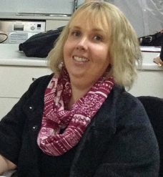
Opened: President Kat opened meeting (on Zoom at home) at 7.10pm and welcomed all members.

Attendance: President Kat Butcher, Geoff Hosking, Ron Roberts, Ray Pitt, Abigail Andersson, Sandy Hoffmann, Vince Evans, Murray Johnston, David Black, Bev Watter, Lex Petersen, Gus Napier, Carmel McKeering, Allan McKeering, Anne Skinner

Guest: Jerem Hinchcliffe (Active Citizen KSHS)

Apologies: Ros Tigell, Kerry Heit, Anna Faunt, Deb Hails, Mark Huston, Neil Black, Brett Otto

Birthday: Leonie Evans 19 March

Wedding Anniversary: Nil

Club Anniversary: Deb Hails 17 March 14 years Anna Faunt 21 March 6 years
……………………………………………………………………………………………………………………………………………………………………………..
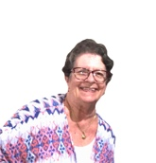

International Toast: Sandy Hoffmann proposed an International Toast to the Rotary Club of Nadi, Fiji. Nadi is one of 53 clubs in the maritime District 9920. The club was chartered on 29 May 1969 and was the third club in Fiji to be established. The club currently has a membership of 18 plus 4 corporate members. This year’s President is Babu Singh. Fiji has a large gap in its socio-economic structure and Covid has impacted heavily. The club works hard to help families in every way possible.

Next meeting’s toast: Gus Napier

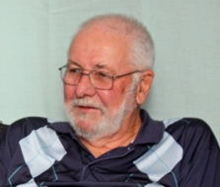
Rotary Information: Ron delved into the Rotary archives to find this week’s information for members… Rotary’s two official mottoes.
Service Above Self and One Profits Most Who Serves Best can be traced back to the early days of the organization. In 1911, the second Rotary Convention in Portland, Oregon approved He Profits Most Who Serves Best and inspired Service, Not Self. The 1989 Council on Legislation established Service Above Self as Rotary’s principle motto because it best conveyed the philosophy of unselfish volunteer service. He Profits Most Who Serves Best was modified to They profit Most Who Serves Best in 2004 and then changed to its current wording of One Profits Most Who Serves Best in 2010.

Guest Speaker: Nil

Secretary: Bev
- Letter from SBRC re ANZAC Parade. If we want to participate we contact the RSL Sub-branch. We don’t usually march.
- Vince to organise the annual book donation for a local school. Thank you.

Treasurer: Mark
- No Report

President Kat:
- Betta Electrical has asked if we want to run our BBQ more often. Club to look into when we might go there to sell sausages.
  - Betta Electrical sign on BBQ trailer. Gus & Lex to investigate. If we are to sell sausages?

Youth: Deb

- RYDA –Geoff. Still battling with the paperwork trail. Had to revamp the budget as RSE will be paying costs directly. Will be cost neutral in the end.
- Geoff is keen to gather a group of helpers. So far – Vince, Ron and Murray

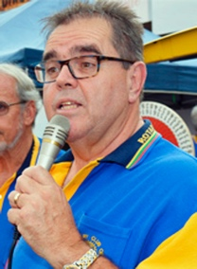
Foundation: Vince / Murray
- Movie Night next Monday. Still looking for more numbers. Bring your friends & colleagues.
- Please contact Vince
- Flyers have been sent to local groups.
- 5.45 Pizza, nibbles & drinks $20pp.
- 34 attending so far. Spread the word!

General Business:

- Blaze Aid – Sandy reported that due to ongoing flooding, some damage has happened again. They have moved to a better area. PCYC was too big. They need volunteers and a stove. Sandy suggested we might be able to source a gas stove for them. Perhaps our club could pay for the installation.
- Geoff and Ray each have an old BBQ that they can use. Sandy will contact the organizer to see if it would be suitable. Kat moved and Bev seconded that we purchase a gas bottle and offer Ray’s BBQ.

- Bev- $229 profit from Nanango IGA BBQ.

  - 9 April bar at Burnett Bands Together event in Kingaroy

  - Next Nanango Races 16 April

  - Moffatdale Boutique Markets – would like our Gold Coin donations we collect to go to flood relief. (Salvation Army. Red Cross. etc) Bev suggested we donate it to Blaze Aid in Murgon. Agreed

- Anne – talked about the possibility of our club funding a Shelter Box for Ukraine. Has been discussed. RI is stepping up with this.

- Abigail – Peanut sculpture being opened on 2 April. All welcome. Lions Park. Time yet to be determined.

- Nanango Little Theatre performance promotion of “Speed Dating In The Nude” 25 – April 2.

- Toastmasters – Trevor Stead came third at the recent Central Division Conference.

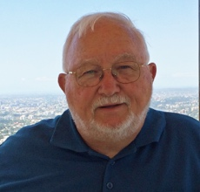
Membership: Neil/Ray
- New Constitution has been sent to board members. All approved. By-Laws to go to members. To be table at a meeting

Interact
- Carmel reported that she had called a meeting. Limited response so far. Suggested to have a member speak on Assembly (Wed) to promote Interact. Past President to attend as well. This should prompt an interest.
- Funds – School Admin request to supply them with club information so funds can be transferred to buy the defibrillator. $1439.50. To be done.

Fines: Nil

Card Draw: Lex 9 Diamonds

Meeting closed 8: 20 pm

Cheers,
Murray

Next Meeting: Mon 21 March Movie Night Members need to let Vince know if not attending.

Reminders
• If you cannot attend a meeting, you MUST contact Vince by NOON on Monday!
• If you don’t cancel by noon you will be billed for a meal.
• New Bank account details
o Account Name: Rotary Club of Kingaroy Inc.
o BSB: 084 763
o Account Number: 254 905 213

• Make sure you wear your badge at every meeting. Makes it easier for guests.

Useful Rotary Websites
Club website www.kingaroyrotary.org.au
Rotary Foundation
- International www.rotary.org
- Australia www.rotaryfoundationaustralia.org.au

BIRTHDAYS – MEMBERS AND PARTNERS  Leonie Evans 19 March  ANNIVERSARIES  Nil  CLUB ANNIVERSARY  Deb Hails 17 March  Anna Faunt 21 March |  | Attendance at each meeting is presumed unless you notify your absence to:  Vince Evans  Phone: 0499 366 007  Email: evansvlj@bigpond.com.au  The Four-Way Test  OF THE THINGS we think, say or do:  - Is it the TRUTH?  - Is it FAIR to all concerned?  - Will it build GOODWILL and BETTER FRIENDSHIPS?  - Will it be BENEFICIAL to all concerned?

Club Meeting Details
21 March | Movie Night

UPCOMING EVENTS – ACTIVITIES – PROJECTS – HAPPENINGS
DATE | CONTACT PERSON | DETAILS
18-20 March | Neil | District 9620 Conference Caloundra
9 April | Kerry | Bar at Burnett Bands Together
16 April | Bev & David | Nanango Races

