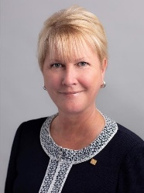  Proud sponsor of the Rotary Satellite Club of Kingaroy Sunrise  Chartered 30 July 2022  “We all have dreams but acting on them is a choice. Imagine a world that deserves our best, where we get up each day knowing that we can make a difference.” |  | The HUB  The weekly bulletin of  The Rotary Club of Kingaroy  Chartered 8 December 1948  21 November 2022  Vale  John Bastable  President 1996-1997  A devoted Rotarian | Club President: Kerry Heit
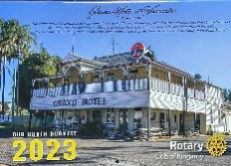
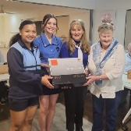
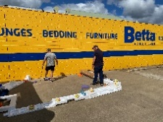
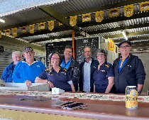
Vale

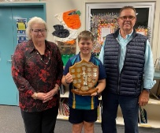
RI President: Jennifer E Jones

We give thanks to Rotary for good fellowship, the opportunity to serve our community and to do good in the world

The General meeting was opened by President Kerry Heit at 7.01pm. All members and guests were warmly welcomed.

Attendance: President Kerry Heit, Lex Peteren, Vince Evans, Gus Napier, David Black, Mark Huston, Geoff Hosking, Ray Pitt, Murray Johnston, Carmel McKeering, Allan McKeering, Ron Roberts, Neil Black, Mark Pitt

Guest: Luke Arnold & Janine Thorn from IMPACT, Evalyn Thompson (new member)

Apologies: Brett Otto, Abigail Andersson, Kat Butcher, Deb Hails, Bev Watter, Anna Faunt, NSHS Active Citizen Jerem Hinchliff, Sandy Hoffmann
Birthdays: Nil
Wedding Anniversary: Nil Not a celebration to be had!
Club Anniversary: Nil

International Toast: Mark proposed an International Toast to the Rotary Club of Napa, California. The club was chartered in 1920 and is in District 5130. This year’s President is Jon Crawford. Members meet at the Napa Elks Lodge each Wednesday at 12.15.
For over 15 years the club has dedicated its energy to supporting returning veterans from wars in Iraq and Afghanistan who are struggling with PTSD, traumatic brain injuries and combat stress as they work to reintegrate themselves into successful civilian life. The main program established is called The Pathway Home project.
For 13 years every third Saturday in April, the RC of Napa produces an award-winning cycling event hosting upwards of 2000 cyclists from all over the country. It is known as the Rotary Ride for Veterans. This event has raised over $2.2million.
An outstanding Rotary club indeed.

Next meeting’s toast: Vince Evans

Rotary Information: Ron
Ron talked about Rotary Projects Around the Globe. This week – Brazil
A year after some of its members participated in their municipality’s inaugural road rally, the RC of Campo Novo do Parecis ventured into a bigger role as a principal driver of the event. The Travessia do Parecis, held in April, followed a 193 km route in the west-central state of Mato Grosso, with 87 vehicles and 261 motorists participating. $4200 was raised.

Chairperson: President Kerry
- Vale John Bastable
  - Geoff Hosking spoke of John’s life and character. He was Kingaroy’s Sergeant of Police for 11 years. John was a member of our Rotary club for 30 years, being club President in 1996-1997. One of his best projects was the overseeing the completion of the Rotary Park project. He was passionate about International Student Exchanges as well. John was skilled at getting people to do things. He was a very social person. He loved the annual Rambling Rotarians weekends and really enjoyed to sing after a few ales. Long and loud!
  - He was also a very generous person – supporting the local Filipino community & Edna’s family. John and Edna have spent the last 12 months in Toowoomba, where John was highly regarded by his community.
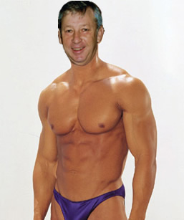
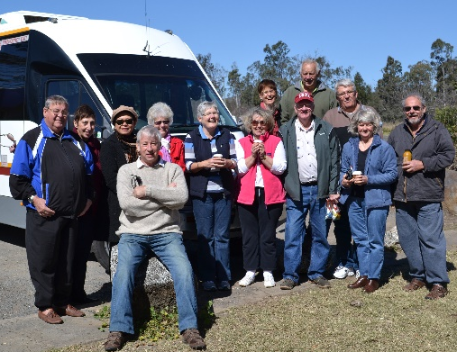
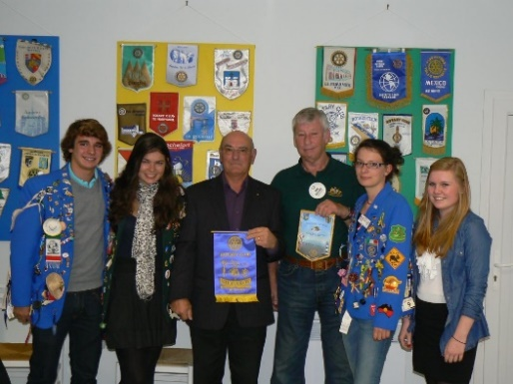
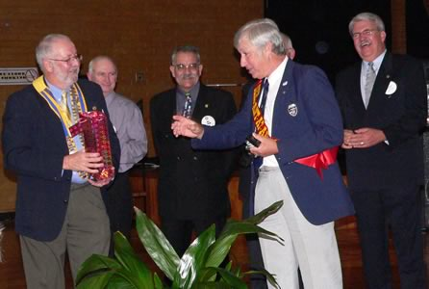
  - Club action – flowers to be arranged by Vince. Members to attend if at all possible (club badge). Funeral is on Thursday at 11.00am at the Crematorium. A bus (leaving from the RSL) will be available for people. John will be buried at the Memerambi Cemetery buried with Jean. Geoff suggested members sign the attendance book, acknowledging his link with the Kingaroy Rotary Club.

- Moved by Ron and seconded by Gus that the Minutes of the last meeting be confirmed as read. Agreed
  - No business arising
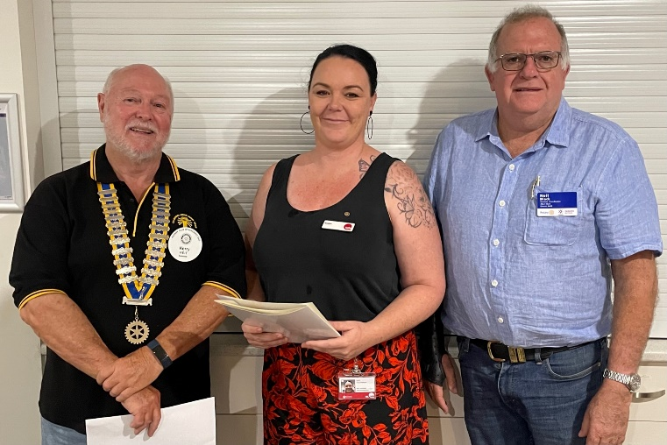
- New member induction.
  - Neil introduced Evalyn Thompson Business Development Officer at TAFE to members. President Kerry then completed the induction procedure to make Evalyn the newest member of our club. Evalyn Thompson – classification Business Development Members warmly welcomed Evalyn…… and made sure she was involved in upcoming club activities …. All action around here Evalyn!
- Kerry thanked IGA BBQ volunteers. $350 profit
- Moved by Murray & seconded by Geoff that the minutes of the 14 November AGM be ratified. Agreed
- QAS Certificate has been delivered by Kerry
- CTC meeting re ownership of site. Kerry and Neil attended and reported that nothing is to change for us. We own the sheds, but they are not on our Asset Register. To be done ASAP
- Letter from Kingaroy Christmas Committee requesting continued sponsorship for the purchase of amusements at the event in Glendon St. (4.00pm – 9.00pm) Remember, our club is running the Ham Wheel.
  - Moved Kerry and seconded by Ray. Agreed

Secretary: Bev
- Away

Treasurer: Mark
- Calendars – Other sales possibilities…
  - Carmel to see if Interact Club will sell some. He will drop some to KSHS
  - TAFE – Evalyn will try to set up a sales point at TAFE

Service Projects: Neil
- Betta Electrical BBQ this Saturday. Geoff to bring trailer. Workers - Ray, Neil and Evalyn. 9.00 start
- Saturday Nanango Races. 11.00am start. Workers – Vince, David, Murray, Sue, Allan & Carmel, Jerem and Flynn
- Saturday night Town Hall bar at Swickers Christmas function. 5.00pm start. Workers - Bev, Flynn Jerem, Evalyn, daughter Lily, Lilly Williams and Gus (later)
- Saturday - Moffatdale Ridge wedding bar. Workers - Ray & Neil
- Sunday 4 December BBQ at Recital in Nanango. David will bring trailer. Workers to be arranged
Satellite Club: Mark
- AGM - executive remains same for the next Rotary year

Vocation: Dave
- NSHS Active Citizen Jerem Hinchliff is speaker next week

Guest Speakers Janine Thorn (manager) and Luke Arnold (local manager) from IMPACT were
introduced by David Black
- IMPACT
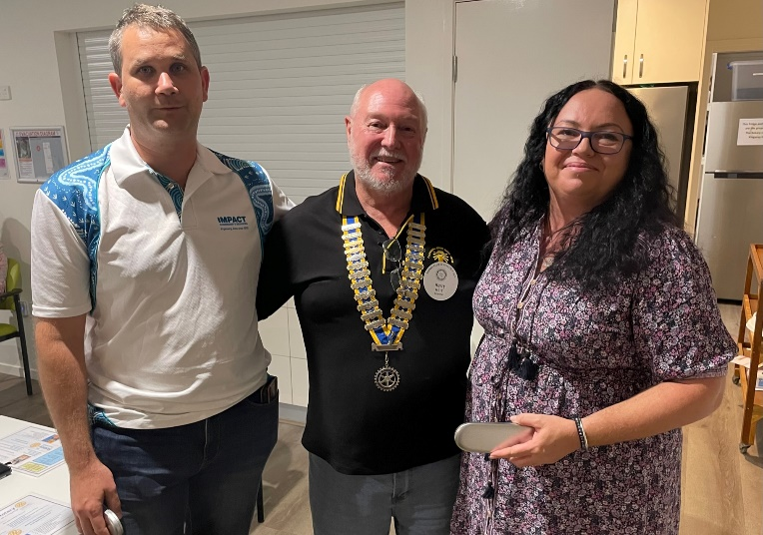
  - formed in 1978. Works with diverse & disadvantaged people in community using low intensity support. Clients are generally16+ with mental health conditions. Staff works 1-1 & with groups. The focus is on using a person’s strengths. The team is staffed by peer workers who have often had first-hand experience with mental health conditions
  - Programs vary according to needs – eg hands-on projects work well / often socializing focus on daily routines & essentials skills
  - Covid has brought on more mental conditions across Australia. Australian Bureau of Statistics reports that 43% of Australians have been diagnosed with a mental health condition
  - IMPACT has a shed space beside laundromat near the Shell petrol station.
  - No one is ever left unaided. IMPACT takes a wholistic approach, looking at the person and those around them. Also tries to work with other community organisations
  - People drop in or are referred by doctors, health services, QPS, etc. Funding increases with volume of people
  - Luke – role is to give people a voice to link to services & a more normal life. It is all about establishing connections

Youth: Deb
- Away

Administration: Ray/Gus
- Ray - R100 Tree Planting Project meeting with SBRC – tomorrow
- Not discussing Rotary Park at this stage
- Gus - SBRC environmental officer has given approval for the use of the old Dept of Health building in Glendon St as the drop in centre

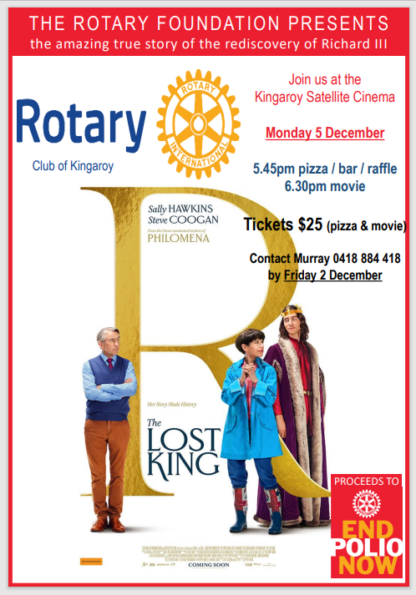
Rotary Foundation: Murray
- Invite everyone you know – partners (date night), family members, friends, neighbours, enemies… anyone….. to our Rotary Foundation movie night. Monday 5 December. This is the club meeting for that week… you have no excuse members!
- $25 (pizza & movie) Bar & Raffle
- Call/text Murray for bookings by Friday 2 December 0418 884 418
- For many years, the Polio Movie Event has been a very popular way for clubs to raise funds for Rotary’s number one priority, Ending Polio.

- This year’s movie is The Lost King, the story of the rediscovery, by an amateur historian, of the five centuries old remains of Richard III… in a Leicester carpark. Critics describe it as “an incredible and inspiring true story about perseverance and not taking no for an answer”.

Interact: Carmel
- Club held meeting recently. Any further fundraising ideas will have to wait until next year. They won’t make their fundraising target this year, but would like to use what has been raised to spend on ORANA art easels. Agreed
- Current Interact President, Emma Uebergang, would like to an Active Citizen next year. Members very pleased with her interest

General Business:
- Geoff reported that Jerem played the bassoon in the Sth Burnett Community Orchestra
- Mark Pitt – community groups signs - designs being drafted now. Total cots of project will be approx. $4000. To be decided as to how much out contribution will be. Board meeting topic.
- Company director ID – anyone need to do it? Advised to get it done ASAP

Sergeant’s Session
- None surprisingly …… not even Vince Evans??????

Card Draw: K HEARTS no winner

Meeting closed 8:38pm

Cheers,
Murray

Members need to let Vince know if not attending.
Reminders
• If you cannot attend a meeting, you MUST contact Vince by NOON on Monday!
• If you don’t cancel by noon you will be billed for a meal.
• New Bank account details
o Account Name: Rotary Club of Kingaroy Inc.
o BSB: 084 961
o Account Number: 254 905 213

Got recycling to drop off - Containers For Change Rotary Club of Kingaroy Account C10071454
(Please get a receipt and hand to Treasurer Mark)

• Make sure you wear your badge at every meeting. Makes it easier for guests.

Useful Rotary Websites
Club website www.kingaroyrotary.org.au
Rotary Foundation
- International www.rotary.org
- Australia www.rotaryfoundationaustralia.org.au
- International Convention 2023 Melbourne https://rotarymelbourne2023.org

BIRTHDAYS – MEMBERS AND PARTNERS  Nil  ANNIVERSARIES  Nil  CLUB ANNIVERSARY  Nil |  | Attendance at each meeting is presumed unless you notify your absence to:  Vince Evans  Phone: 0499 366 007  Email: evansvlj@bigpond.com.au  The Four-Way Test  OF THE THINGS we think, say or do:  - Is it the TRUTH?  - Is it FAIR to all concerned?  - Will it build GOODWILL and BETTER FRIENDSHIPS?  - Will it be BENEFICIAL to all concerned?

Calendar of Events
Date | Event
26 November | Betta BBQ
28 November | Guest speaker - Jerem Hinchliff NSHS Active Citizen
2 December | Dalby Stock Horse sale - BBQ
3 December | Nanango Races pm
 | Nanango Markets Calendar sales am
 | Swickers Christmas Party at Town Hall - bar
4 December | Nanango Music Recital
5 December | Rotary Foundation Movie Night
8 December | Kingaroy Christmas Carnival
10 December | Nanango IGA Sausage Sizzle
12 December | Guest speakers - 3 Bursary students
13 December | Christmas BBQ for Child Safety & Partners in Foster Care 10.00am – 1.00pm
15 December | Tarong Christmas Party luncheon
17 December | Christmas Party
9 January 2023 | First meeting for 2023 – BBQ at Rotary Park
18 February | Strategic Planning workshop

