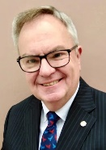  RI President: R Gordon R McInally |  | The HUB  The weekly bulletin of  The Rotary Club of Kingaroy  23 October 2023  Chartered 8 December 1948  Proud sponsor of the Rotary Satellite Club of Kingaroy Sunrise  Chartered 30 July 2022  “RI President R. Gordon R. McInally calls for Rotary to create hope in the world by working for peace and mental wellbeing. He urges members to engage in tough conversations and earn the trust that’s necessary to realize these values.” | 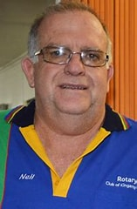  Club President: Neil Black
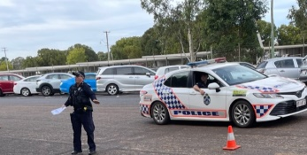
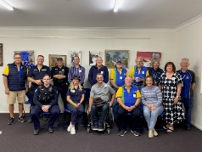
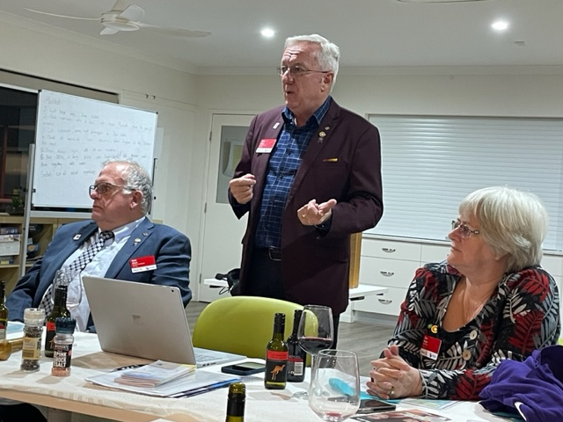

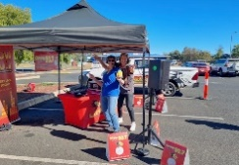
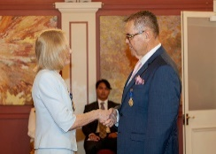
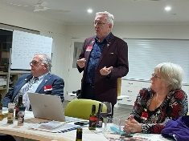
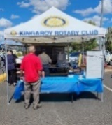
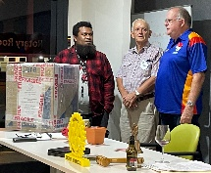
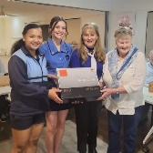

We give thanks to Rotary for good fellowship, the opportunity to serve our community and to do good in the world.

The General meeting was opened by President Neil Black at 6.30pm. All members and guests were warmly welcomed.

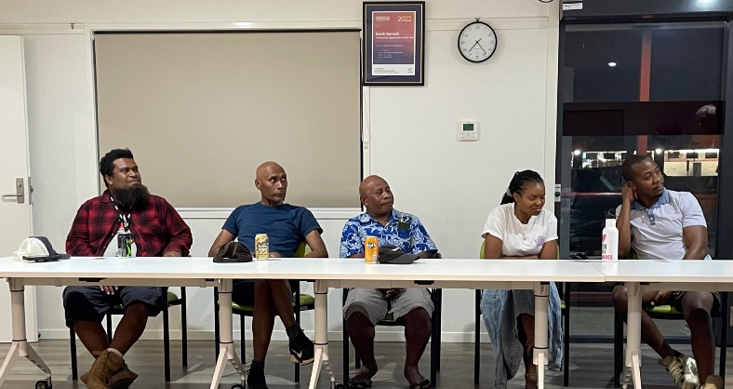
Attendance: Neil Black, Kerry Heit, Ray Pitt, Gus Napier, David Black, Geoff Hosking, Bev Watter (zoom), Kat Butcher (zoom), Murray Johnston, Deb Hails

Guests: Introduced by Gus Napier - Thornley Talasaia, Roy Gizo, Morris Galafa, Hiliary (SBCC IT) & Maggie Hwara

Members on Leave: Lex Petersen, Ron Roberts

Apologies: Anna Faunt, Brett Otto, Emma Lindholm (Active Student)

Birthdays; Nil

Wedding Anniversaries: Nil

Club Anniversaries: Nil

International Toast – presented by Kerry Heit to the RC of London, Ontario. The club was chartered in 1915 and lies in District 6330. Interestingly, the district incorporates part of the Province of Ontario in Canada and the state of Michigan in the USA. Membership averages about 100. Members have a ‘virtual meeting’ on the second Monday of each month and an ‘in person meeting’ on the fourth Monday of each month.

The club has a strong commitment of inclusivity: - “The club has roles for everyone that wants to help. If you are looking to give back to the community, please join us and you will soon find that your talents will be put to good use, you will make new friendships, help people in the community and abroad, and improve the world we live in.”

Over $1.75 million has been raised since 1999 and therefore the club has been able to achieve significant input to its community:-
- $100K to install a 14ft clock in the tower in Covent Garden Markets
- Youth for Christ ‘Streetlight Mobile Youth Centre’ $100K
- Rotary Reading Garden $400K
- Rotary Fire Hall $25KYouth for Christ ‘Streetlight Bus’$45K
- Annual Secondary School Scholarship Award $25K
- Thames Valley Children’s Centre $550K
- Polio eradication $200K
- Honduras Water & sanitation project $$150K
- Annual Rotary Exchange Student funding $35K

President: Neil Black
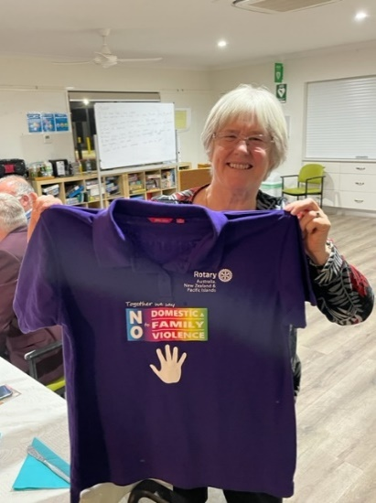
- 9 November Corporate membership zoom seminar. See Neil if interested
- 12 November District AGM. Neil attending
- RARE donation. Hospital beds are to be picked up soon. Semi is organised
- $28 000 raised at RARE fund raiser in Brisbane
- Purple shirt day 1 December. Promoting the fight against domestic violence. All clubs in the District are encouraged to purchase t-shirts and wear them on 1 December. Cost is $25. t-shirts need to be ordered ASAP. Mark will email order form to all members
There is a march planned in Brisbane

Secretary: Kat Butcher
- Minutes of the previous meeting were accepted as a true & correct record. Moved: Gus & Seconded: Neil
- Australia Day Award nomination application form for 2024 has been received
- Following up on Christmas Carnival booking

Treasurer: Mark Huston
- Bunnings last Saturday made $776
- Bega Lunch last week - donation to be paid this week $1725
- Profits two events/items recently of $145.60 & $22.70. Can anyone tell me what these are?
- Dropped 25 calendars at Murgon Info Centre & left 75 for Sandy to sell at the Music Muster
- Dropped 3 wheelchairs at Graham House in Murgon
- Have quotes from Design & Print for a pull-up stand sign & Corflute sign. To be discussed at board meeting

Directors Reports

Community Projects: Bev Watter:
- Updated Calendar for rest of year presented & discussed
- Bev went through recent events and outlined profit made
- The Calendar of Events in this Hub is the current up to date version

Youth: Deb Hails
- Persuasive Speech Competition this Thursday at 4.00pm. 11 students speaking. Each speech is to be a 3 minute persuasive speech on a topic of choice
  - Winner & Runner-up will present their speeches to the club on 6 November
- Following up on 4 Outgoing Exchange Students’ orientation visit 4 Dec.
  - Program - meet at Information Centre & visit Museum, Mt Wooroolin, then lunch at Apex Park. All members are invited to attend. Contact Deb if you can make it

Rotary Foundation: Kerry Heit
- Tomorrow is World Polio Day
- 8 Nov Foundation Recognition Dinner at Brisbane Tattersall’s Club. Guest speaker is Barry Rassin Chair Rotary Foundation Trustees. See D9620GIST for details

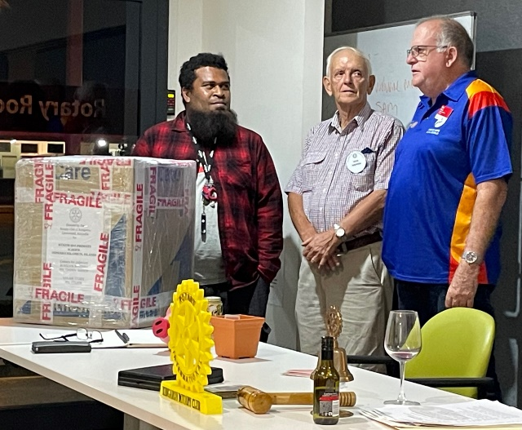
General Business:
- Gus – laptop project
  - Showed members box of 12 laptops that have been upgraded for use. They are to be sent to Honiara on Wednesday for use in Roy’s son’s school (that has no computers at all) in Honiara. Box is going in a shipping container from Toowoomba. Used to send items back to family members in Honiara.
  - There are more laptops too but need Dell power supplies
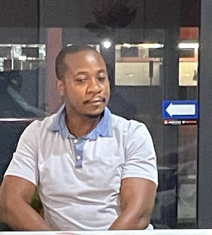
- Neil - PCA catering. Used chip fryer for the first time. Went really well. The Costco chips were excellent
- Geoff - Baine Marie. It has no safety tag & has a 15 amp plug. Must be repaired otherwise it will not be covered by insurance. Geoff will do repair & have it tagged. Moved Kerry & Sec Mark carried
- Ray – BBQ trailer. A few items to be updated

Guest Speaker – Murray Johnston OAM Award
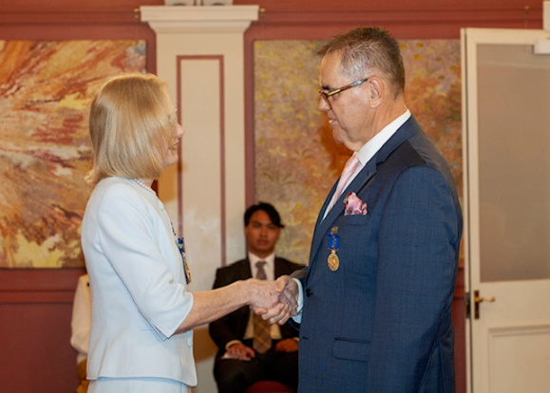
Murray was presented with an OAM (Medal of the Order of Australia-General Division) by Her Excellency the Honourable Dr Janette Young at Government House on 14 September.

He reported that it was an amazing and humbling experience for him and his family, who were there to share in the celebration.

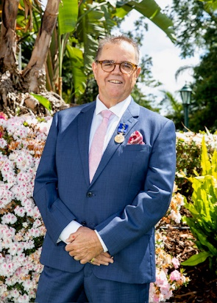
There was 1 AO recipient and 21 OAM recipients. Awardees were recognized for a wide range of community commitments, including - obstetrics & gynaecological research, /services to the Goomeri community (Judith Bandidt), service to women, indigenous communities, commmunity health, young musician education, emergency services, charitable organisations, sporting organisations & the transport industry.

Each person’s profile was read out and Her Excellency the Honourable Dr Jeanette Young warmly welcomed each awardee, presented them with their award and spoke with genuine interest to them about their work.

My profile listed the 5 schools I worked at (Nobby, Dirranbandi, Hebel, Formartin and Coolabunia) and my roles in the Kingaroy RC. I flew the flag for small schools and the impact of Rotary in our local community.

The King’s List this year included 1192 people across the Order of Australia categories. 157 were Queenslanders.
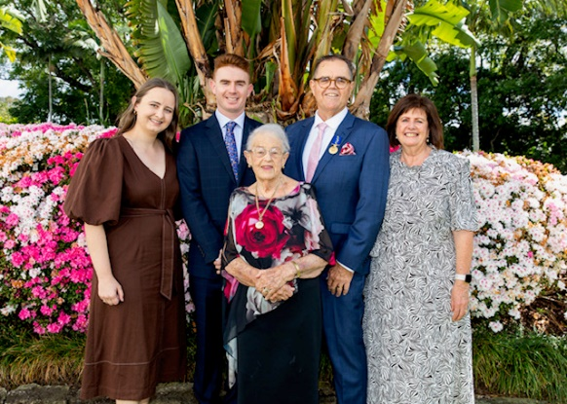
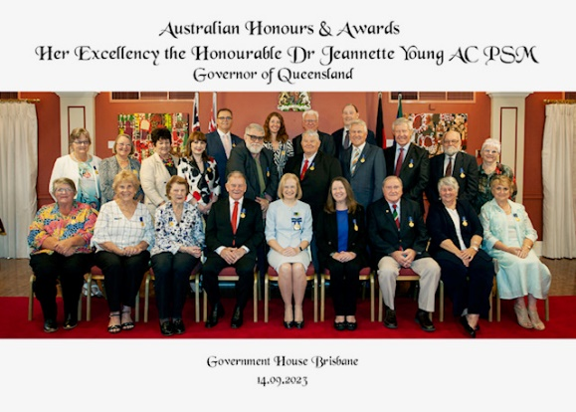

Card Draw: 7 clubs won by guest Morris Galafa

Fines
- Kerry fined Neil for PCA chip fryer pilot light difficulties - gas wasn’t on
- Neil fined Kerry as didn’t know how to complete the Induction form for the cooker

Meeting closed: 7.57pm

Cheers

Murray

Members need to let Kat know if not attending.
Reminders
• If you cannot attend a meeting, you MUST contact Kat by NOON on Monday!
• If you don’t cancel by noon you will be billed for a meal.
• New Bank account details
o Account Name: Rotary Club of Kingaroy Inc.
o BSB: 084 961
o Account Number: 254 905 213

Got recycling to drop off - Containers For Change Rotary Club of Kingaroy Account C10071454
(Please get a receipt and hand to Treasurer Mark)

• Make sure you wear your badge at every meeting. Makes it easier for guests.

Useful Rotary Websites
Club website www.kingaroyrotary.org.au
Rotary Foundation
- International www.rotary.org
- Australia www.rotaryfoundationaustralia.org.au

BIRTHDAYS – MEMBERS AND PARTNERS  Nil  ANNIVERSARIES  Nil  CLUB ANNIVERSARY  Nil |  | Attendance at each meeting is presumed unless you notify your absence to:  Kat – South Burnett Podiatry  Phone: 07 41627633 or 0417 627 316  Email: reception@southburnettpodiatry.com.au  Numbers need to be in by 12 noon.  The Four-Way Test  OF THE THINGS we think, say or do:  - Is it the TRUTH?  - Is it FAIR to all concerned?  - Will it build GOODWILL and BETTER FRIENDSHIPS?  - Will it be BENEFICIAL to all concerned?

C A L E N D A R

Date | Event | Time
24 October | KCCI event Bar | 5.00 – 9.00pm
26 October | Persuasive Speech competition Kingaroy SS | 4.00 start
4 November | Town Hall – bar and BBQ duties 10 workers | 5.00 – 9.30pm
6 November | Dinner Meeting  Persuasive Speech students | 6.00 for 6.30pm
11 November | Nanango IGA Sausage Sizzle Driver + 2 workers | 07:30 – 12:30
20 November | Meeting – no meal | 6.00 for 6.30pm
23 November | Town Hall Forecourt Meet & Greet Bar 4 workers | 4.30 – 7.00pm
25 November | Bunnings Sausage Sizzle Teams of 3 | 07:15 – 2:00
3 December | BBQ Pioneer Pk Nanango 3 workers | 3.00 – 5.00pm
4 December | Dinner Meeting – partners invited.  - Bursary Recipients attending | 6.30
8 December | Town Hall Bar 4 workers | 7.00 - 10.00pm
9 December | Nanango IGA Sausage Sizzle Driver + 2 workers | 07:30 – 12:30
14 December | Ham Wheel – Kingaroy Christmas Carnival  Min 8 workers | 6.00 – 9.00pm
15 December | Town Hall Event Bar 4 workers | 12.30 – 3.00pm
16 December | Nanango Races Bar 8 workers | 11.30 – 4.00pm
17 December | Christmas Party | 12.00 - ????
23 December | Bunnings Sausage Sizzle Teams of 3 | 07.15 – 2:00
?? December | Tarong Christmas Barbeque
13 January 2024 | Swickers Party @ Town Hall Bar  Min 4 workers | 6.00 – 11.00pm
20 January | Nanango Swim Club BBQ | TBA
4 May 2024 | Stanwell | Catering event for 1000
Legend

Bunnings
IGA
Nanango Races
Multiple Events on same day
Other events
Meetings

