President: Shekhar Mehta |  | The HUB  The weekly bulletin of  The Rotary Club of Kingaroy  28 February 2022
 | We give thanks to Rotary for good fellowship, the opportunity to serve our community and to do good in the world

Opened: President Kat Butcher opened the meeting at 7.02 pm and welcomed all members and guests.

Attendance: , Mark Huston, Ray Pitt, Ron Roberts, Geoff Hosking, Deb Hails, Vince Evans, Neil Black, David Black, Kat Butcher, Kerry Heit, Bev Watter, Gus Napier, Mark Pitt

Apologies: Murray Johnston, Anne Skinner, Allan & Carmel McKeering, Abby Andersson, Sandy Hoffman

Guests: Jerem Hinchliff (Active Citizen), Flynn Woodall (Active Citizen)

Birthdays: nil

Wedding Anniversary: nil

Club Anniversary: nil

International Toast: Mark Huston - Milton Rotary Club District 9980 New Zealand meet fortnightly on Monday nights at 6pm. A passing thought from one of their previous meetings ‘Success is the sum of small efforts repeated day in and day out’ – how true. Milton Rotary Club has raised 1.4 million dollars. They are aligned with the Otago Tramping Club. The tramping club is a nonprofit charity club. The funds they raise throughout the year on their many walks is distributed between Milton Rotary Club and Otago youth adventure trust. These funds are, in turn, put towards deserving youth and community projects throughout Otago. Something to consider Kingaroy – Maybe we should put our hiking boots on and do guided walks around the district and earn some money for Rotary. Thank you Mark.

Rotary Information: Ron Roberts.
Ron provided us with information about Australia’s past Rotary International President – Glen Kinross– Rotary Club of Hamilton. Glen was RI President 1997-98. His theme for that year ‘Show Rotary Cares – for your community; for our world; for its people. Glen has achieved some amazing things for Rotary, too many for me to list. He has a book ‘Glen Kinross History – Rotary’s Global History Fellowship’ written by Basil and Beth Shaw. This can be found on the internet. I’m afraid I would probably do this account of his life an injustice by trying to summarize it. Glen was in the furniture making business (a very successful one, I hear). Ron Roberts told us, he has the last Teak table made by Glen. A little bit of trivia. Thank you Ron for your informative talk.

5 Second Rule: All participants participated in questions like 3 cities in UK ; 3 singers; 3 things made of glass; 3 fashion accessories; 3 French Wines; 3 daily newspapers; 3 farm animals; 3 foods starting with C; 3 places to sleep; 3 brands ice creams; 3 things you do before leaving home; 3 things to do on an plane flight. Most of our Rotarians passed with flying colours. Don’t know if they will earn their Masters , but Kat is working on them. Thank you Kat.

Guest: Flynn – has had a good start to his university life. A project he had to do, was make an automated fire truck. If this comes to fruition, I’m sure our very own Rotarian David would be more than interested to put it to good use at his Rural Fire Station.

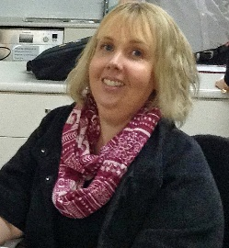
President: Kat
- PETS in Toowoomba on the 5 – 6 March Bev Watter attending this on behalf of the Club
- Reminder - Bookarama needs help on Friday (set up), Saturday and Sunday (pack up after 12) Refer to email sent out previously for information.
- Danita Potter wants to present Australia Day Award. Neil, Ron, Vince and Gus to receive the awards on Club’s behalf. Neil to arrange with Danita about same.
- Think about the email sent out last night from DG Wendy Protheroe - what can we do as Rotarians to help flood victims.

Treasurer: Mark Huston
- Members please ensure that you pay your fees – please contact Mark if you are unsure

Secretary: Bev Watter
- No report

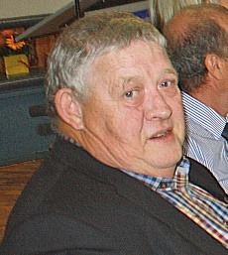
Vince Report:
- Acting for Murray in relation to Foundation – working on the movie night in March – Vince has suggested 2 dates – 14th or 21st March. These are Monday nights. Vince would appreciate help with this event as Murray is still not feeling well enough to resume his Rotarian duties. Murray is slowly progressing and will be back when he’s feeling better. Take care Murray. We miss you.

Community – Kerry
- No report We Have no fund raising events coming up apart from our Nanango IGA Sausage Sizzle- 12th March and 16th April Easter Saturday Nanango Races.

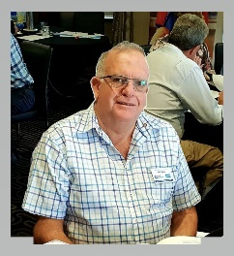
Neil Report:
- De Fib for Girl Guides; Money is still available for grants. Application needs to be lodged for defibrillator. Club members agreed with Neil to go ahead and lodge the application for same.

Youth – Deb Hails
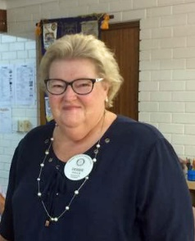
- Club shirt for Jerem has been ordered. Thank you, Deb and Vince. Rotary breakfasts are back at school and Rotary readers will start again on 7/03/22

Club Membership - Ray
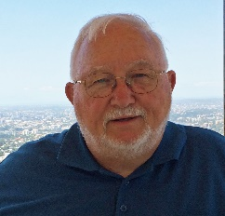
- Has been getting enquiries via FB page. Jenny Thompson from Hamilton SA is in the district for 4 weeks. Would love to attend a meeting if and when we get back to SB Care. Hopefully soon. I think our members are missing Judy’s cooking. There are several guest speakers lined up for our meetings.
- Hands on Project – Seat besides old PO needs to be replaced. Neil and Mark Pitt to investigate it.

Vocation: Dave
- No Report

Other Business:

- Blaze Aid – thanks for the calendars – very thankful.
- Gus – Meals for homeless are going slowly. Unfortunately, he had to do it on his own last week as the club responsible for that week, didn’t show.
- Geoff – RYDA – New form to be completed, which he will see to.

Meeting Close: 7.50 pm

FOOD FOR THOUGHT:- Handle every stressful situation like a dog. If you can’t eat it or play with it, just pee on it and walk away.
Cheers,
Bev

BIRTHDAYS – MEMBERS AND PARTNERS  Nil  WEDDING ANNIVERSARIES  Nil  CLUB ANNIVERSARIES  Sandy Hoffman 8 March 1 year  Allan & Carmel McKeering 15 March 1 year  Deb Hails 17 March 14 years | Attendance at each meeting is presumed unless you notify your absence to:  Vince Evans  Phone: 0499 366 007  Email: evansvlj@bigpond.com.au  The Four-Way Test  OF THE THINGS we think, say or do:  - Is it the TRUTH?  - Is it FAIR to all concerned?  - Will it build GOODWILL and BETTER FRIENDSHIPS?  - Will it be BENEFICIAL to all concerned?

Club Meeting Details
28th Feb | Zoom Meetings until clearance from SB Care 7.00pm – we will let people know the venue

UPCOMING EVENTS – ACTIVITIES – PROJECTS – HAPPENINGS
DATE | CONTACT PERSON | DETAILS OF ACTIVITY
12 March | David & Bev | Nanango IGA – Sausage Sizzle
16 April | David & Bev | Nanango Races – Bar Work

