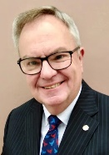  RI President: R Gordon R McInally |  | The HUB  The weekly bulletin of  The Rotary Club of Kingaroy  4 December 2023  Chartered 8 December 1948  Proud sponsor of the Rotary Satellite Club of Kingaroy Sunrise  Chartered 30 July 2022  “RI President R. Gordon R. McInally calls for Rotary to create hope in the world by working for peace and mental wellbeing. He urges members to engage in tough conversations and earn the trust that’s necessary to realize these values.” | 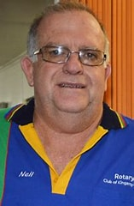  Club President: Neil Black
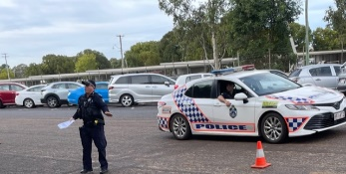
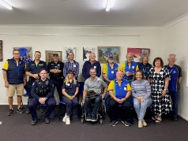
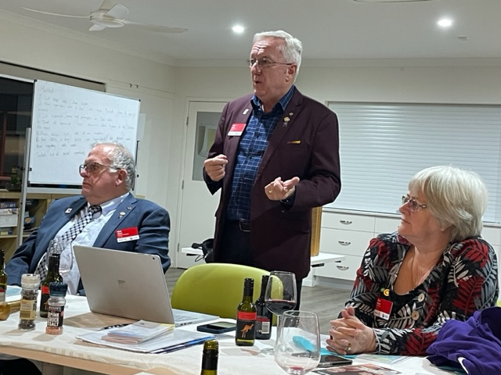

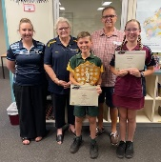
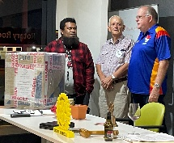
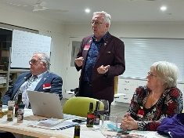
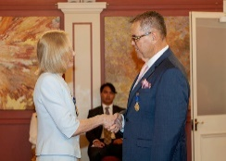
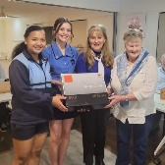

We give thanks to Rotary for good fellowship, the opportunity to serve our community and to do good in the world.

The General meeting (and last for the year) was opened by President Neil Black at 6.37pm. All members and guests were warmly welcomed. What a great attendance!

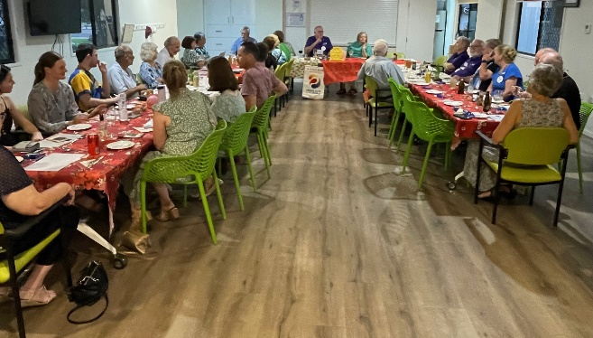
Attendance: Neil Black, Kerry Heit, Ray Pitt, Gus Napier, Geoff Hosking, David Black, Bev Watter, Murray Johnston, Deb Hails, Carmel McKeering, Ian Hall

Guests:
- Deb Hails introduced club Bursary students – Jade Zischke, Flynn Woodall, Abbey Kapernick, 2023 recipient Charlotte Landherr + parents Adrian & Emma & brother Will
- Partners & family members - Dianne Kowalski, Warren Hosking, Pat Pitt, Lyall Black, Margaret Huston, Sue Johnston, Allan McKeering, Ros Heit, Cath Roberts, Abby & Elleanor Andersson
- Emma Lindholm (Kingaroy SHS Active Student) + Justine Evangelista

Members on Leave: Lex Petersen

Apologies: Bursary recipient Zach Night, Anna Faunt, Brett Otto, Kat Butcher, Mark & Nicola Pitt
Birthdays;
4 December Lex Petersen
20 December Kat Butcher
27 December Gus Napier

Wedding Anniversary: 10 December Mark & Margaret Huston

Club Anniversary: 10 December 2018 Kerry Heit

Rotary Information
Ron challenged members to think about why we need to update how we Rotarians do things.
One of the problems we face is membership numbers not keeping up pace with a growing population. 3 in every 10 Australians are volunteers. Rotarians need to consider ways to tap into this large number of people to boost membership.
One of Rotary’s strategic goals is to increase the ability to adapt. Today, people want to be a part of an organization that welcomes diverse perspectives and provides value. They want opportunities to serve, lead and network, but not necessarily within a rigid hierarchy. So, in 2018 the Rotary Board of Directors tasked the Shaping Rotary’s Future Committee with developing an innovative plan to enhance the current membership experience, improve our ability to adapt and create a structure that attracts and engages new participants for generations to come.
…more next meeting

President: Neil Black
- Neil asked Deb to report on Kat’s progress – she has been very unwell over the last 4 weeks with a CO₂ build-up in her lungs and is currently in the ICU @ St Vincents Hospotal in Toowoomba. Kat’s mother reported today that Kat was sitting up when she arrived and was more positive. Progress is very slow at this stage.
- Outbound Youth exchange visit today – Neil indicated that the current outgoing students are the first since Covid. Quite significant! The students (Sean, Hugh, C….. and James are heading off to Brazil, Denmark and Japan. Neil thanked Deb for coordinating the lunchtime event and members for their support. Neil accepted a Certificate of Appreciation from the students. The SBRC also provided a Sth Burnett Gift pack.

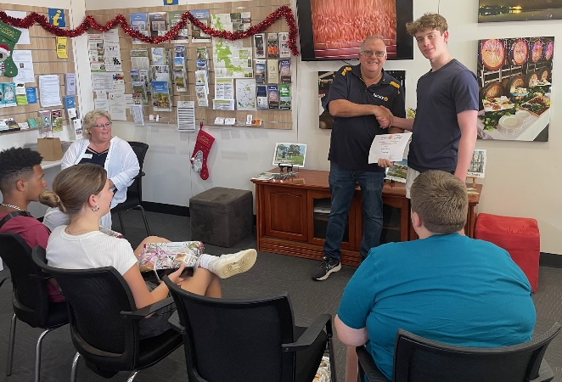
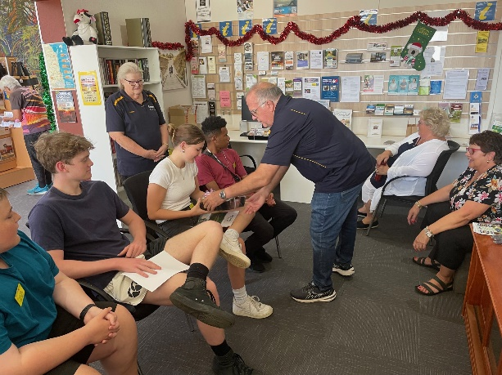

- Neil thanked Mark, Margaret and Bev for their work at the Nanango Recital yesterday. A very successful BBQ

- Thanked past member Abby Andersson for storing RARE equipment. Abby invited members to Toastmasters Christmas function this Thursday.

- Minutes of the previous meeting were accepted as a true & correct record. Moved: Mark & Seconded: Murray. Approved

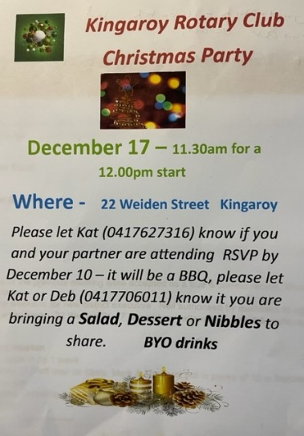
Acting Secretary: Deb
- 17 December Rotary Christmas Party 22 Weiden St.
- Please now contact DEB HAILS re attendance. Not Kat
- List sent around re salad or dessert

Treasurer: Mark Huston
No report

Directors Reports

Community Projects: Bev Watter:
- Thanked recent Bunnings workers
- Thanked Mark & Margaret for Nanango Recital help
- 9 Dec workers for Orana BBQ needed Deb Ray Lyall Ian
- Extra workers for Tarong needed. So far Bev, Slip, David & Des Cook, Neil, Ray, Ian, Gus, Kerry
- Ham Wheel - 53 hams Murray Deb Margaret
- Bunnings 5-7 this Thursday - Bev, Dave, Ray

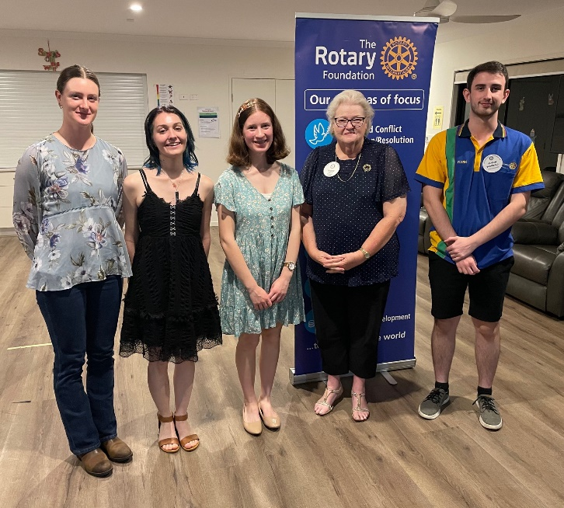

Youth: Deb Hails Bursary Students
- Deb was delighted to introduce the club’s 4 Bursary students to the meeting
- Bursary students are selected from Kingaroy SHS each year and receive $1000 for 4 years to support them in their university studies.
- Each student was asked to speak briefly about their studies this year and highlight particular points of interest…

- Jade Zischke (4th year in 2024) is at UQ studying Bachelor of Molecular Science. She finds her studies more exciting each year. Kade is micro lab technician at present. Two highlights this year were a developmental brain science course and animal movements and populations investigations
- Flynn Woodall (3rd year 2024) is at UQ Studying Chemical Engineering with an environmental focus. Highlights have been metallurgy studies and connecting with industry. He also really enjoyed environmental subjects
- Abbey Kapernick (2nd year in 2024) is at UQ Gatton studying Agricultural Science with an agronomy focus. This year she has had a focus on basic biology and farming principles. She enjoys lots of hands on work as she has a farming background
- Zac Knight (2nd year in 2024) was unable to attend as he is currently at Cairns hospital completing a GP placement and general surgery experience. He did however supply Deb with a report – been a really interesting semester studying reproduction, pathophysiology and skeletal systems. He is President of the student body
- Charlotte Landherr (1st year in 2024) Hasn’t yet received Yr 12 results but plans for study medicine at JCU in Townsville. She wants to focus on rural medicine as there is such a huge need in rural areas. Charlotte’s JCU interview is tomorrow.
- Deb thanked the students for their dedication to their studies and taking the time to meet with us to share some of their experiences. Mark gave each student a new club calendar

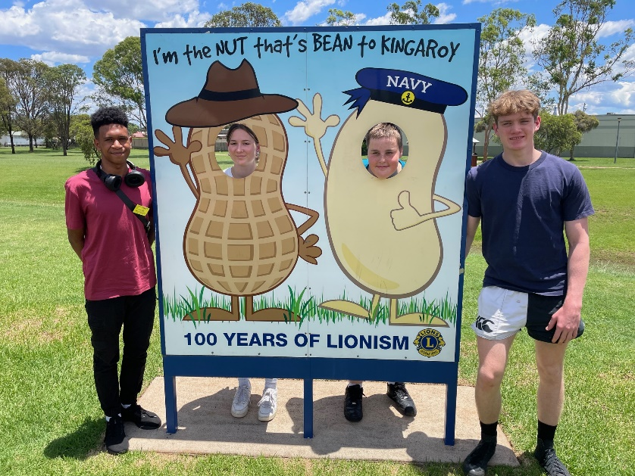
- Outbounder visit today – Deb, Mark, Margaret and Murray hosted lunch and a tour of the local Historical museum for 4 outbound students today. They are amongst the first group of outbounders since Covid. The students had been to a training weekend at Lake Perseverance and were heading to Tin Can Bay. As Neil indicated, each student received a gift of local products from the SBRC. The students presented President Neil with a Certificate of Appreciation.
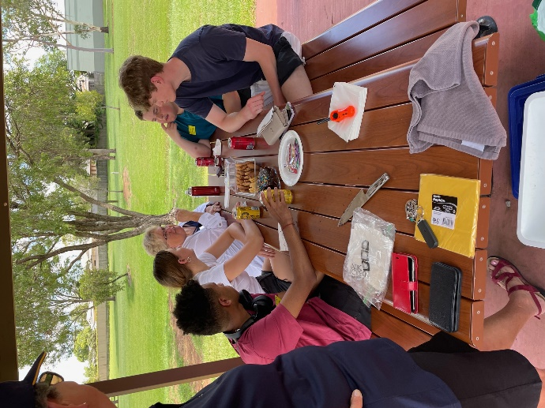
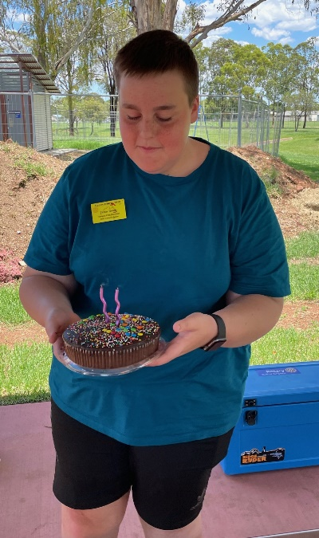
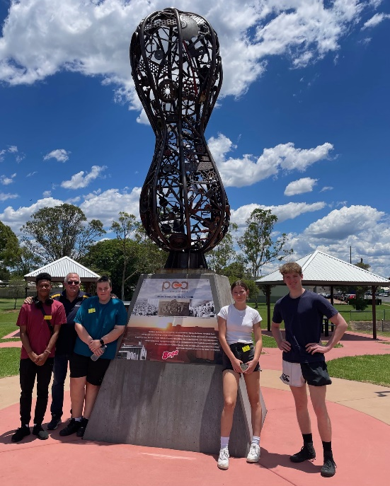
- Destinations - Sean (from PNG) is off to Brazil, Cinthia & Hugh to Denmark and James to Japan. It was James’ birthday today too. What an exciting year ahead!

- Letter of thanks received from students & staff from KSHS for supporting Speech Night

- Murray informed members that RYDA 2024 will be held at Kingaroy SHS again with 412 students attending. Dates are 30 April & 1 May.

Rotary Foundation: Kerry Heit
Nil

Interact: Carmel
This year donations were to give Canowindra Aged Care facility a table setting (which was presented on assembly) and give $200 to the RSCPA. Some funds left to start 2024. Last day of year 12 water balloon toss at teachers fund raiser was an amazing success.
Containers for Change – there were always bad smells when cleaning containers. Became a good detention activity. Now CFC comes to the school to sort & remove containers. Much better!

Membership: Ray Pitt
No report

General Business:
None
Lucky Door Prize Draw Won by no. 55 Pat Pitt

Card Draw: 4 clubs Marg Huston

Fines:
Nil

Meeting closed: 8.20 pm

Cheers

Murray

Members need to let Kat know if not attending.
Reminders
• If you cannot attend a meeting, you MUST contact Kat by NOON on Monday!
• If you don’t cancel by noon you will be billed for a meal.
• New Bank account details
o Account Name: Rotary Club of Kingaroy Inc.
o BSB: 084 961
o Account Number: 254 905 213

Got recycling to drop off - Containers For Change Rotary Club of Kingaroy Account C10071454
(Please get a receipt and hand to Treasurer Mark)

• Make sure you wear your badge at every meeting. Makes it easier for guests.

Useful Rotary Websites
Club website www.kingaroyrotary.org.au
Rotary Foundation
- International www.rotary.org
- Australia www.rotaryfoundationaustralia.org.au

BIRTHDAYS – MEMBERS AND PARTNERS  4 December Lex Petersen  20 December Kat Butcher  27 December Gus Napier  ANNIVERSARIES  10 December Mark & Margaret Huston  CLUB ANNIVERSARY  10 December 2018 Kerry Heit |  | Attendance at each meeting is presumed unless you notify your absence to:  Kat – South Burnett Podiatry  Phone: 07 41627633 or 0417 627 316  Email: reception@southburnettpodiatry.com.au  Numbers need to be in by 12 noon.  The Four-Way Test  OF THE THINGS we think, say or do:  - Is it the TRUTH?  - Is it FAIR to all concerned?  - Will it build GOODWILL and BETTER FRIENDSHIPS?  - Will it be BENEFICIAL to all concerned?

C A L E N D A R

Date | Event | Time
7 December | Bunnings PR & Calendar sales – Bev, Dave Ray | 5.00 – 7.00pm
8 December | Town Hall Concert – Leaving Jackson Johnny Cash show Bar Workers – Mark & Margaret, Anna, Bev, Neil, Emma, Gus | 7.00 - 10.00pm
9 December | Orana BBQ Workers Bev, Deb, Ray, Lyall, Ian | 7.00 – 12 noon
14 December | Ham Wheel – Kingaroy Christmas Carnival  Workers – Bev, Anna, Deb, Murray, Helen, Mark & Margaret, Ian, David – all Club members please  Tarong Christmas Party  Workers – Bev, Slip, David & Des Cook, Neil, Ray, Ian, Gus, Kerry | 6.00 – 9.00pm  11.00 – 3.00pm
15 December | Town Hall SBRC Christmas party Bar Workers – Mark, Margaret, Bev & Helen | 12.30 – 3.00pm
16 December | Nanango Races Bar  Workers – Bev, Vince, Mark, Margaret, David, Koray, Michael, Craig & maybe Flynn | 11.30 – 4.00pm
17 December | Christmas Party | 11.30
23 December | Bunnings Sausage Sizzle  Workers – Bev, Anna + 2 more workers please | 07.15 – 2:00
13 January 2024 | Swickers Christmas Party @ Town Hall Bar  Workers – Mark, Margaret, Bev + 1 more please | 6.00 – 11.00pm
20 January | Kingaroy Swim Club BBQ  Workers – Mark, Margaret, Bev | TBA
30 Ap & 1 May | RYDA @ Kingaroy SHS SB High schools
4 May 2024 | Stanwell | Catering event for 1000

Legend

Bunnings
IGA
Nanango Races
Multiple Events on same day
Other events
Meetings

