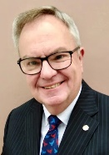  RI President: R Gordon R McInally |  | The HUB  The weekly bulletin of  The Rotary Club of Kingaroy  5 February 2024  Chartered 8 December 1948  Proud sponsor of the Rotary Satellite Club of Kingaroy Sunrise  Chartered 30 July 2022  “RI President R. Gordon R. McInally calls for Rotary to create hope in the world by working for peace and mental wellbeing. He urges members to engage in tough conversations and earn the trust that’s necessary to realize these values.” | 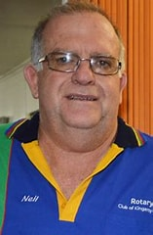  Club President: Neil Black
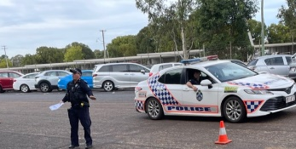
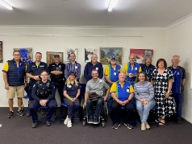
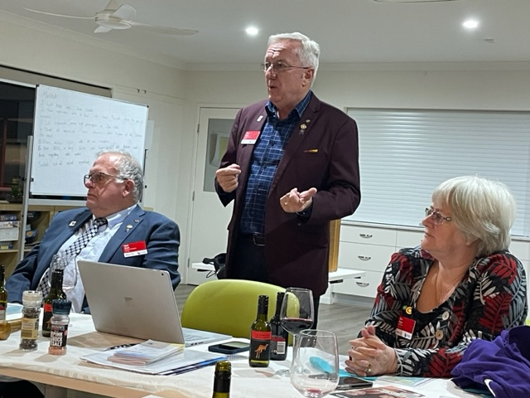

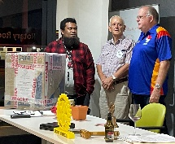
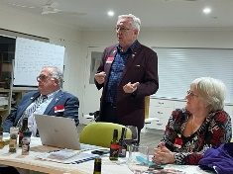
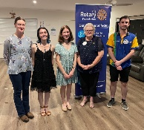
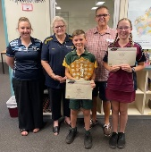
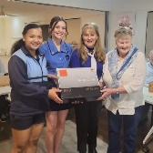

We give thanks to Rotary for good fellowship, the opportunity to serve our community and to do good in the world.

The General meeting was opened by President Neil Black at 6.37 pm. All members and guests were warmly welcomed.

Attendance: Neil Black, Mark Huston, Kat Butcher, Kerry Heit, Ray Pitt, Geoff Hosking, Murray Johnston, Deb Hails, Carmel McKeering, Ron Roberts, Gus Napier

Guests: Brian Tessmann, Dennis Cupitt, Bev Napier, Cath Roberts, Pat Pitt, Ros Heit, Nicola & Mark Pitt, Koray Akdogan & Craig Harvey (Harvey Norman), Di Kowalski, KSHS Active Citizen Emma Lindholm & friend Justine Evangelista, NYSF student Mia De Guzman & parents Evalyn & Philip, President RC Honiara Lawrence

Members on Leave: Lex Petersen
Apologies: Anna Faunt, Brett Otto, Bev Watter, David Black, Ian Hall

Birthdays:
11 February David Black 12 February Ros Heit

Wedding Anniversary:
Nil

Club Anniversary:
Nil

Rotary Information: Ron Roberts
Step right up 2: In Rotary’s membership game, everyone’s a winner – more ideas for clubs

Create a list of all the great things about your club
The point is not just growing your club, but boosting Rotary’s capacity to make a difference around the world.
List your star members, the advantages of your meeting location, how many members you have, the kinds of projects and events you host, and so on. The list can serve as a template when sending an email or letter to a potential member. Make sure to tailor any correspondence so it addresses the specific interests and wants of any potential member. For instance, if someone is interested in international work, your email or letter should focus on that.

Keep a list of potential members
It doesn’t matter if it’s a paper list or if it’s kept on the desktop of your computer. Either way, it makes you think about those people who might be a fit for your club. Discuss the list at board meetings – not just the concept of bringing in new members, but the specific names and who’s going to contact them and when. And don’t overlook some obvious suspects, such as members’ spouses, Youth Exchange host parents – “they already have a taste of what Rotary is about” – and even former members. “We had two founding members rejoin recently,” Gump says. “Sometimes people need to leave for a reason and then later they have more time and just have to be asked to come back.”

Know your club’s strengths
Most things are strengths if you target the right audience. If you meet in the morning, you’re probably a good fit for someone working 9 to 5. Meet at noon and you’re more likely to appeal to retirees or parents of schoolchildren. “Not every club is right for every potential member,” Gump says. “If someone doesn’t fit your format, recommend them to another club.” Keep in mind that the point is not just growing your club, but boosting Rotary’s capacity to make a difference in communities around the world. And with any luck, that other club will send you a potential member one day. Gump points to one member who joined his club last year after a recommendation from the Rotary Club of Edina, which typically meets middays. “Morning meetings worked better for him than noon meetings,” Gump says. “He has already become a Paul Harris Society member, leads our beer tasting committee, and led our 100th anniversary celebration for The Rotary Foundation.”
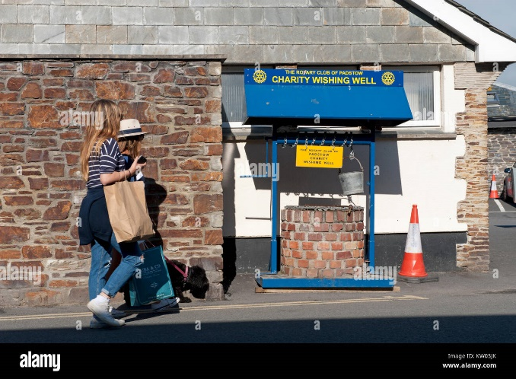
International Toast:
Murray proposed an International Toast to the Rotary Club of Padstow in Cornwall, UK.

Tonight, we focus on Rotary in the hometown of one of the finest seafood chefs and travel presenters in England – Rick Stein. Rick Stein started his restaurant life with Rick’s Chippy in 1975. Today in Padstow he still owns Rick’s Chippy as well as a seafood restaurant, a fishmonger’s business, a 40 room hotel, several B&B’s, 4 shops and a cookery school. He also owns 10 other restaurants around the world including 2 in Australia.

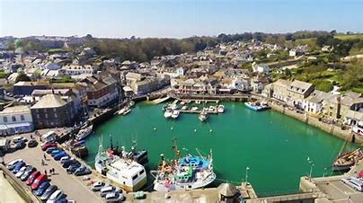
These enterprises are just a small part of the delightful seaside village of Padstow. When in Cornwall, you just have to go to Padstow and eat at Rick’s restaurant! What a great place for a rotary club.
The RC of Padstow No. 1262 in District 1290 was chartered in 1976. Padstow Rotary Club has always played an important part in the life of the local community. It is active in fundraising for charity and has been very supportive of local causes, particularly those involving the young and the old. An average of £20,000 is distributed annually to local charities.
The Club has a full and varied social calendar with speakers attending club meetings, visits to places of interest and in the past had a special entente cordial with Rotary Club of Concarneau in Brittany. It is hoped that in the future a relationship might develop with Padstow NSW. Yes, there is a Padstow club in Sydney, NSW, that was sponsored by the RC of Bankstown in 1957.
Recent club achievements include – lighting up the harbour with a 4000 coloured lights display, Midsummer music festival, RYLA involvement, Music in the Park Festival, supporting local Sea Cadets, Youth Speaks Speech Competition, Padstow in Bloom Garden Competition and running an interclub bowls competition.
The RC of Padstow meets at the Golden Lion Hotel each Tuesday at 6.00pm. No doubt excellent seafood is often on the menu. Poor buggers!!

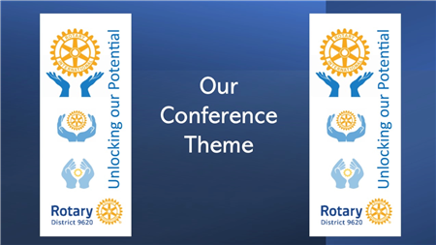
Next meeting’s toast will be proposed by Kerry Heit

President: Neil Black
- Reminded members about the upcoming District Conference which is being held at Seaworld 8 – 10 March
- Conference raffle tickets 6 for $10. See Neil

Secretary: Kat
- Minutes of the previous meeting were accepted as a true & correct record. Moved: Kat & Seconded: Murray
- Preparations for changeover 15 June at the Town Common Hall are underway
- 75th club birthday – will book Kingaroy Town Hall
- All General & Dinner Meeting dates are in the Calendar in The Hub

Treasurer: Mark Huston
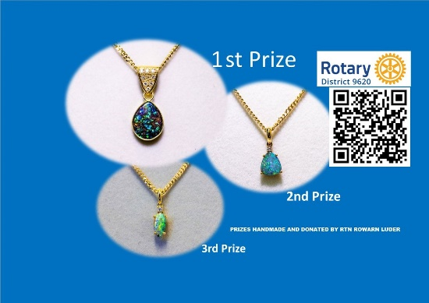
- A few outstanding membership fees due
- Calendars – all unsold calendars to come in please

Directors Reports

Community Projects: Bev Watter:
- Unfortunately, our Bunnings SS on January 28 had to be cancelled due to inclement weather. Thank you to the volunteers Ray, Murray, Kerry, Anna who put their hands up to help. Never fear we have the next one on Sunday February 25 where you can practice your cooking skills on the bbq.
Please let me know if you are available for same as soon as
possible.
Volunteers so far are Ray, Neil & Emma

- This Saturday February 10 we have Nanango IGA SS, thank you to Geoff, Ian & Cath for volunteering. David will meet you at the IGA to help you set up.

- We also have Nanango races on the same day and my thanks go to David, Anna & Brett, Neil, Gerard and I’ll be there as well.

Thanks to all our volunteers, Rotary is alive and active in this great community of the South Burnett.
Cheers Bev
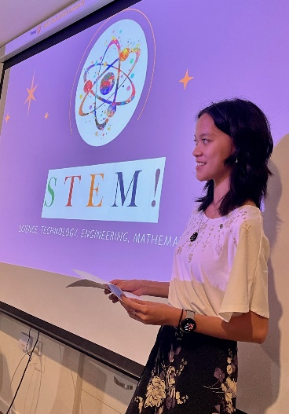
Youth: Deb Hails – Guest Speaker - NYSF student Mia De Guzman
The club proudly sponsored Mia’s attendance at this year’s recent NYSF experience.

NYSF stands for National Youth Science Forum. It is a not-for-profit organisation that runs programs at universities around the country to encourage young people in their passion for science. Rotary was a founding partner in 1984.

The program targets Yr 11 students going into Yr 12 and is designed to offer insight into career options in maths, science & technology.

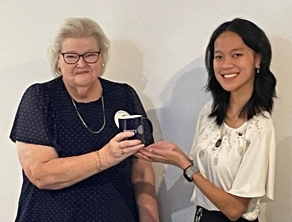
Our club has had a long-standing commitment to providing opportunities like this (and others) to the youth of the Sth Burnett. It is ALWAYS a great investment in our youth!

Mia gave an outstanding presentation of her NYSF experiences and plans for the future…

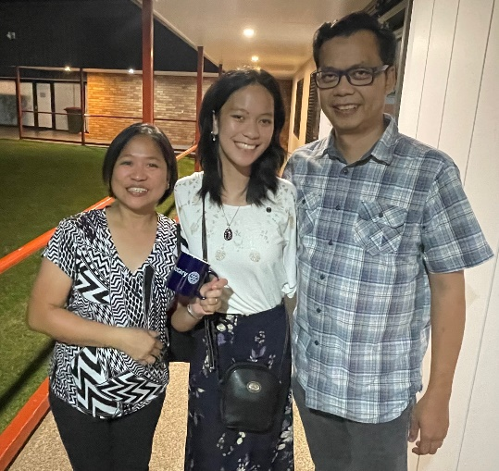
- Currently a student at St Mary’s CC
- SB region’s Young Citizen recipient
- Loves STEM (Science Technology Engineering Mathematics) and has interests in psychology, quantum computing, maths, biology… just to name a few

NYSF Highlights
- STEM visits – Qld Museum, Pathology Learning Centre (held a real heart), ARC centre for plant success, Psychology & Neuroscience speakers
- Debates on ethics in STEM
- STEM communications session
- Keynote speakers
- Specialist lectures – bioorganic chemistry, how fish see the word
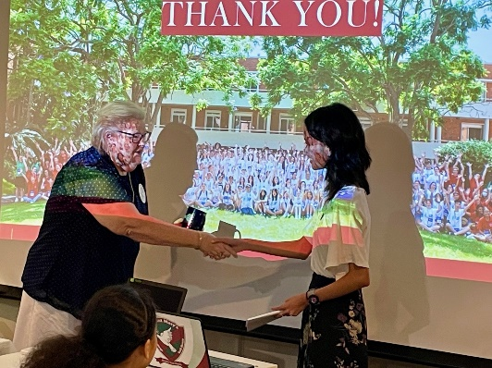
- Careers day – opportunities to speak with experts about what they do
- Stayed at King’s College – great accommodation. Food, disco & concert
- Supportive Staffies – met several UQ student volunteers
- Making lifelong friends

A few interesting facts…
13% of rural students are studying stem courses at present
15% of STEM enrolments are held by women
27% of the STEM workforce are women
45% of NYSF students are rural
65& of these are women

Rotary Foundation: Kerry Heit
Nil

Interact: Carmel
- Interact 2024 is well underway!

Membership: Ray Pitt
- Welcomed prospective members. Still working on further new memberships.
- Looking for further topics and guest speakers for future dinner meetings
Satellite club
- 23 March Vocational Training Awards night report by Mark Pitt
  - Good nominations coming in
  - Still need more school-based apprenticeships nominations
  - Nominations close this Wednesday 7 February
  - Principal sponsor to be announced shortly
  - There is great widespread support for this event and its purpose
- Neil thanked Mark and the Satellite Club for its outstanding efforts to make this such a success

General Business:
Gus
- The Support Alliance – got charity status today. A long time coming, but well worth it
- Kerry suggested members recognise Gus’s efforts and determination in his project. A hearty round of applause and congratulatory comments were directed to Gus

Guest Speaker – Lawrence Fatiaki, President of the RC of Honiara
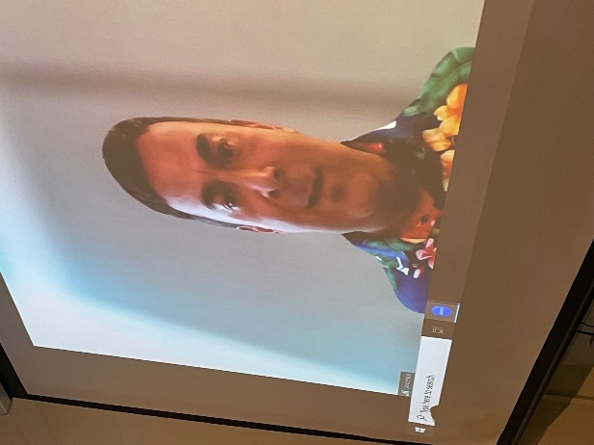
Introduced by Gus Napier
- Gus introduced members to President Lawrence Fatiaki on Zoom.
- Gus has been working on providing laptops (sourced mainly so far, from St Mary’s CC) to the Kukim Valley SDA Primary School in the Solomon Island through the RC of Honiara. This joint project has provided 12 computers for this school of 600 upper primary students and their teachers
- Lawrence reported on the setting up of the lab for the upper primary students & teacher use. He considered the set up as impressive. There are always management issues to contend with but all is going well thanks to the husband of the Principal’s husband, who is the IT technician for the local state central bank
- Internet access for schools in the major towns and cities varies a lot but is reasonable. In rural areas it is non-existent
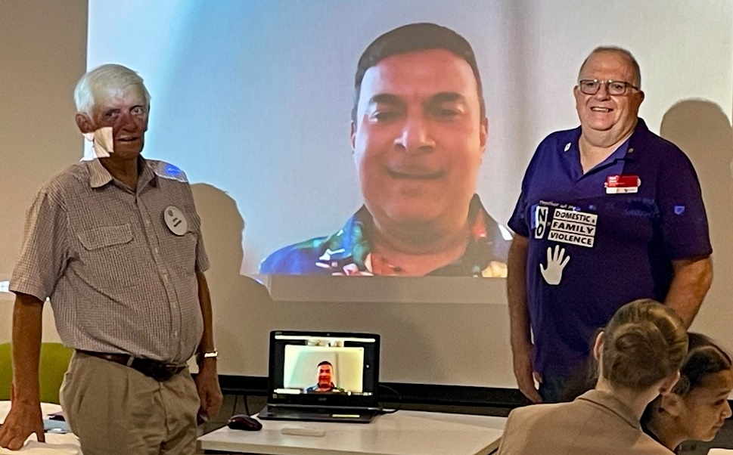
- Power blackouts are an issue for them, though not so bad in Honiara itself following infrastructure improvements for the Pacific Games, so laptops (with batteries) are more useful. Surge protectors would be useful too
- Freight costs for larger units are prohibitive
- Technical support can be challenging as is software. This school has a Microsoft Office license
- Until now, the school only had 4 computers in total, with only two working
- Gus has another 12 ready to go to another school
Gus & Lawrence are developing ties with a local Rotaract club to eventually become involved in project – over 100 members. They are a great source of IT skills
- Gus has been working tirelessly on this project for quite a while. Congratulations on your determination Gus!
- If anyone you know has surplus laptops, dead or alive, please let Gus know and he will collect them. Dead ones often provide the parts to fix other dead ones.

Card Draw:
Q diamonds Mark Huston

Fines:
Nil

Meeting closed: 8.20 pm

- Next General meeting 19 Feb

- Next Dinner Meeting 4 March Guest speaker is Tony Heading from the RC Burleigh Heads

Topic - The Rotary Foundation

Cheers

Murray

Members need to let Kat know if not attending.
Reminders
• If you cannot attend a meeting, you MUST contact Kat by NOON on Monday!
• If you don’t cancel by noon you will be billed for a meal.
• New Bank account details
o Account Name: Rotary Club of Kingaroy Inc.
o BSB: 084 961
o Account Number: 254 905 213

Got recycling to drop off - Containers For Change Rotary Club of Kingaroy Account C10071454
(Please get a receipt and hand to Treasurer Mark)

• Make sure you wear your badge at every meeting. Makes it easier for guests.

Useful Rotary Websites
Club website www.kingaroyrotary.org.au
Rotary Foundation
- International www.rotary.org
- Australia www.rotaryfoundationaustralia.org.au

BIRTHDAYS – MEMBERS AND PARTNERS  11 February David Black  12 February Ros Heit  ANNIVERSARIES  Nil  CLUB ANNIVERSARY  Nil |  | Attendance at each meeting is presumed unless you notify your absence to:  Kat – South Burnett Podiatry  Phone: 07 41627633 or 0417 627 316  Email: reception@southburnettpodiatry.com.au  Numbers need to be in by 12 noon.  The Four-Way Test  OF THE THINGS we think, say or do:  - Is it the TRUTH?  - Is it FAIR to all concerned?  - Will it build GOODWILL and BETTER FRIENDSHIPS?  - Will it be BENEFICIAL to all concerned?

C A L E N D A R

Date | Event | Time
5 Feb | Dinner meeting | 6.00 for 6.30pm
10 Feb | Nanango Races
10 Feb | Nanango IGA BBQ
19 February | General meeting | 6.00 for 6.30pm
25 Feb | Bunnings BBQ | 7.00am – 2.00pm
4 March | Dinner meeting | 6.00 for 6.30pm
18 March | General meeting | 6.00 for 6.30pm
8 April | Dinner meeting | 6.00 for 6.30pm
15 April | General meeting | 6.00 for 6.30pm
29 April | General meeting (possible due to public holidays) | 6.00 for 6.30pm
30 Ap & 1 May | RYDA @ Kingaroy SHS SB High schools
4 May 2024 | Stanwell | Catering event for 1000
13 May | Dinner meeting
20 May | General meeting | 6.00 for 6.30pm
3 June | Dinner meeting | 6.00 for 6.30pm
15 June | Changeover meeting + 75th celebrations | 6.00 for 6.30pm
17 June | General meeting | 6.00 for 6.30pm

Legend

Bunnings
IGA
Nanango Races
Multiple Events on same day
Other events
Dinner Meetings
General
Meeting

