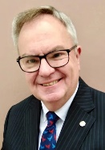  RI President: R Gordon R McInally |  | The HUB  The weekly bulletin of  The Rotary Club of Kingaroy  6 November 2023  Chartered 8 December 1948  Proud sponsor of the Rotary Satellite Club of Kingaroy Sunrise  Chartered 30 July 2022  “RI President R. Gordon R. McInally calls for Rotary to create hope in the world by working for peace and mental wellbeing. He urges members to engage in tough conversations and earn the trust that’s necessary to realize these values.” | 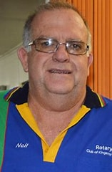  Club President: Neil Black
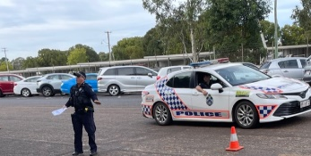
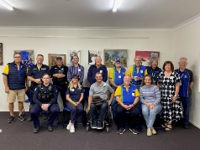
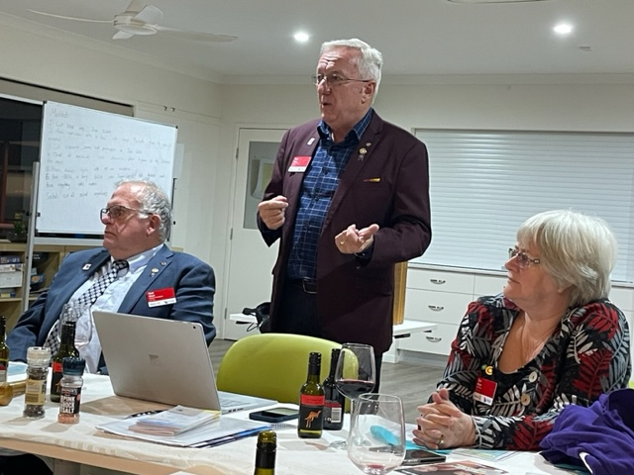

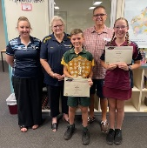
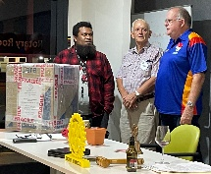
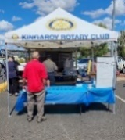
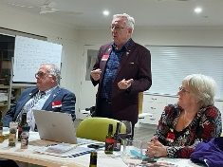
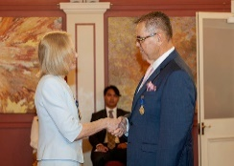
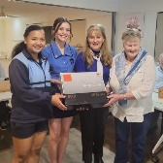

We give thanks to Rotary for good fellowship, the opportunity to serve our community and to do good in the world.

The General meeting was opened by President Neil Black at 6.32pm. All members and guests were warmly welcomed.

Attendance: Neil Black, Kerry Heit, Ray Pitt, Gus Napier, Geoff Hosking, David Black, Bev Watter, Kat Butcher, Murray Johnston, Deb Hails, Lex Petersen

Guests:
- Deb Hails introduced winner & runner-up from District Primary Schools Persuasive Speech Competitors and their parents – Jake Pickels Coolabunia SS and mum Bec + Teegan Starkey Nanango SS and mum Bree
- Visitors from Harvey Norman – Koray Akdogan, Michael Ryan and Craig Harvey
- Partners & family members - Dianne Kowalski, Marian Petersen, Sandy & Allan Salty, Pat Pitt, Lyall Black, Margaret Huston and Bev Napier
- Emma Lindholm (Kingaroy SHS Active Student)
Members on Leave: Ron Roberts

Apologies: Anna Faunt, Brett Otto

Birthdays;
16 November Ron Roberts
18 November Sue Johnston
19 November Allan McKeering
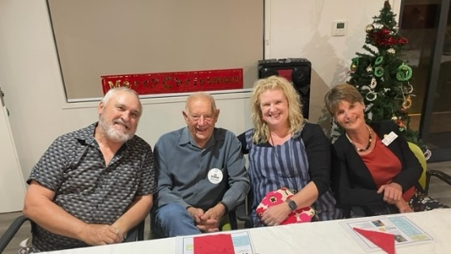
Wedding Anniversaries: Nil

Club Anniversaries: 1 November 1971 Lex Petersen

International Toast – President Neil proposed a toast to the Rotary Club of Chinchilla for supporting Tara during the bushfires. A job very well done, along with many other community groups.

President: Neil Black
- Thanked everyone for helping on Saturday’s bar & BBQ at the Town Hall – including Marian, Sandy, Emma; and Koray, Michael and Craig from Harvey Norman. A big day with a healthy profit for the club.
- Thanked Ray for helping him run a BBQ at Childcare Centre recently
- District AGM is on this Sunday
- Our AGM on 20 November
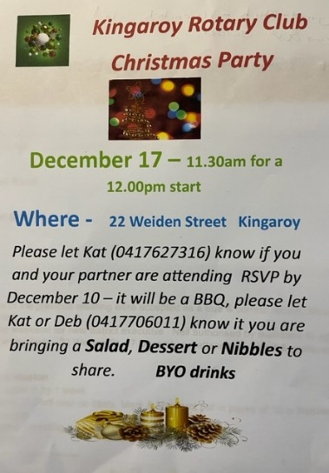
- Friday – will be a drought community fund raiser in Toowoomba
- 8 November Foundation Dinner Brisbane
- Thanked Bev for all her efforts recently. Very hard worker. Much appreciated by all members

Secretary: Kat Butcher
- Minutes of the previous meeting were accepted as a true & correct record. Moved: Kat & Seconded: Murray
- Vote this weekend for new district executive. Neil authorised by members to do so on our behalf
- 17 December Rotary Christmas Party 22 Weiden St. Attendance & menu contribution choices sheet circulated. For those absent, see the poster here and call Kat ASAP please.

Treasurer: Mark Huston
- T-shirt orders in by 1 week please. Response has been good so far. Thanks members
- Weekend’s 217 left over rib fillets. Mark & Margaret put in packs of 10 in freezer. Clearly labelled
- Cans etc for recycling collection to happen this week

Directors Reports

Community Projects: Bev Watter:
- Also thanked all helpers on Saturday - 12 workers
- Thank Marian & Cath Roberts for their time
- Harvey Norman helpers Koray, Michael and Craig are helping at the next Nanango Races
- 11 Nov IGA sausages - workers OK
- 18 Nov - Sausage sizzle at Harvey Norman A new event to the calendar
- 23 Nov Meet & Greet at Town Hall - workers OK
- Dec is really busy and we need all hands on deck please
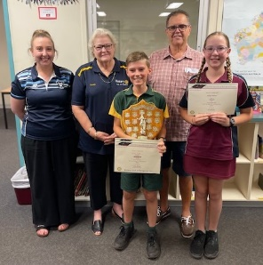
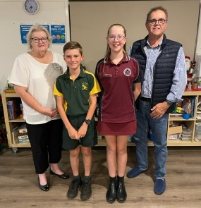

Youth: Deb Hails Guest Speakers
- Persuasive Speech Competition.
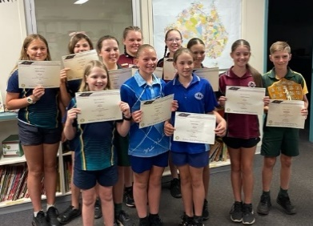
  - Deb introduced District Primary Schools Persuasive Speech winner Jake Pickels from Coolabunia SS (and mum Bec) and runner-up Teegan Starkey from Nanango SS (and mum Bree)
  - Deb and fellow adjudicator Sam Wilke from Kingaroy SHS found the speeches to be of a high standard and difficult to judge. Such fluency and presence. It was a great event.
  - The students presented their 3 minute speeches to members:-
  - Jake Pickels – There Should Be Stricter Limitations on Screen-time for “tweens”.
  - Teegan Starkey – Girls in Education
- 4 Dec The club’s 4 Bursary recipients from KSHS coming to next dinner meeting. This year’s recipient will be coming as well
- Request from Taabinga SS for club to continue its $100 donation towards annual Dux Prize. Members agreed

- Reminder - 4 Outgoing Exchange Students’ orientation visit 4 Dec.
  - Program - meet at Information Centre & visit Museum, Mt Wooroolin, then lunch at Apex Park. All members are invited to attend. Contact Deb if you can make it. Meet at 10.30 at Info Centre

Rotary Foundation: Kerry Heit
Nil

General Business:
Calendars
- Mark - encouraged members to take calendars to sell. $5.00 each. Focus is Drone photos of the Sth Burnett
- Confirmation from Sandy Hoffman who sold 51 calendars at the Murgon Country Music Muster
- Ray - Gas supply on weekend – 2 of the new ones have new set ups. In the future older bottles will no longer attach to our equipment. Needs further investigation
- Kerry – School Breakfasts. Talking with coordinator Wendy Fairbairne & suggested we do a bacon & egg burger breakfast at the end of each term. KSS to supply the food & we help out if needed.
  - Kerry moved & Ray seconded that we support this special breakfast at the end of each term. Agreed

Card Draw: 10 diamonds No winner

Fines
- Murray fined by Neil. Coolabunia SS students still coming through as speech winners
- Bev fined Neil for the oil on floor problem. Cleaned it several times
- Neil fined Ray for chatting, drinking beer with SlipJervis etc instead of working

Meeting closed: 8.21pm

Cheers

Murray

Members need to let Kat know if not attending.
Reminders
• If you cannot attend a meeting, you MUST contact Kat by NOON on Monday!
• If you don’t cancel by noon you will be billed for a meal.
• New Bank account details
o Account Name: Rotary Club of Kingaroy Inc.
o BSB: 084 961
o Account Number: 254 905 213

Got recycling to drop off - Containers For Change Rotary Club of Kingaroy Account C10071454
(Please get a receipt and hand to Treasurer Mark)

• Make sure you wear your badge at every meeting. Makes it easier for guests.

Useful Rotary Websites
Club website www.kingaroyrotary.org.au
Rotary Foundation
- International www.rotary.org
- Australia www.rotaryfoundationaustralia.org.au

BIRTHDAYS – MEMBERS AND PARTNERS  16 November Ron Roberts  18 November Sue Johnston  19 November Allan McKeering  ANNIVERSARIES  Nil  CLUB ANNIVERSARY  1 November 1971 Lex Petersen |  | Attendance at each meeting is presumed unless you notify your absence to:  Kat – South Burnett Podiatry  Phone: 07 41627633 or 0417 627 316  Email: reception@southburnettpodiatry.com.au  Numbers need to be in by 12 noon.  The Four-Way Test  OF THE THINGS we think, say or do:  - Is it the TRUTH?  - Is it FAIR to all concerned?  - Will it build GOODWILL and BETTER FRIENDSHIPS?  - Will it be BENEFICIAL to all concerned?

C A L E N D A R

Date | Event | Time
6 November | Dinner Meeting  Persuasive Speech students | 6.00 for 6.30pm
11 November | Nanango IGA Sausage Sizzle Driver + 2 workers | 07:30 – 12:30
18 November | Harvey Norman BBQ
20 November | Meeting – no meal | 6.00 for 6.30pm
23 November | Town Hall Forecourt Meet & Greet Bar 4 workers | 4.30 – 7.00pm
25 November | Bunnings Sausage Sizzle Teams of 3 | 07:15 – 2:00
3 December | BBQ Pioneer Pk Nanango 3 workers | 3.00 – 5.00pm
4 December | Dinner Meeting – partners invited.  - Bursary Recipients attending | 6.30
8 December | Town Hall Bar 4 workers | 7.00 - 10.00pm
9 December | Nanango IGA Sausage Sizzle Driver + 2 workers | 07:30 – 12:30
14 December | Ham Wheel – Kingaroy Christmas Carnival  Min 8 workers | 6.00 – 9.00pm
15 December | Town Hall Event Bar 4 workers | 12.30 – 3.00pm
16 December | Nanango Races Bar 8 workers | 11.30 – 4.00pm
17 December | Christmas Party | 12.00 - ????
23 December | Bunnings Sausage Sizzle Teams of 3 | 07.15 – 2:00
?? December | Tarong Christmas Barbeque
13 January 2024 | Swickers Party @ Town Hall Bar  Min 4 workers | 6.00 – 11.00pm
20 January | Nanango Swim Club BBQ | TBA
4 May 2024 | Stanwell | Catering event for 1000
Legend

Bunnings
IGA
Nanango Races
Multiple Events on same day
Other events
Meetings

