The HUB
The weekly bulletin of
The Rotary Club of Kingaroy
7 February 2022
We give thanks to Rotary for good fellowship, the opportunity to serve our community and to do good in the world

Opened: President Kat opened the meeting at 7.00pm and welcomed all members.

Attendance:

President Kat Butcher, David Black, Mark Huston, Geoff Hosking, Anna Faunt, Ray Pitt, Bev Watter, , Ron Roberts, Neil Black, Roz Tigell, Deb Hails and District Governor Elect Tim Keeler.

Apologies:

Murray Johnston Kerry Heit, Allen & Carmel McKeering,.Anne Skinner, Abby Andersson, Sandy Hoffman, Gus Napier

Guest Speaker: Nil

Birthdays:

David Black 11th February - Happy birthday for Frida. Apologies if I missed anybody’s birthday.

Wedding Anniversary:

Club Anniversary: Nil

International Toast;
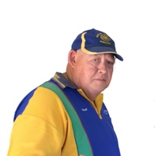
Vince took us to Karachi in Pakistan. District 3271. Original club was set up 15/5/33. It has 130 active members. Apart from its work in helping to eradicate polio (12 months free in Pakistan) the club has many projects – supplying artificial limbs, solar pumps for water, speech therapists and hearing aids to name a few.
.
Rotary Information:

Ron’s Rotary Quiz: RI Presidents from Australia.

5 RI Presidents from Australia. 2 RI Presidents from New Zealand.
Our first Australian RI President was Angus Mitchell 1948-1949. He was instrumental in reestablishing Rotary in Japan after the war.

Secretary:

Mail:- Letter from Deb Frecklington congratulating us on our Australia Day Award. 2 Rotary magazines
.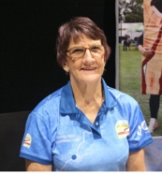
Treasurer:

Invoices for club fees has gone out to all members.
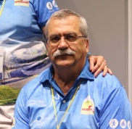
.
Events:
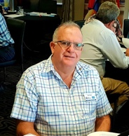
Neil Black informed us that everything is organized for Chinchilla rodeo. A number of our members will be attending to help other Rotary clubs run the food vans.
Kat reminded members of the Trivia Night at Toowoomba Metropolitan Rotary Club on 5/3/2022.

NYSF

Deb read out a couple of reports from our NYFS students Luca and Sienna, from their 12 day Seminar that they attended. They both enjoyed it
Immensely and expressed their gratitude for the opportunity that was afforded to them
.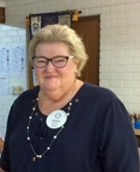

Ray: Encourages all club members to explore club runner and see what it has to offer. If you are not so tech savvy, Ray will sit down with you and go through it with you. Once we get back to SB Care I intend to take my laptop in and do just that. I encourage you to do the same, cause eventually everything will be done through club runner.

Geoff:
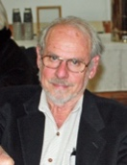

RYDA is being held on 3rd & 4th May. These dates have been locked in and approved. Geoff is organized and ready to go. Just need to organize volunteers for those 2 days.

Tim Keeler

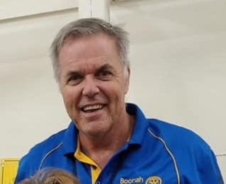

played a short film clip from a fellow Rotarian from the States to show us how powerful Rotary can be. This Rotarian was asked if she could help getting a woman out of Afghanistan when the Taliban took over. A few phone calls and 24 hours later the woman was on a plane to safety. Tim has had a lot of broken sleep taking part in zoom meetings from all over the world. Isn’t the power of technology wonderful.
.

Next meeting: 14th February

.

BIRTHDAYS – MEMBERS AND PARTNERS  David Black 11th February  ANNIVERSARIES  CLUB ANNIVERSARY |  | Attendance at each meeting is presumed unless you notify your absence to:  Vince Evans  Phone: 0499 366 007  Email: evansvlj@bigpond.com.au  The Four-Way Test  OF THE THINGS we think, say or do:  - Is it the TRUTH?  - Is it FAIR to all concerned?  - Will it build GOODWILL and BETTER FRIENDSHIPS?  - Will it be BENEFICIAL to all concerned?

Club Meeting Details
14th February | Zoom Meeting unless notified otherwise. Read your emails.

UPCOMING EVENTS – ACTIVITIES – PROJECTS – HAPPENINGS
DATE | CONTACT PERSON | DETAILS
12 Feb | Geoff | NANANGO IGA SAUSAGE SIZZLE
12 Feb | David | NANANGO RACES – Bar Work
18 Feb | Neil | Chinchilla Rodeo – Food Van
12 Mar | David & Bev | NANANGO IGA – Sausage Sizzle
16 Apr | David & Bev | NANANGO RACES – Bar Work

