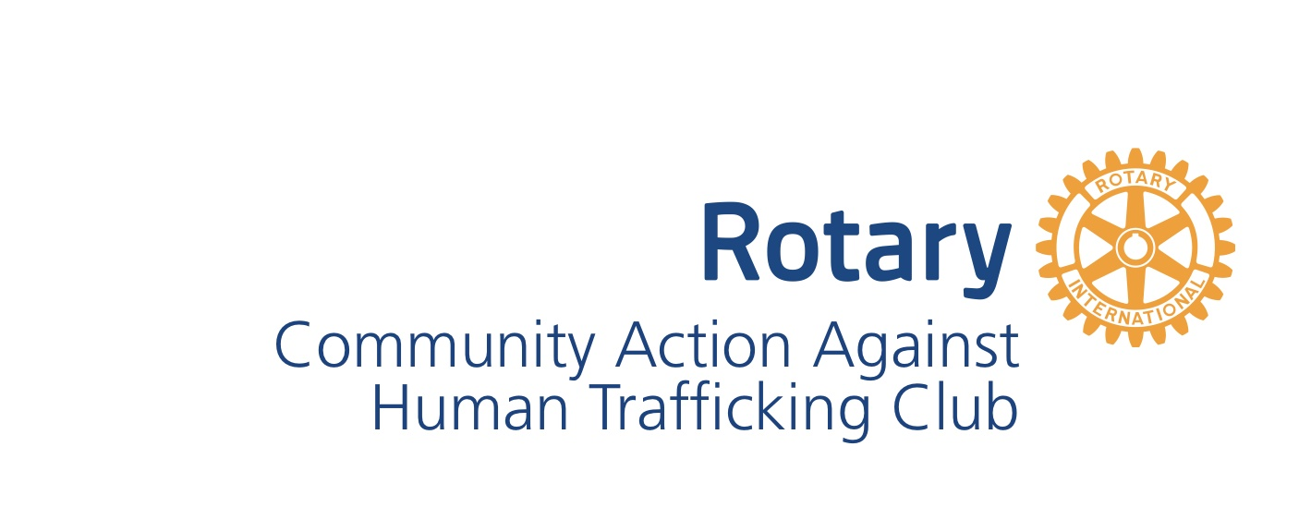

CAAHT Rotary Club dues invoice – Renewal Member

July 1, 2025 – June 30, 2026

Dues are payable every 6 months, in January and July. Dues are distributed to Rotary International, District 5710, and CAAHT Club in the following manner:

6 month payment

* + Rotary International dues $107.44 53.72
  + District dues $ 42.00 21.00
  + Club administration $ 55.00 27.50

Sub Total $204.44 **102.22**

* + **Service project** donation for club projects $30.00 15.00

**TOTAL** $234.44 **$117.22**

You will receive an invoice from our club management software, ClubRunner. We prefer you pay via that method if possible.

Alternative options for payment:

* Venmo: @CAAHTRotary (Please pay $120.70 for 6 months if paying via Venmo)
* Paypal: @rotarycaaht (Please pay $120.70 for 6 months if paying via PayPal)
  + With a check:

Make your check payable to CAAHT Rotary Club and mail to:

Patti Mellard, Treasurer

CAAHT Rotary

1540 SE 93rd St

Wakarusa, KS 66546

Please include your contact information so your payment is credited to the correct account.

Name: _____________________________________________

Address: ___________________________________________

Phone #: ___________________________________________

Questions please contact:

Patti Mellard

Email: patti@keystaffing.com,

Text: 785 640-9999