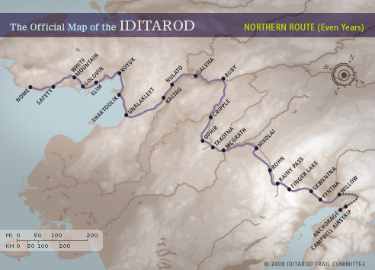

EVERY CLUB ENTERED IS A WINNER!!!
$ 25 Official Musher Status
$ 50 Skwentna Award
$ 75 Redington Award
$ 100 Balto Husky Award
$ 250 Check Point Kaltag Award
$ 500 Endurance Unalakleet Award
$ 750 White Mountain Award
$1049 The Gold Panner Award

