Diversity, Equity & Inclusion
Membership and Marketing

The Four Ps of Marketing The Four Ps of Marketing (purelybranded.com)

Marketing Mix, a term coined by Neil Borden, are the ingredients that combine to capture and promote a brand or product’s unique selling points, those that differentiate it from its competitors. The ideas behind Borden’s model were refined over the years until E. Jerome McCarthy reduced them to 4 elements called “The Four Ps.” This proposed classification has been used by marketing companies, branding agencies and web design companies throughout the world.
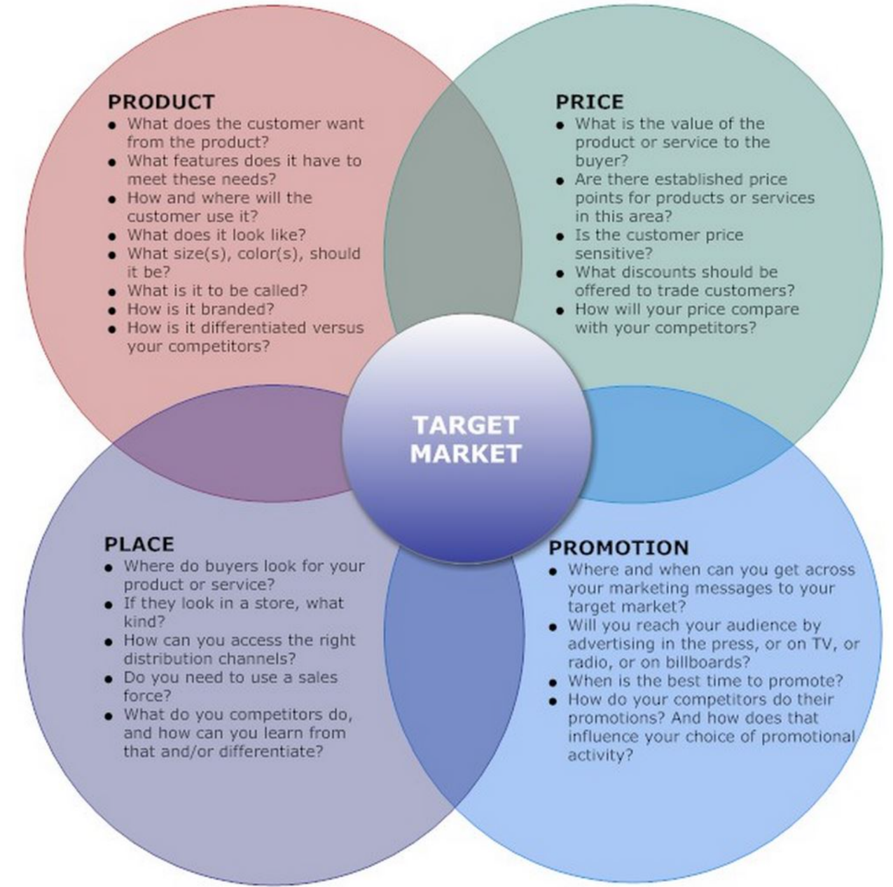
https://areteonconsulting.files.wordpress.com/2015/10/marketing-4p.jpg

The Four Ps | Rotary club references
Product – The first of the Four Ps of marketing is product. A product can be either a tangible good or an intangible service that fulfills a need or want of consumers. Whether you sell custom pallets and wood products or provide luxury accommodations, it’s imperative that you have a clear grasp of exactly what your product is and what makes it unique before you can successfully market it. | Who are the people in our local market we want to build the future of our club and the value of Rotary?  What is our competition?  What is the Rotary experience?  What do we have to offer to the person who wants to give back to our community?  What are the needs in the community? (resources are available to identify those needs with the Local Community Projects Committee)  How does Rotary have the capacity to act on your contribution in fellowship with other people of action?  Are we prepared in various ways to deliver on this promise of experience?  Are we prepared to not just invite, but accommodate and include people as we pursue the Rotary strategy of Diversity Equity Inclusion (DEI)?
Price – Once a concrete understanding of the product offering is established we can start making some pricing decisions. Price determinations will impact profit margins, supply, demand and marketing strategy. Similar (in concept) products and brands may need to be positioned differently based on varying price points, while price elasticity considerations may influence our next two Ps. | Are we pricing ourselves out of our market?  It costs every Rotarian each year:  - $350 fees  - $25 x 4 months lunch = $1,200+/yr  - $50 happy/sad dollars/yr?  - $100 min./yr donations  - TOTAL: $1,700/yr  Can young people afford that?  Can retired people afford that?  Are there ways to reduce the cost of meetings, by finding a lower cost venue or having a more flexible and varied schedule?
Promotion – We’ve got a product and a price now it’s time to promote it. Promotion looks at the many ways marketing agencies disseminate relevant product information to consumers and differentiate a particular product or service. Promotion includes elements like: advertising, public relations, social media marketing, email marketing, search engine marketing, video marketing and more. Each touch point must be supported by a well positioned brand to truly maximize return on investment. | What is the Rotary brand?  Many people think promotion is marketing, but it is only once element  Public Image Committee can address this  We are what we do and what we promote (StoryWalk, Food Hampers and Food Pantry, Special Needs Adults, etc. plus international plus the huge contribution of Rotary to the world) – some clubs promote some fun activities, but our projects are solid, meaningful contributions where there is need in the community  Do we appear in photos, etc. to still be just a “bunch of old guys” in business doing local service to make themselves feel good?  We cannot just invite prospects, we have to make it clear how we can make members feel they “belong” and can achieve a purpose  How do we communicate these points for the future members?  We have to be prepared to accommodate our members, if we listen to what they want and need.
Place – Often you will hear marketers saying that marketing is about putting the right product, at the right price, at the right place, at the right time. It’s critical then, to evaluate what the ideal locations are to convert potential clients into actual clients. Today, even in situations where the actual transaction doesn’t happen on the web, the initial place potential clients are engaged and converted is online. | Where are our future members?  How do they meet and communicate?  When it comes to embracing DEI (as federal minister Qualtrough recently advised re physically challenged people) as in attracting women to politics, one has to reach out and ask member prospects several times

Some questions to ask when incorporating the four Ps to help define a brand’s marketing mix.
- What do consumers want from your product or service?
- How does your product meet those needs?
- Where do potential buyers look for your particular product or service?
- How do you differentiate from your competitors?
- What is the perceived value of your product or service?
- What current interactions do you have with potential clients?

Club Marketing (District 5320, in Southern California), many links to resources
https://resources.rotary5320.org/club/club-marketing/
Promoting Rotary to the general public can be as simple as wearing your Rotary pin or as elaborate as organizing an integrated marketing campaign. By increasing the public’s understanding of Rotary, we’re strengthening our ability to make an impact in communities around the world. Whether you’re new to PR or a professional, below are resources to help. We encourage you to visit the Rotary Brand Center, where you will find a variety of media-ready materials that can be adapted to your needs.

Search results for videos on marketing Rotary:
https://www.bing.com/videos/search?q=Rotary+and+marketing&docid=608042398592405966&mid=E3586328C05ABB6A4851E3586328C05ABB6A4851&view=detail&FORM=VIRE

Do we want to get into supporting younger people with their careers and others in transition in the workplace? (if so, could be a Zone 24 or joint District project for the future)
https://rotary.works/: Rotary Zones 33 & 34 Career Resources; Rotary Works Career Development Initiative; A website dedicated to supporting Rotarians and Rotaractors who are in career transition or need access to useful career-related resources
Rotary Works: Making it Happen: Creating and Implementing Marketing and Action Plans

