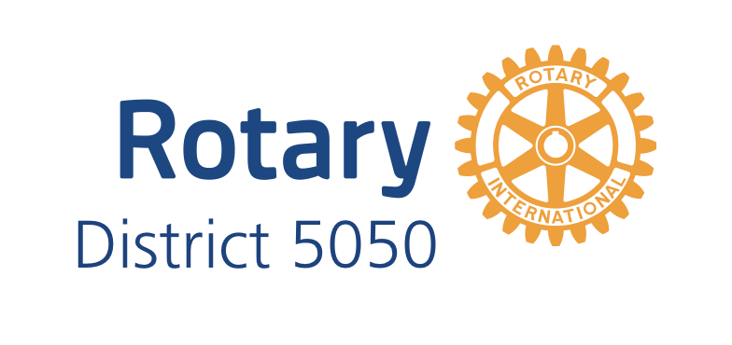Rotary Year 2021-2022
People of Action Award
Nomination Form
People of Action Award: People of Action Awards are presented to Rotarians in District 5050 who take action to create lasting change in their communities and the world. It is anticipated that approximately 5 People of Action Awards will be awarded annually. Nominations may be made by any District 5050 Rotarian and require the endorsement of the Club President or Assistant Governor on behalf of a District 5050 Rotary club
Please use additional pages if required and attachment supplementary information if appropriate. It is appropriate to consult with the president of the nominee’s club to ensure accuracy of the information supplied.
.

Date:

Nominee:
Classification:
Club:

Nominated by:
Phone:
Cell:
E-Mail:
Nomination endorsed by:
Club President or AG:
Phone:
Cell:
E-Mail:
__________________________________________________________________________________________

Background:

Date joined Rotary:
This year’s Attendance (%):
Position(s) held (Club, District, Zone etc.):
_________________________________________________________________________________________

Area of Service:

Leadership:

Involvement:

Outcome:

Recognition:

Any pertinent additional information concerning the nominee that will aid in the selection process:

Any additional pertinent information:

