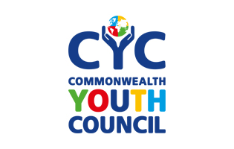  Mentor Application Form  Inter- generational mentorship programme | 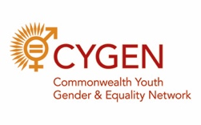    
ALL information you provide is strictly confidential and will be stored securely. Please answer ALL questions only if you are comfortable sharing the information; please note the data collected will enable the best matches possible

Contact Information
Name
Citizenship
Date of Birth
Address

Home Phone
Work Phone
Email
Twitter/Facebook ID (if applicable)
What is the best way to contact you?

Rotary International Information
What Rotary Club do you belong to?
What Rotary District is your Club in?
How long have you been a Rotarian?
What is your Rotary professional designation?

Why did you join Rotary?
Please provide an example of your Rotary Story, or tell us about a Rotary experience that has made a difference in your life.

Professional and/or Education Information
Highest form of education completed and/or professional designation/level
Are you still a student? | Yes No
If ‘yes’, please give more details.
Are you employed? | Yes No Retired
If ‘yes’ or ‘retired’, please give more details of what you do/did.
Please provide us with any other information you think is relevant
Area of mentorship

Please indicate your area(s) of choice – ONLY answers those that are applicable to you
Personal development/life skills career/ guidance | Yes No  If you ticked yes to any of these options, please explain briefly why:
Political leadership/ participation | Yes No  If you ticked yes to any of these options, please explain briefly why:
Corporate leadership | Yes No  If you ticked yes to any of these options, please explain briefly why:
Business/ Entrepreneurship/ start up | Yes No  If you ticked yes to any of these options, please explain briefly why:
Third Sector – NGOs/ Volunteering other than Rotary International | Yes No  If you ticked yes to any of these options, please explain briefly why:
Activism or Advocacy  (for example: specific activities relating to equality / women’s emancipation / LGBT / disability / domestic violence/environmentalism, etc.) | Yes No  If you ticked yes to any of these options, please explain briefly why:
Other  If other, please state and explain briefly. | Yes No

Why are you interested in our programme?

Firstly, explain what you think makes a good mentor and secondly, what do you think are the benefits of a mentorship programme?

What are you looking for in a mentee?

Please provide a few examples of your leadership or previous mentorship experience

Activities and interests

Please briefly explain your activities and interests. It will help us match you better with a mentee.

Other information:

If there is any other information you would like to provide then please let us know here:

Agreement and Signature

By completing this application, I agree to the goals and purpose of the mentoring programme. I will keep in regular contact with my mentee and inform the steering committee if I have any problems.
Name (printed)
Signature
Date

Our Policy

It is our policy to provide equal opportunities without regard to race, color, religion, national origin, gender, sexual preference, age, or disability.

Thank you for completing this application form and for your interest in the Inter- generational mentorship programme.

Please return all completed applications to: cyouthmentorship@gmail.com. Please put the email subject as ‘MENTOR APPLICATION.’

