Virtual Community Service Websites
(Aug 2020)

https://www.countryliving.com/life/a32096550/virtual-volunteering-ideas/
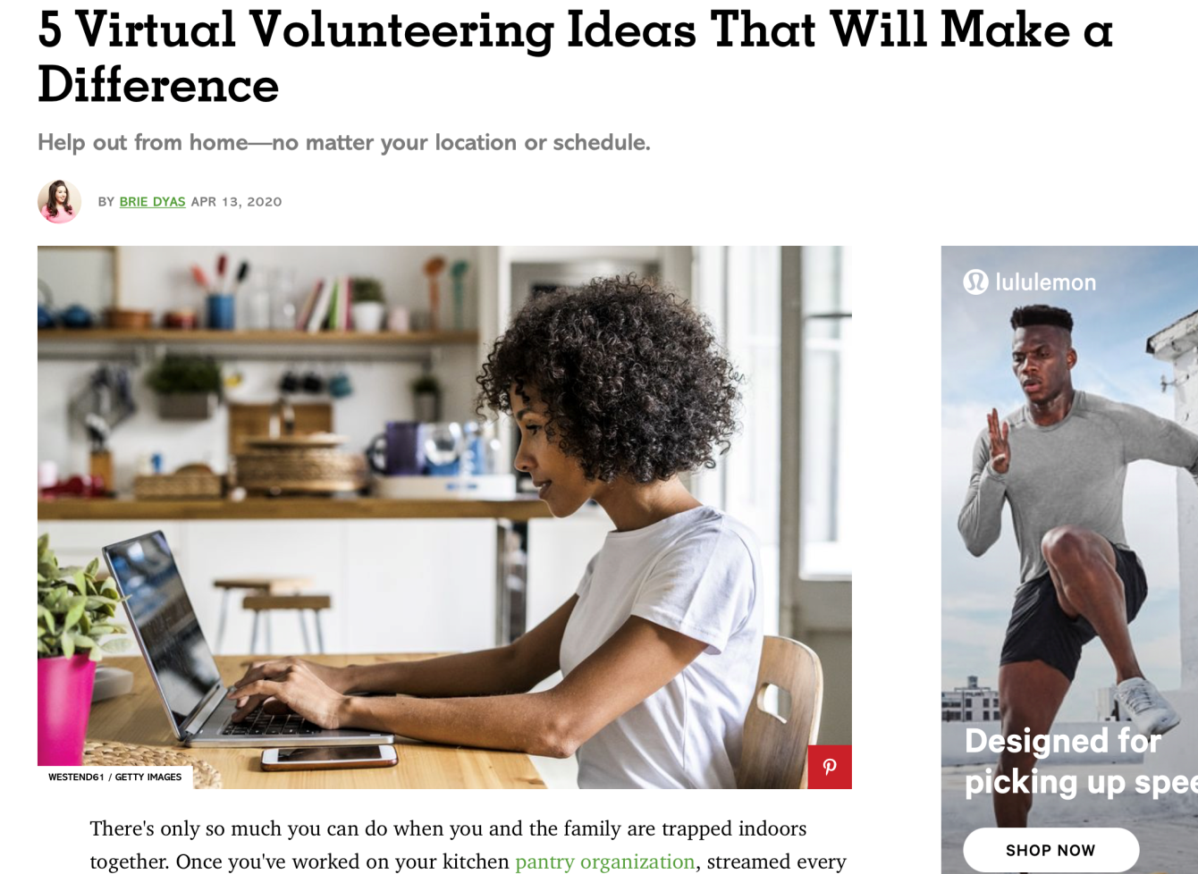

https://www.operationwarm.org/blog/25-volunteer-jobs-to-do-from-home/
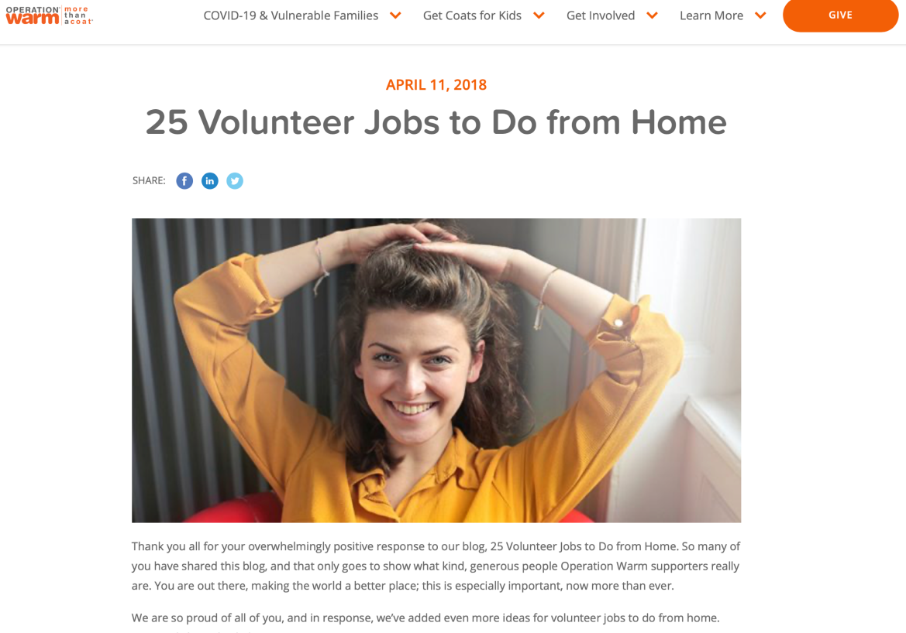
https://www.wildapricot.com/blogs/newsblog/2020/04/08/volunteer-from-home
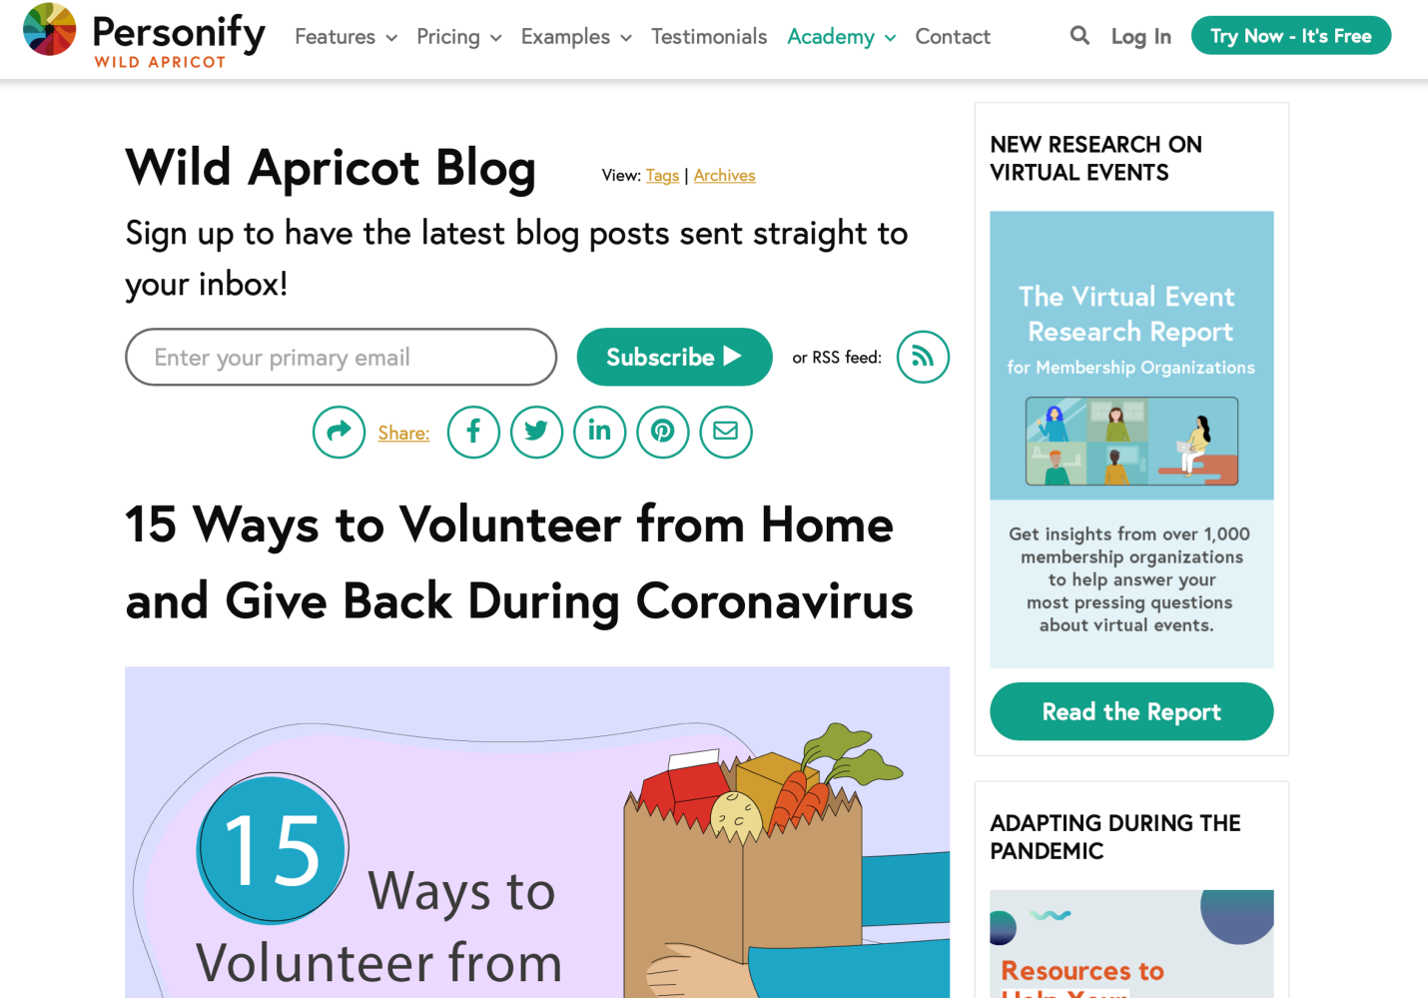

https://www.careeraddict.com/online-volunteering-opportunities
