Virtual Fundraising Websites
(Aug 2020)

https://www.soapboxengage.com/blog/1863-virtual-fundraising-ideas
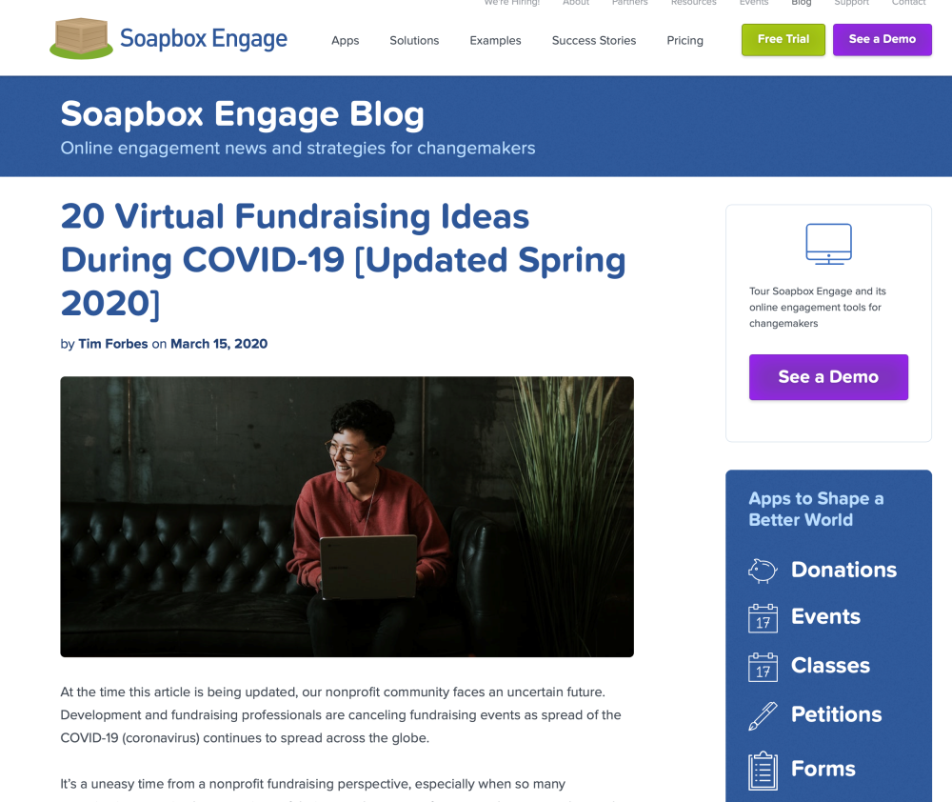

https://www.causevox.com/blog/online-fundraising-ideas-nonprofits-charities/

https://www.wildapricot.com/blogs/newsblog/2020/04/14/virtual-fundraiser
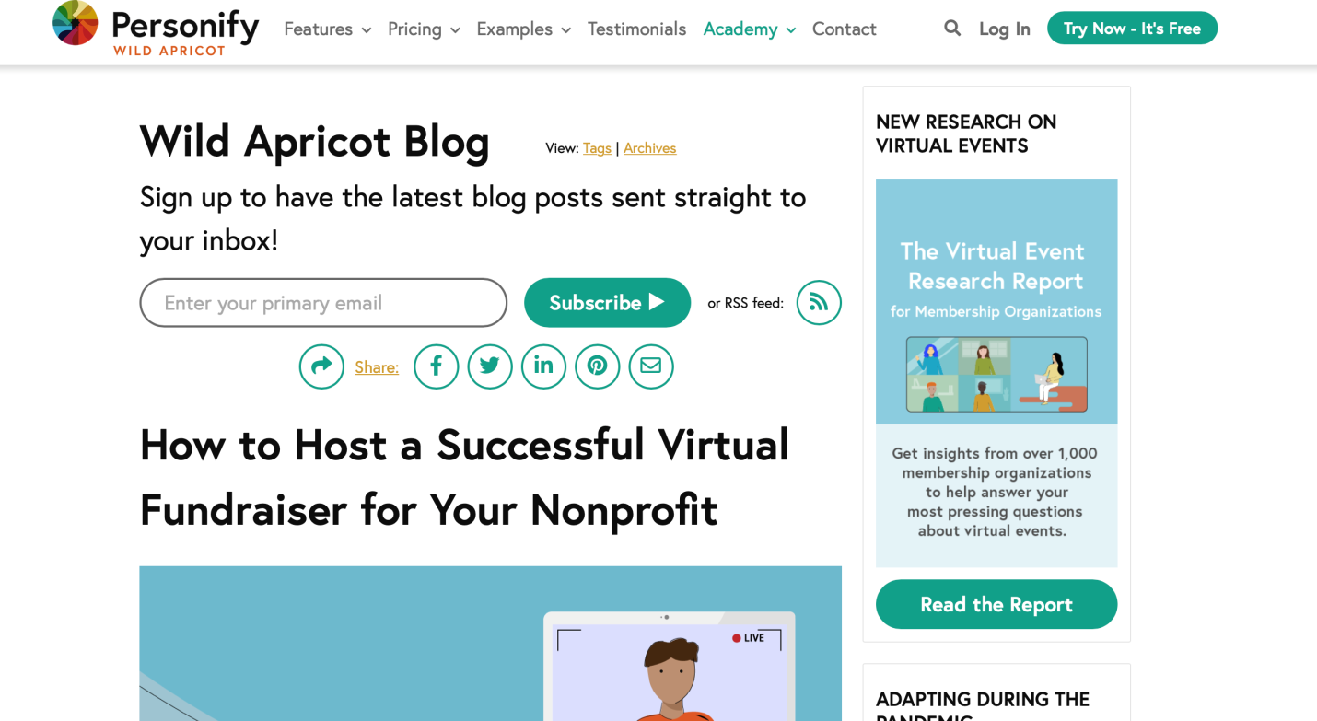

https://www.canadahelps.org/en/charity-life/fundraising-2/7-creative-virtual-fundraising-ideas-you-can-use-to-replace-your-cancelled-event/
