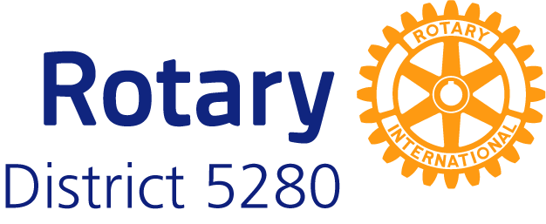 **Wildfire Disaster Relief Grant Application**

Rotary International - District 5280 is accepting grant applications to support service projects assisting those impacted by the Los Angeles wildfires. Please complete the form below with all required details.**Grant Details**

* **Grant Amount Range:** $1,000 - $3,500 per club (maximum $7,000 for partnered clubs)
* **Eligibility:** Rotary and Rotaract Clubs in District 5280
* **Application Deadline:** Applications will be reviewed on a rolling basis until funds are fully distributed.

**Application Form**

**1. Date of Submission:**

**2. Project Name:**

**3. Primary Club Information**

* **Club Name:**
* **Primary Contact Person:**
  + Name:
  + Phone:
  + Email:

**4. Partner Club Information (if applicable)**

* **Club Name:**
* **Partner Contact Person:**
  + Name:
  + Phone:
  + Email:

**5. Needs Assessment**

Provide a detailed description of the needs assessment conducted to determine the necessity and value of the proposed service project. Include contact information of the proposed beneficiary:

**6. Description of the Service Project**

Describe the project, including its plan for execution and its intended short- and medium-term impacts.

**7. Project Timeline**

Provide an estimated timeline for the project, including key milestones and a follow-up plan.

**8. Budget**

Provide a detailed breakdown of the project’s budget, including all costs.

**9. Grant Amount Requested**

State the amount of funds requested (between $1,000 and $3,500 per club; maximum $7,000 for partnered clubs).

**10. Additional Notes (Optional)**

Include any additional details or supporting information relevant to your application.

**Application Submission**

**Once completed, submit your application to Tori Szabadi at office@rotary5280.org**

**Important Notes**

* Ensure that your project aligns with Rotary’s mission and the Four-Way Test.
* Submit an accounting of the funds within **60 days** after completing the project expenditures.
* Clubs may apply for multiple grants, and receiving a grant does not preclude further applications for District Community Grants.
* Collaborations between clubs are encouraged for larger projects.

For any questions or additional guidance, contact Disaster Relief Chair Mark Benthien at markbenthien@me.com