AUCTION DONATION FORM
The Auction Donation Form is for Live Auction and Silent Auction items. The goal is for each Rotary Club to provide an auction item to the Governor during his visit to the club.

Suggested Items: Entertainment and sport event tickets, getaways and vacation packages, golf outings, premium wines, gift baskets, gift certificates or something unusual that would be considered priceless. Live and Silent Auction Donors receive one half the foundation credits and the buyer receives the other half of the foundation credits from the selling price. Thank you for your generous support of The Rotary Foundation!
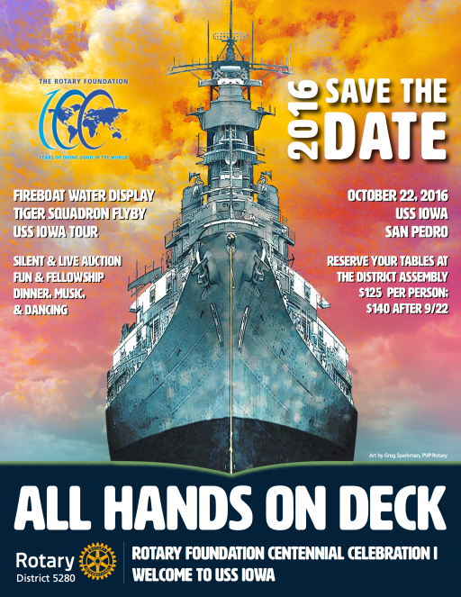

How to use this Word Document form:
1. Save this generic form.
2. Complete the form by typing in the information below. Be as detailed as possible.
3. Re-save as “Auction Form ‘your Rotary name’ #” Example: Auction Form San Pedro 1.
4. Email the completed Auction Form to KarenInRotary@gmail.com . Attach photos if needed.
5. Present the Club’s Auction Item to Governor Greg O’Brien at the Governor’s Visit.
6. If not presented at the visit, mail or deliver items and forms to the District Office address below, no later than October 7, 2016.

Please note: It is suggested that donated items (either an individual item or, collectively, a group if smaller items) be valued at least $300. Donated items valued less than $300 may be grouped by the committee with a combination of items. Foundation credits may not be guaranteed for grouped items. Items donated and not sold become the property of District 5280 unless otherwise arranged.

Live Auction or Silent Auction Item Description (Please use an additional page for complete details.)

Estimated Value
Restrictions (if any)

Name Rotary Club of
Rotarian Number (Available from Club Secretary, Foundation Chair or Rotarian Magazine Label)
Address
City Zip
For more information contact:  Karen Greenberg  KarenInRotary@gmail.com  310-266-7567  Send Completed forms to  KarenInRotary@gmail.com |  | Rotary 5280 District Office  8939 S. Sepulveda Blvd. Suite 210  Los Angeles, CA 90045  Tel:310-670-9792 Fax: 310-670-9795  Office@Rotary5280.org
Phone Cell Email

