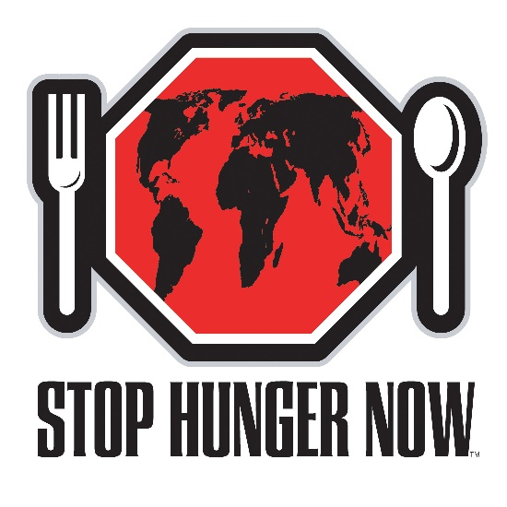

Meal Packaging Planning and Logistics
For Event Hosts

This document takes you through the process of hosting an international Meal Packaging Event from inception to the day of the event. It includes information on creating your vision, developing your team, fundraising, venue requirements, ingredient specifications, customs clearance and logistics, volunteer management, and marketing and promotion.

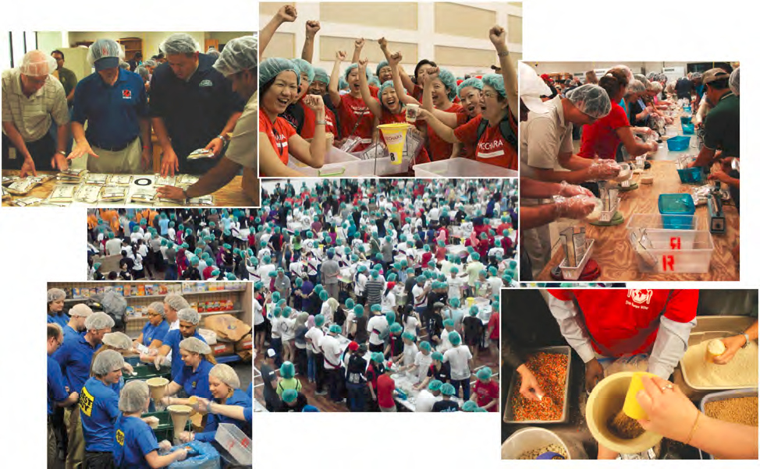

Table of Contents

Section 1: Creating the Vision for your Event………………………………… 3
Section 2: Non-disclosure and Memorandum of Understanding..…………… 4
Section 3: Developing Your Event Team…….………………………………… 4
Section 4: Fundraising for your Event……….………………………………… 4
Section 5: Venue Requirements………………………………………………… 5
Section 6: Ingredient and Equipment Specifications..………………………… 5
Section 7: Marketing and Promotion………...………………………………… 7
Section 8: Recruiting and Registering Volunteers..…………………………… 7
Section 9: Planning your Agenda…………...………………………………….. 8

Appendix:
Event Host Checklist
Timeline of Hosting an Event

Section 1:
Creating the Vision for your Event

Congratulations! You have decided to host a Stop Hunger Now meal packaging event that will affect the lives of hundreds of people. Your event will not only impact the lives of children in developing countries, it will touch the lives of each and every volunteer you engage.

The first step to hosting a meal packaging event is establishing your vision. Schedule a call with Stop Hunger Now staff and work with them to answer the following questions about your event. Please do not return this questionnaire until you have all of the answers.

- What organization is hosting this meal packaging event?
- What is the name, contact information, and role of each member on your team planning the event? (Note: A typical team is about 5 people)
- What is the best way to contact your team? Please include details such as emails, phone numbers, or Skype names for each team member
- How many meals do you hope to package at your event? Note: A typical international event starts at 142,560 meals. This is enough meals to fill a small 20ft shipping container.
- Do you already have funds raised for your event? If not, do you have a plan for raising the funds needed for your event? Note: The cost is 0.29 USD per meal or the equivalent in local currency.
- What is the date of your event?
- What is the address of your event venue?
- When will you be having set-up for your event?
- What is your shift schedule for the event?
- Is your event public or private?
- How many people do you envision participating in this event? Note: Typically, 1 volunteer can package 300 meals in the 2 hour event shift. For example, 100 people can package 30,000 meals in 2 hours
- Do you want media to attend your event? If so, do you plan on contacting them or would you like assistance?
- Have you been able to locate vendors for all ingredients and supplies needed? What was the cost for each item? Please send detailed specifics to Director of Intl. Affiliate Development, Andrew Sulivan.
- Where will you be storing the equipment and ingredients before the event?
- Who is your consignee for clearing the shipment of equipment from the US at customs in your country? Please include: organization name, address and primary contact name, email and phone number
- How do you plan to get the shipment to your storage location?
- Have you signed and returned the Non-Disclosure Agreement?
- Have you signed and returned the Declaration of Mutual Understanding?
.

Section 2:
Non-disclosure and Memorandum of Understanding

After working with Stop Hunger Now to establish your vision for the event, a Non-Disclosure Agreement will be presented by Stop Hunger Now to be signed by the host organization before any ingredients or equipment can be ordered. Please be sure to get this back to Stop Hunger Now in a timely manner.

After establishing the main details of your event, a Declaration of Mutual Understanding will be produced by Stop Hunger Now for the host organization to sign 12 weeks before the event once the main details of the event have been determined. This document will summarize the essential goals, roles and responsibilities as detailed in this letter and will also list the essential details of the event including: Date and Location of Event, Meal Packaging Goal, Number of Volunteers, Total Fundraising Goal, Portion of Funds sent to Stop Hunger Now, and the specific Date for when funds must be received by Stop Hunger Now.

Section 3:
Developing Your Event Team

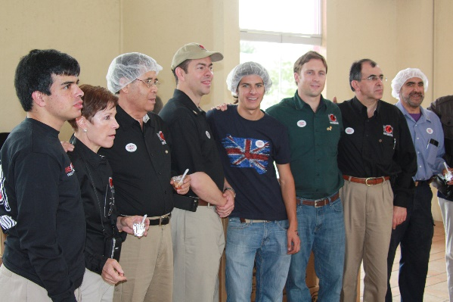
Stop Hunger Now asks that each event host organization assembles a team of 2-5 people to carry out the event planning process. Each person performs a role essential to organizing the event. Make sure to identify the team leader, who will serve as the main point of contact between Stop Hunger Now and your organization.

Sample roles can include:
- Team Leader
- Fundraising Coordinator
- Volunteer Coordinator
- Marketing and Promotion Coordinator

Section 4:
Fundraising for your Event

Each event host must raise your countries equivalence of $0.29 USD (.38 CAD) per meal to cover the costs of the Meal Packaging Event, $2,000 USD for staff travel/ accommodations assistance, and $500 for customs clearance fees ($3250 CAD). The $0.29 per meal figure is an estimate depending on access to ingredients and equipment and therefore it is possible that additional funds may need to be raised.

Stop Hunger Now will need to receive its portion of the funding 6 weeks before the Meal Packaging Event to allow sufficient time to purchase and ship the materials and to provide travel arrangements for Stop Hunger Now staff to facilitate your event. For larger events, Stop Hunger Now may need additional time and may request funding up to 10 weeks in advance of the event. Please work with your Stop Hunger Now event coordinators to establish fundraising deadlines for your event.

Section 5:
Venue Requirements

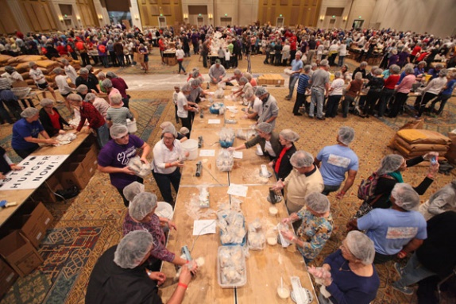
The most ideal venue for a large meal packaging event is a conference center or large gymnasium. A large open area is required with easy access to loading areas. Meal packaging must take place indoors for sanitary reasons and to avoid complications caused by weather. For every person attending you will need approximately 20 square feet of space.

Here are some other things to keep in mind when selecting a venue:
- For a group size of 500 volunteers, a space the size of 3 basketball courts would be required. This would measure: 85 meters (L) X 45 meters (W).
- For a group size of 1,000 volunteers a space twice this size would be required.
- Venue should have access to truck loading/unloading docks
- Meal Packaging should ideally take place on the ground floor. This will help to avoid bringing thousands of KGs of ingredients and meals up and down stairs or elevators.
- Ideally a large room close or adjacent to the meal packaging room could be used for volunteer registration and orientation.
- The building should have a large parking lot for volunteers
- The building should have a truck parking area close by
- Ideally the building will have access to a forklift, pallet jacks and rolling carts for moving pallets of ingredients to and from the trucks and packaging area.
- The building should have access to projection screens and media equipment
- Be sure to rent the venue for set-up time one day prior to the event when booking

Section 6:
Ingredient and Equipment Specifications

Stop Hunger Now will purchase most of the equipment and ingredients for the Meal Packaging Event and ship the materials directly to the host country before the event. These shipments will include everything that is needed for the Meal Packaging.
The Stop Hunger Now shipment of materials will arrive 1-2 weeks prior to your event. As an event host, you are responsible for receiving and storing this shipment. All of the items included in the shipment will be used in your Stop Hunger Now event. These items include the following:

- Stop Hunger Now vitamins
- Boxes
- Soya
- Rice
- Dehydrated veggies
- Metal funnel stand with funnel
- Digital scales
- Scale tray
- Clear plastic bowls (for scales)
- Plastic spoons (for scales)
- AA Batteries (for scales)
- Plastic bins
- Pallet wrapping
- Gong with stand and mallet
- Hair nets
- Tape dispenser and packing tape
- Sharpie markers for labeling
- Ballpoint pens for volunteer sign-in
- Laminated “counting board” sheet

Temporary Storage Location

The most ideal storage location is a warehouse with access to truck docks or available space at the meal packaging venue. The amount of space required will depend on the number of meals being packaged. You will be storing ingredients and equipment in this location prior to the event. Be sure to see if you can get the space donated!

Here are some other things to keep in mind when selecting a storage location:
- The storage location must be clean, dry, and secure. Raw ingredients will attract pests such as insects and rodents. It is important that the space be sealed and kept clean at all times.
- The storage location must be well lighted.
- The storage location must have access to large bay doors and truck docks for receiving and loading ingredients and equipment.
- Ideally the storage location will have access to a forklift, pallet jacks and rolling carts for moving pallets of ingredients and equipment.
- In the event that we cannot transport meals directly from the meal packaging event, the storage location should be able to accommodate the finished meals.
- For a 285,000 meal event a storage location of approximately 230 sq meters would be adequate
- For a 575,000 meal event a storage location of approximately 300 sq meters would be adequate
- For a 1,000,000 meal event a storage location of approximately 500 sq meters would be adequate
- Note: If it is possible to store the raw materials/equipment in the meal packaging venue, costs and logistical arrangements will be reduced!

Section 7:
Marketing and Promotion

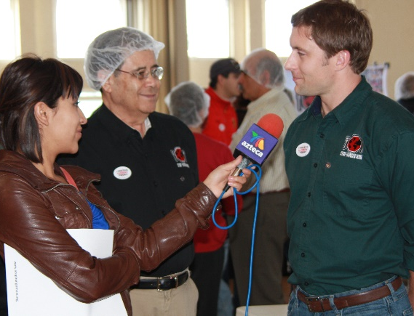
Stop Hunger Now can work with you to develop your events marketing campaign. There will be a toolkit of helpful information and materials available on the District 5370 webpage. You can find posters and flyers on our website as well as promotional videos. Stop Hunger Now’s marketing department is also happy to work with you to develop a press release on your event and send it to local and international media. A press release is a great resource to give local media all the info on your event in one document. Notify your local paper or news station to see if you can get some coverage of your event so that you can inspire others in the community to take action as well!

Be sure to promote your event on social media and tag Stop Hunger Now so that we can share and retweet to our international network of volunteers!

Section 8:
Recruiting and Registering Volunteers

Meal Packaging Volunteers can be members of your organization or employees. You can also invite family members or members of the public! Meal packaging is great for any age group (ages 5 to 105!)! Volunteers package approximately 300 meals per hour, so to find the amount of volunteers you need, just divide the amount of meals you are packaging by 300.

If your venue will not fit all of the volunteers at once, it could be best to organize them into shifts. Shifts will last approximately 2 hours and need to have a proportional amount of volunteers to meals being packaged. It could also be helpful to find specific volunteers for set-up and event day assistance. You will need approximately 15-20 volunteers, the Stop Hunger Now event team may request more volunteers if needed) volunteers to unload the trucks and a few volunteers to help with registration, hand sanitation, handing out hairnets, and serving as event day captains so that volunteers know who to ask when they have questions or need something to do.

Stop Hunger Now will also provide your group with an event webpage where your volunteers can sign in online. The host main contact will be provided a link to monitor sign in.

Section 9:
Planning your Agenda

Stop Hunger Now Staff Arrival

Stop Hunger Now staff will arrive 2-3 days before the event to allow 3-4 days in country to facilitate your event. All travel arrangements will be booked by Stop Hunger Now’s office but if you have any hotel suggestions, please let us know. The agenda typically starts when Stop Hunger Now staff arrives in country. Be sure to schedule time for the staff to visit the storage facility and venue in advance to double-check equipment and specifications. This typically happens as soon as the staff arrives in country.

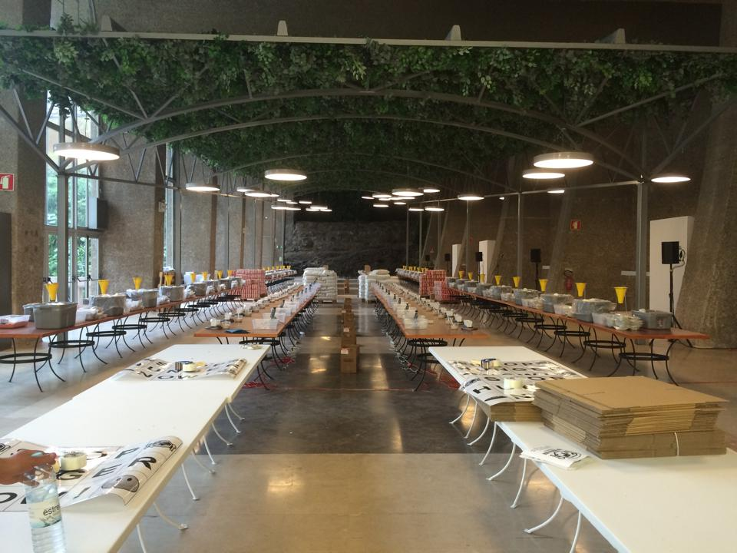
Event Set-up

Event set-up typically occurs the day before the event. Please be sure to take this into account when booking your venue. On this day, your team and the Stop Hunger Now staff will work together to set-up everything for the event like the assembly line, registration/orientation areas, and arrange last-minute preparations for the event.

Some activities include:
- Raw ingredients and equipment transferred to the venue
- Volunteers 15-20 volunteers, the Stop Hunger Now event team may request more volunteers if needed will arrive to help unload trucks and set-up the ingredients and equipment. They will also be trained on the meal packaging process.
- Orientation/Merchandise sales areas will be set up with booths and displays
- Parking for key sponsors and staff will be reserved
- Last minute items will be purchased if necessary
- Media contacted and confirmed for the event tomorrow
- Your team will meet with the Stop Hunger Now staff after set-up completion to discuss the next day event and report on progress.
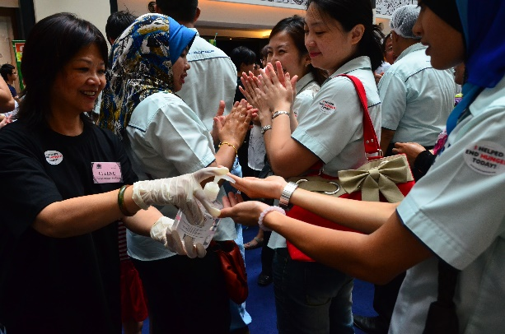
Day of Your Event

Finally it will be time for your event! Volunteers of all ages will gather in shifts to package meals for the hungry while learning about poverty and service.

Aside from meal packaging, some activities on your agenda include:

Before the Event:
- Your team and the Stop Hunger Now staff will meet 90 minutes before the start of the first shift to run last minute checks of the set-up
- Your main event team (captains) will be trained on the assembly line so you can assist with volunteer management and common questions
- Your team and Stop Hunger Now staff will work together to facilitate orientation and registration and directing volunteers to their stations
- A designated member of your team will assist any media outlets in gathering interviews, footage, etc.

During the event for each shift:
- Volunteers arrive, get registered and attend orientation
- Volunteers transfer to meal-packaging-event packaging room, apply hand sanitizer and a hair net, and follow their team leader to their positions
- Volunteers will start packaging food
- If there is more than one shift: At the end of the shift, volunteers will help to prepare for the following shift by cleaning up their station.

After the event:
- The meals will be packaged and loaded into the truck throughout the event. At the end of the event volunteers can watch the truck drive away with all of the meals. From there, the meals will be shipped to their end destination.
- Event hosts and Stop Hunger Now staff gather to have a celebration dinner - After the event it’s always nice to have a dinner to celebrate your successful event!
- Stop Hunger Now staff will depart the following day back to the US – they will follow-up and let your team know when their meals shipped and when they have arrived at their end destination. They can also provide photos of the distribution!
- 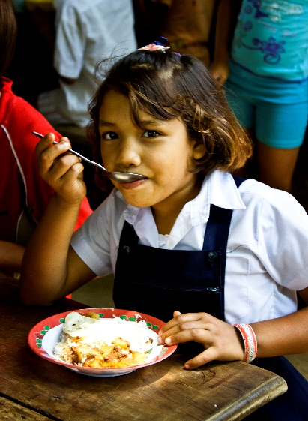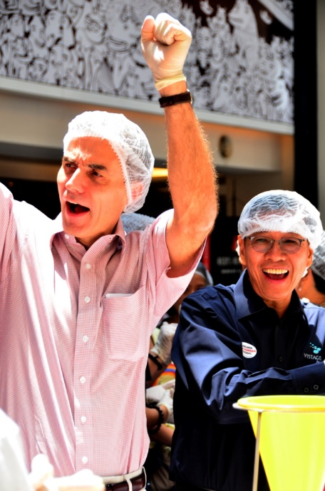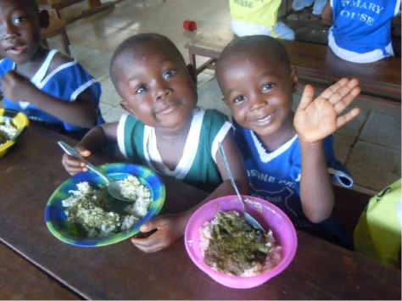Stop Hunger Now also encourages all event staff and volunteers to stay involved in the fight to end hunger – get involved locally or schedule your next Stop Hunger Now event!

Event Host Checklist

Developing your vision:
- Read the website to learn how to host an event
- Received “International Event Planning and Logistics” document
- Had a call with Stop Hunger Now staff to form the vision for the event
- Signed the Stop Hunger Now Non-Disclosure Agreement
- Developed a meal packaging team (3-5 people) and send all contact info to Stop Hunger Now International Team
- Picked the team leader
- Did a call with my team and Stop Hunger Now assigned team

Planning details of your event:
- Determined the meal packaging meal goal
- Determined the venue of my event
- Received the Memorandum of Understanding with Stop Hunger Now
- Determined and confirmed the date of my the event with Stop Hunger Now staff
- Secured meal packaging event date with venue and the day prior for set-up
- Signed the Memorandum of Understanding with Stop Hunger Now
- Procured funding for the event at $0.29 per meal

Receiving Ingredients and Equipment:
- Received list of ingredients to receive.
- Established a storage space for ingredients/equipment before the event
- Secured the storage space for the event
- Establish a team member to be the Consignee and send contact information to Stop Hunger Now event team
- Worked with Stop Hunger Now Team to confirm the electrical outlets
- Received ingredient purchases and informed Stop Hunger Now team
- Received shipment of equipment from Stop Hunger Now US

Marketing and Promotion for the Event:
- Worked with Stop Hunger Now Marketing department to develop marketing strategy for the event
- Started marketing campaign to recruit volunteers for the event
- Created a press release and started pushing the event out to media - determined if a news station should attend the event

Pre-Event Preparations:
- Assisted Stop Hunger Now Staff in determining travel arrangements including hotel suggestions and flight agenda
- Planned the agenda for the event including set-up, day of, and take-down of the event
- Confirm 15-20 volunteers for 2 hours to set-up the event
- Confirm 15-20 volunteers for 2 hours to clean-up the event
- Found volunteers to assist in set-up and day-of event tasks
- Organized and double-checked all of the ingredients and equipment
- Planned the music and overall audio/ visual for the event.
- Developed volunteer registration plan for pre-registration if desired (or use Stop Hunger Now’s online registration tool)
- Plan celebration dinner (after event) if desired

Week of the event:
- Welcomed Stop Hunger Now staff as they arrive to facilitate the event
- Gave Stop Hunger Now staff a tour of storage facility
- Gave Stop Hunger Now staff a tour of the venue
- Assisted Stop Hunger Now staff with event set-up the day before the event
- Test the sound/music for the event
- Assisted with Stop Hunger Now staff to procure any last minute items for the event
- Reminded media and volunteers of the event
- Confirm celebration dinner (after event) if desired

Day of the event:
- Arrive at the event 90 minutes early
- Ensure that 4-5 key event staff (captains) are trained on the assembly line process to assist with volunteer management and common questions
- Ensure all items have been set up properly and back-up materials are readily available
- Confirm that the music is working properly
- Set up all registration and hand sanitizing stations
- Begin to register all volunteers as they arrive
- After event, see the shipment off
- Have a celebration dinner with Stop Hunger Now staff (if desired)

After the event:
- Complete after event survey with Stop Hunger Now staff
- Provide a testimonial (if desired)
- Send a thank you to all of your volunteers (or have Stop Hunger Now send one if registration was done through Stop Hunger Now)
- Follow the meals to their end destination and receive images/video footage as available
- Sign up for your next event!

Timeline of Hosting an Event

This document takes you through the process of hosting an event from inception to the day of the event. The total process takes approximately 16 weeks or more (approximately 4 months.

Month 1:

Week 1
- Initial Interest Email or Call to International Operations Assistant
- Receive How to Host Document and Questionnaire 1- Fill Out

Week 2
- Return Questionnaire 1
- Start conversation about the event with Director of International Affiliate Development
- Start thinking about event participants, venue, funding, date, and meal goal
- Start Fundraising $.029 USD per meal for your event
- Look for large donors, grants, create a way for people to donate towards the event, etc.
- Develop a fundraising plan of potential sponsors, donors, volunteer groups

Week 3
- After interest is confirmed, receive Questionnaire 2 (to be completed as soon as answers are available)
- Start conversation between Event Host and Director of International Affiliate Development
- Start filling out Questionnaire 2
- Assemble your meal packaging event planning team – Ideally at least 5 people with individual roles
- Continue fundraising for your event
- Develop the leader of your planning team

Week 4
- Establish your meal packaging goal
- Establish the number of volunteers
- Establish the shift schedule for your volunteers at the event
- Sign and return the Non-disclosure Agreement
- Research Venues
- Continue fundraising for your event

Month 2:

Week 5
- Locate potential venues
- Why local purchasing? Purchasing local creates an added benefit for local business people and farmers. It will also decrease our carbon footprint!
- The ingredients needed will be:
  - Long grain white rice
  - Textured soy flour
  - Lentils
  - Boxes to pack and transport meals
  - Extension cords and power strips for sealers
- Return Questionnaire 2 to Director of International Affiliate Development
- Continue fundraising for your event

Week 6
- Confirm venue for the event (include set-up time when booking)
- Work with Stop Hunger Now to develop a Marketing Campaign for the event and create specific marketing guidelines.
- Continue fundraising for your event

Week 7-8
- Establish a storage facility for ingredients/equipment before the event
- Receive the Declaration of Mutual Understanding from Stop Hunger Now
- Continue fundraising for your event
- Return signed Declaration of Mutual Understanding to Stop Hunger Now
- Start recruiting volunteers for your event
- Start your marketing campaign for the event
- Stop Hunger Now to start planning trip for their staff to facilitate the event
- Continue fundraising for your event

Month 3:

Week 9-10
- Start organizing your volunteer groups and setting up registration for the event
- Shipment of any ingredients or equipment from the US sent (week 10 or 11)
- Create a press release for your event
- Continue fundraising for your event

Week 11-12
- Send event funds to Stop Hunger Now
- Notify Local Media about your event with Press Releases
- Plan the entire agenda for the set-up and event
- Continue fundraising for your event

Month 4:

Week 13-15
- Continue Fundraising for your event
- Continue signing up volunteers
- Remind local media about the event
- Ingredients from US arrive

Week 16 – Week of the event!

- SHN Staff members arrive in country to assist in final preparations/ planning.
- SHN Staff to visit MPE venue and storage facility to take inventory of supplies.
- Host Team to report on any challenges on existing issues.
- Host Team and SHN Staff to gather last minute items for MPE.
- Transportation/freight companies contacted to confirm delivery

Friday – MPE SET UP DAY

On this day, SHN Staff, MPE Team, and 15-20 volunteers will work at the MPE venue to set up the entire meal packaging assembly line, registration/orientation areas, and make last minute preparations for the MPE. Some of these activities will include:

- All raw ingredients and equipment will be transported from the storage site to the MPE venue
- A team of volunteer leaders (around 15 to 20) will arrive the day before to help unload the trucks and set up the assembly line. SHN Staff and MPE Team will facilitate this process. These volunteer leaders will be trained on meal packaging and each will lead a team of volunteers the following day during each MPE shift.
- The orientation/registration area for the volunteers will also be set up to receive the volunteer groups.
- Parking for key sponsors/staff will be reserved
- Last minute items purchased if necessary
- Sound check, music check and audio/visual check
- Media contacted and confirmed for event tomorrow
- SHN Staff and MPE Team will meet after set up is complete to discuss the following activities and report on progress.

Saturday: MEAL PACKAGING EVENT

Volunteers of all ages will gather in shifts to package hundreds of thousands of meals for the hungry while learning about poverty, and service. Aside from meal packaging, some other activities include:

Before the event:
- MPE Team and SHN Staff will meet 90 minutes before the start of the first shift to run last minute checks of equipment, assembly line.
- MPE Team and SHN Staff will split into two parts. One part will leave to facilitate the orientation and registration of volunteers. The other will stay and get ready to receive and direct the volunteers.
- A designated member of the MPE team will assist any media outlets in gathering interviews, footage, etc.

During the event for each shift:
- Volunteers arrive, get registered and attend orientation
- Volunteers transfer to MPE packaging room, apply hand sanitizer and a hair net, and follow their volunteer team leader (from day before) to their positions
- Volunteers will start packaging food
- If there are more than one shift: At the end of each shift volunteers will help to prepare for the following shift by cleaning up their stations.
- All volunteers will receive closing comments.

After the event: Celebrations!

