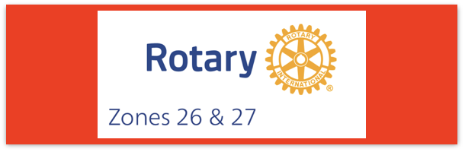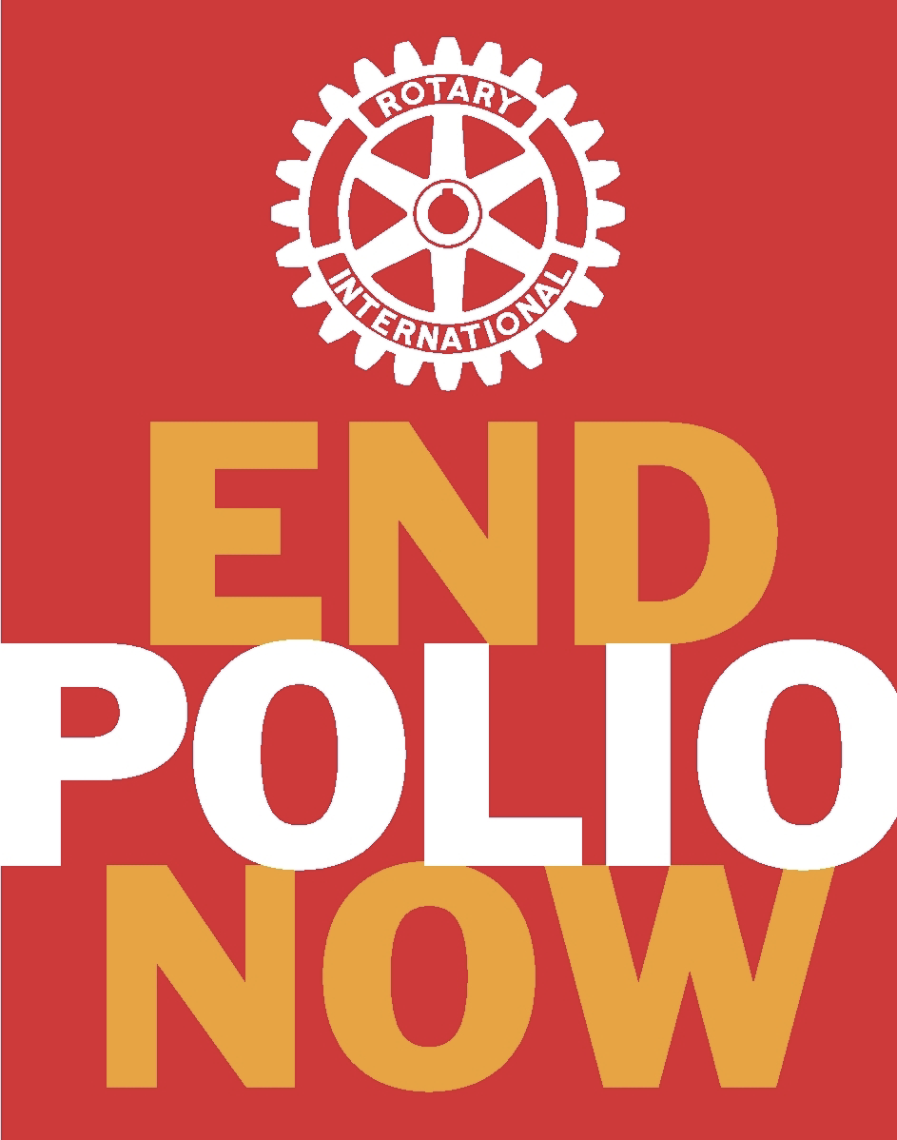

Join us on the “last mile” to end polio!!
End Polio Now Coordinators/Leaders: Mike Crosby & Marny Eulberg
mikePolioPlus@outlook.com and marnyeul@me.com
Almost weekly polio update……….. December 1, 2023
Good News—no wild poliovirus cases reported this week and no positive environmental samples for Wild Poliovirus!
Wild Poliovirus Cases reported this week: None
Most recent wild poliovirus cases: Afghanistan: 9/4/23
Pakistan: 10/15/23
 | As of 11/28/23 | Total | Total | Total | Total
 | 2023 (2022ytd) | 2022 | 2021 | 2020 | 2019
WPV (Wild Poliovirus) | 11 (30) | 30 | 6 | 140 | 176
WPV-Afghanistan | 6 (2) | 2 | 4 | 56 | 29
WPV-Pakistan | 5 (20) | 20 | 1 | 84 | 147
WPV- Other countries | 0 (8) | 8 | 1 | 0 | 0
cVDPV circulating vaccine-derived | 373 (529) | 877 | 699 | 1117 | 378
Virus detected from other sources (environmental) this week; 2023 ytd in { }; and total in 2022 in ( ).
Wild poliovirus= 0; cVDPV (variant) Types 1,2,3 = 12; {280}; 491
Summary of new polioviruses this week:
- Central African Republic (CAR): one cVDPV2 case
- Chad: two cVDPV2 cases
- Côte d’Ivoire: four cVDPV2-positive environmental samples
- DR Congo: one cVDPV2 case and one cVDPV2-positive environmental sample
- Nigeria: seven cVDPV2-positive environmental samples
HEADLINES
- nOPV2 rollout: Approximately 950 million doses of nOPV2 have been administered across 35 countries under its WHO Emergency Use Listing (EUL) to date. An additional 16 countries have met the requirements for nOPV2 use in the event of an outbreak. Visit the nOPV2 webpage for more information.
Here is the information about Yemen that Bob Rogers asked about in our Zoom meeting yesterday:
Yemen--No cVDPV2 cases were reported this week. There have been three cases reported this year and 162 cases last year. Mike McGovern did say that Yemen is using the nOPV2 vaccine. I’d say that is significant improvement!!!

Rick Barry signed basketballs still available!
Limited edition Rick Barry signed basketballs are still available for your District or club to purchase and use for a fundraiser for polio. Contact Mike Crosby at mikePolioPlus@outlook.com for questions or ordering information.
RI President Elect Stephanie Urchick and Rotary General Secretary John Hewko Invite you to join them in a Help Rotary Strike Out Polio event on July 23, 2024 at a MLB Event in Stephanie's hometown (Pittsburgh). Stephanie witll be throwing the first pitch!
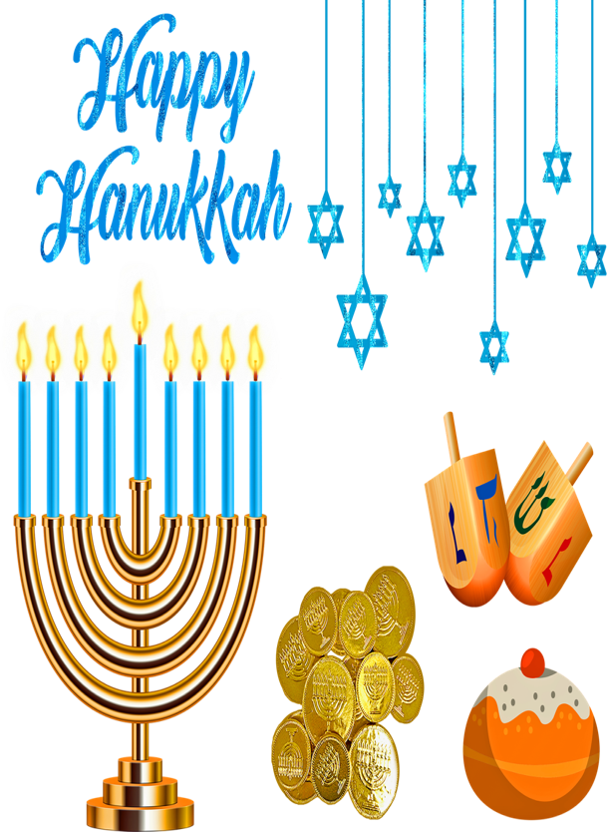
This Photo by Unknown Author is licensed under CC BY
This Photo by Unknown Author is licensed under CC BY-NC-ND

And Best Wishes for a joyous and meaningful Holiday Season for those celebrating with other traditions also!!

Note: This update is going out to those on Bob Roger’s previous list and all Zones 2627 DGs and DPPCs. Let me know if you no longer wish to receive these updates or if you have others that should be added. Email me: marnyeul@me.com
For those of you that send out copies or use this newsletter as a template for sending info to your Polio Warriors, I have added attachments in common formats to this email message.

