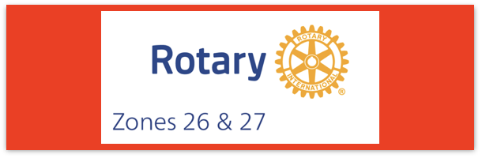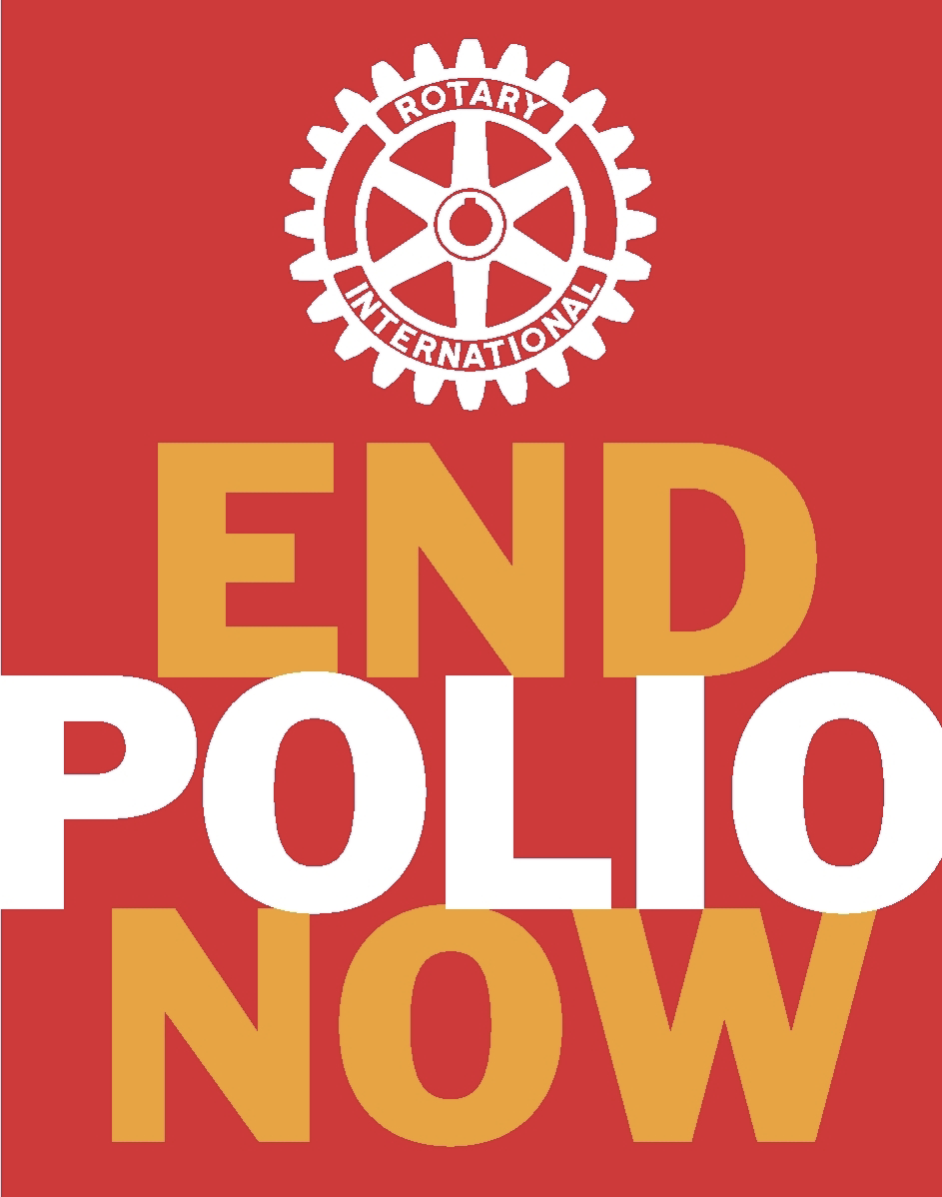
Join us on the “last mile” to end polio!!
End Polio Now Coordinators/Leaders: Mike Crosby & Marny Eulberg
mikePolioPlus@outlook.com and marnyeul@me.com
Almost weekly polio update……….. December 29, 2023
Mostly good news—no new cases of wild poliovirus caused paralysis this week, but 4 positive environmental samples in Pakistan.
Wild Poliovirus Cases reported this week: None
Most recent wild poliovirus cases: Afghanistan: 09/04/23
Pakistan: 10/24/23
 | As of 12/28/23 | Total | Total | Total | Total
 | 2023 (2022ytd) | 2022 | 2021 | 2020 | 2019
WPV (Wild Poliovirus) | 12 (30) | 30 | 6 | 140 | 176
WPV-Afghanistan | 6 (2) | 2 | 4 | 56 | 29
WPV-Pakistan | 6 (20) | 20 | 1 | 84 | 147
WPV- Other countries | 0 (8) | 8 | 1 | 0 | 0
cVDPV circulating vaccine-derived | 430 (577) | 877 | 699 | 1117 | 378
Virus detected from other sources (environmental) this week and total for 2022 in ( ).
Wild poliovirus= 4; (65) cVDPV (variant) Types 1,2,3 = 16; (510)
Only 2 new cases caused by variant polioviruses this week: 1 in Indonesia and 1 in Mauritania—no new cases in DRC or Nigeria this week!!

Rick Barry signed basketballs still available!
Limited edition Rick Barry signed basketballs are available through June, up to no more than 500 balls total, for your District or club to purchase and use for a fundraiser for polio. Contact Mike Crosby at mikePolioPlus@outlook.com for questions or ordering information.

Media News: (supplied by Reg Ling)

The week started with statement on 21 December following the 37th meeting of the IHR Emergency Committee for Polio. This followed a face-to-face meeting and, via video conference with affected countries, a review of the data on WPV1 and cVDPV in the context of the global target of eradication of WPV and cessation of outbreaks of cVDPV2. The committee recommended that the programme continues to strengthen and improve timeliness including by introducing direct detection methods. The statement enumerates the many factors affecting polio infections and provided the UN Director-General with advice aimed at reducing the risk of international spread. There is a risk stratification and assessment criteria. Once a country meets these criteria as no longer infected, the country will be remain on a ‘watch list’ for a further 12 months for a period of heightened monitoring. After this period, the country will no longer be subject to Temporary Recommendations. The report continues with lists of those countries with potential risk of international spread and suggests what each should do. The Director-General accepted the assessment and determined that the poliovirus situation continues to constitute a PHEIC and extended the Temporary Recommendations under the IHR to reduce the risk of the international spread of poliovirus. The statement is very long but I recommend that you read it. (I also recommend reading it for much more detail.)
Statement following the Thirty-seventh Meeting of the IHR Emergency Committee for Polio (who.int)

There were a surprising number of alerts received over the holiday period. As usual Pakistan had the most but some came from Afghanistan and India is now facing up to the possible imports from Pakistan with increases ES.

Note: This update is going out to those on Bob Roger’s previous list and all Zones 2627 DGs and DPPCs. Let me know if you no longer wish to receive these updates or if you have others that should be added. Email me: marnyeul@me.com
For those of you that send out copies or use this newsletter as a template for sending info to your Polio Warriors, I have added attachments in common formats to this email message.

