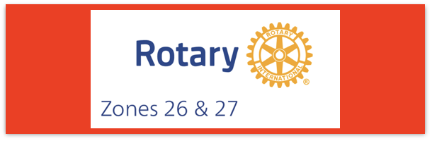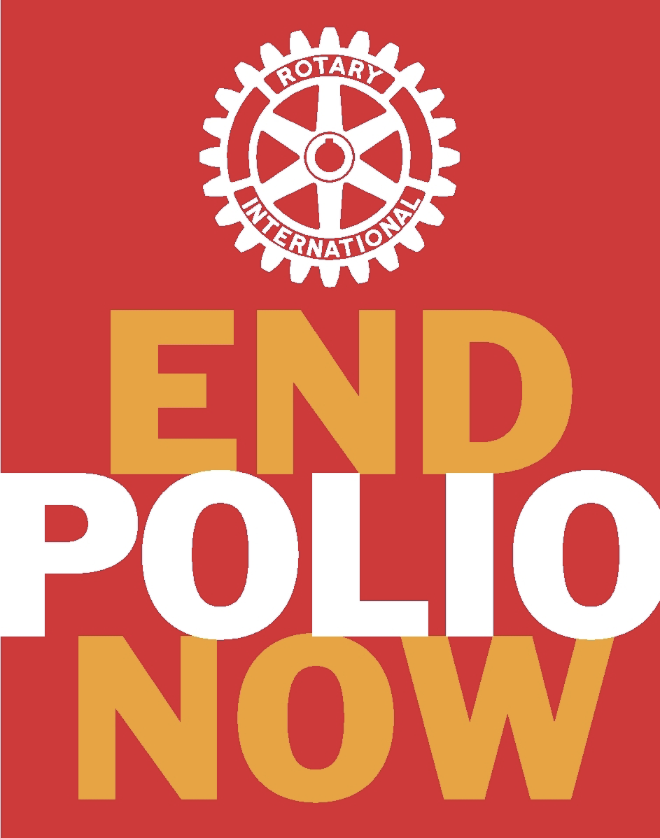
Join us on the “last mile” to end polio!!
End Polio Now Coordinators/Leaders: Mike Crosby & Marny Eulberg
mikePolioPlus@outlook.com and marnyeul@me.com
Almost weekly polio update……….. February 16, 2024
Note: no new wildpoliovirus cases have YET been reported from 2024, no positive environmental samples for wild poliovirus this week, BUT there is a possible case that is awaiting full confirmation.
Wild Poliovirus Cases reported this week: None
Most recent wild poliovirus cases: Afghanistan: 09/04/23 Pakistan: 10/24/23

Human cases confirmed | As of 2/13/24 | Total | Total | Total | Total
 | 2024 | 2023* | 2022 | 2021 | 2020
WPV (Wild Poliovirus) | 0 (3 at this time in 2023 | 12 | 30 | 6 | 140
WPV--Afghanistan | 0 | 6 | 2 | 4 | 56
WPV-Pakistan | 0 | 6 | 20 | 1 | 84
WPV- Other countries | 0 | 0 | 8 | 1 | 0
Variant (circulating vaccine derived -cVDPV polioviruses | 0 | 499 (703 at same time from 2022) | 878 | 699 | 1117
*some cases with onset of paralysis in 2023 still likely to be confirmed and reported.
Polioviruses reported from other sources (environmental) this week.
Wild poliovirus= 0 cVDPV (variant) Types 1,2,3= 7
Variant poliovirus caused 4 cases of polio paralysis reported this week in 1 country (Nigeria)-- still all cases are from 2023.
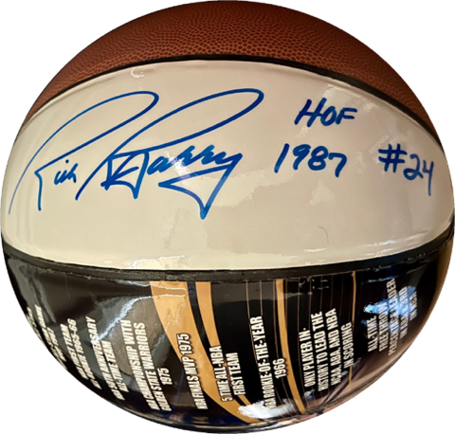
Rick Barry signed basketballs still available!
Limited edition Rick Barry signed basketballs are available through June, up to 500 balls total, for your District or club to purchase and use for a fundraiser for polio. Contact mikePolioPlus@outlook.com for questions or ordering info.

For those who question if the money spent toward eradicating polio is worth it—this news article from the WHO says “yes”.
A new invstment case finds that successful polio transition in the 8 priority countries of the WHO Eastern Mediterranean Region will deliver a return of nearly US$39 for every dollar spent. The study, which was referenced by the outgoing Regional Director for the Eastern Mediterranean Region, Dr Ahmed Al-Mandhari, at the 154thWHO Executive Board, projects economic and social benefits totaling an estimated US$ 289.2 billion through sustaining polio assets and integrating them into expanded immunization, surveillance and emergency response programmes. These findings underscore the opportunity for national governments, donors and stakeholders to use polio assets to sustain a polio-free world and build strong, equitable and resilient health systems.
Congratulations: The February issue of Rotary Magazine listed the recipients of the 2022-2023 Service Awards for a Polio-Free World and the following awardee is from the Big West: Charlotte Smith of District 5000! Congratulations to Charlotte!!

Note: This update is going out to those on Bob Roger’s previous list and all Zones 2627 DGs and DPPCs. Let me know if you no longer wish to receive these updates or if you have others that should be added. Email me: marnyeul@me.com
For those of you that send out copies or use this newsletter as a template for sending info to your Polio Warriors, I have added attachments in common formats to this email message.

