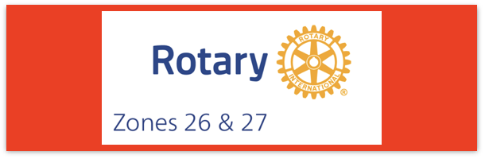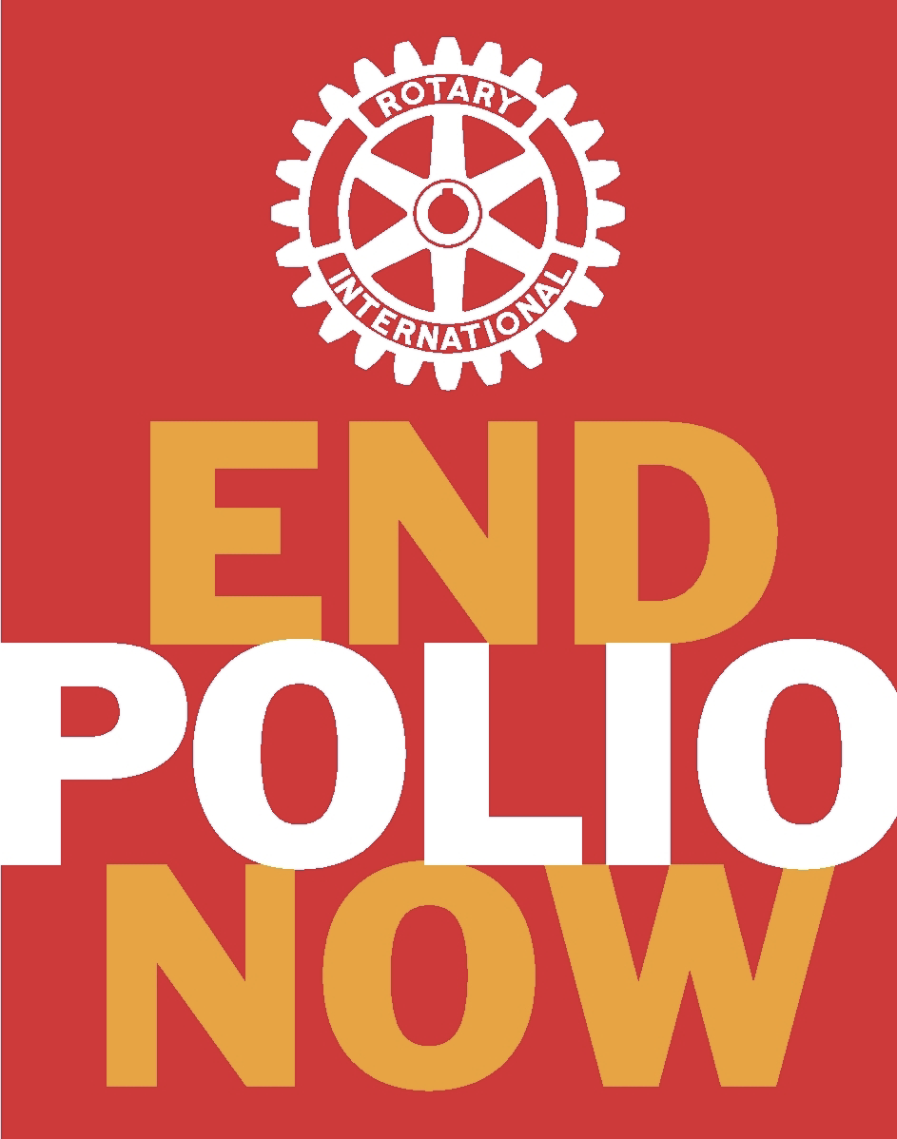
Join us on the “last mile” to end polio!!
End Polio Now Coordinators/Leaders: Mike Crosby & Marny Eulberg
mikePolioPlus@outlook.com and marnyeul@me.com
Almost weekly polio update……….. February 29, 2024
Still no new wildpoliovirus or cVDPV (variant) cases have YET been reported from 2024. But three positive environmental samples for wild poliovirus were collected in 2024 –both from Pakistan
Wild Poliovirus Cases reported this week: None
Most recent wild poliovirus cases: Afghanistan: 09/04/23 Pakistan: 10/24/23

Human cases confirmed | As of 2/27/24 | Total | Total | Total | Total
 | 2024 | 2023* | 2022 | 2021 | 2020
WPV (Wild Poliovirus) | 0 (0 at same time in 2023) | 12 | 30 | 6 | 140
WPV--Afghanistan | 0 | 6 | 2 | 4 | 56
WPV-Pakistan | 0 | 6 | 20 | 1 | 84
WPV- Other countries | 0 | 0 | 8 | 1 | 0
Variant (circulating vaccine derived -cVDPV polioviruses | 0 (4 at same time in 2023) | 504 | 878 | 699 | 1117
*some cases with onset of paralysis in 2023 still likely to be confirmed and reported.
Polioviruses reported from other sources (environmental) this week, and in brackets{} are the total reported from 2023.
Wild poliovirus= 32 {187} cVDPV (variant) Types 1,2,3= 3; {391}
Variant poliovirus caused 1 case of polio paralysis reported this week in 1 country, Nigeria-- all cases reported are still from 2023!
Rick Barry signed basketballs still available!
Limited edition Rick Barry signed basketballs are available through June, up to 500 balls total, for your District or club to purchase and use for a fundraiser for polio. Contact mikePolioPlus@outlook.com for questions or ordering info.

World Immunization Week is April 24-30, 2024. This is an additional opportunity for promoting polio vaccines and donations to End Polio. After all, the success of the polio vaccine is proof that vaccines do work (as do several other vaccines, by the way!) Campaign materials are available now at www.endpolio.org

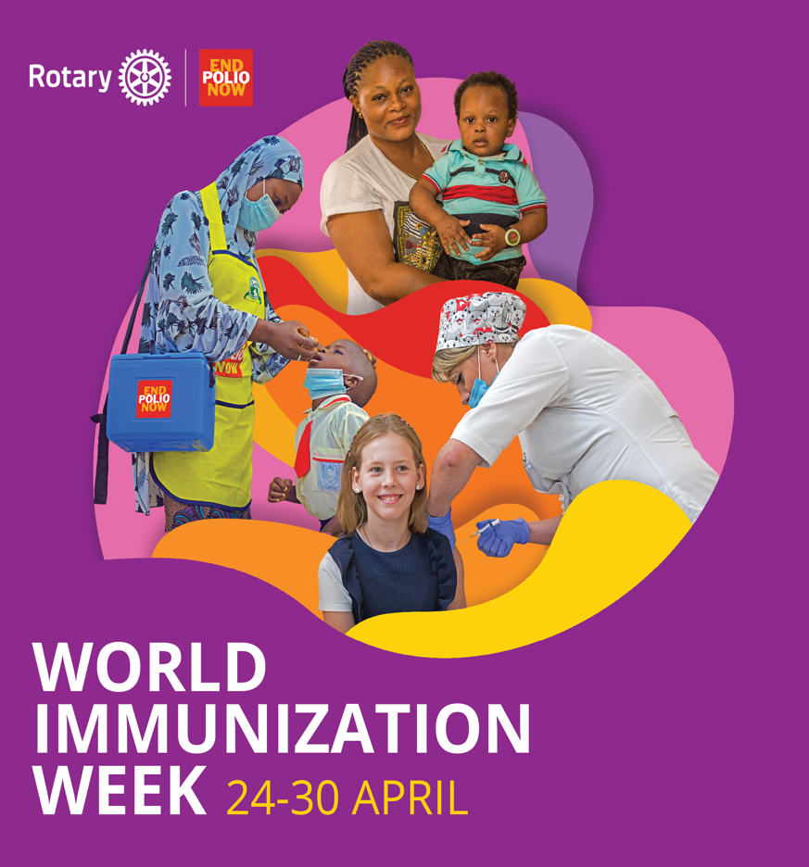
HEADLINES
- To mark the International Women’s Day on the 8th of March, you are invited to attend a webinar about the powerful impact of women in the global effort to eradicate polio. During the webinar, women working on the frontlines in Afghanistan, the Democratic Republic of the Congo, Nigeria and Pakistan will share the experiences and challenges they face in the fight against polio. More information and registration details are available here.
- The Immunization Agenda 2030 envisions a world where everyone, everywhere, at every age, fully benefits from vaccines to improve health and well-being. Gender-related barriers and gender inequality can prevent people, both male and female, from getting vaccinated. The goal of gender equality is to ensure that everyone has the same chances and opportunities to access and benefit from immunization services. A second webinar series on Why Gender Matters for Immunization: IA2030, aims to further improve awareness and understanding of how gender-related barriers impact immunization. The webinar series will run across 5 sessions, on Thursdays from 15-16h (CET): 7 March, 4 April, 9 May, 6 June, and July. Registration is available here.

Note: This update is going out to those on Bob Roger’s previous list and all Zones 2627 DGs and DPPCs. Let me know if you no longer wish to receive these updates or if you have others that should be added. Email me: marnyeul@me.com
For those of you that send out copies or use this newsletter as a template for sending info to your Polio Warriors, I have added attachments in common formats to this email message.

