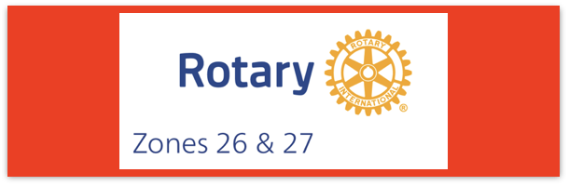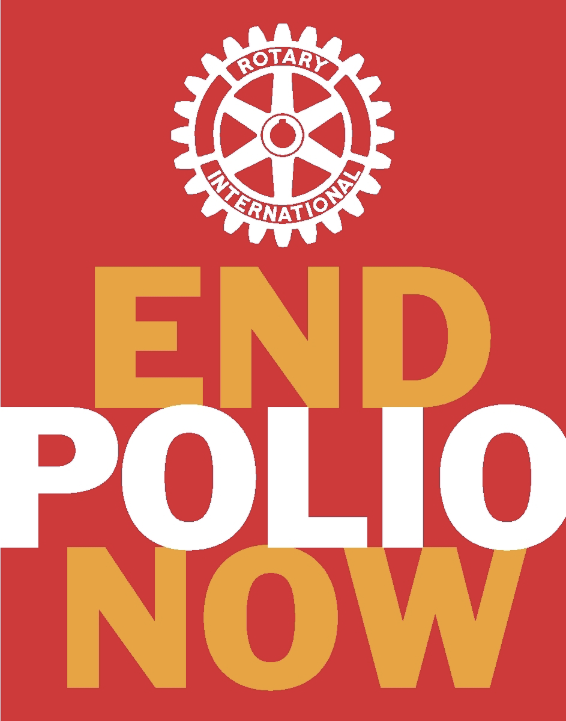
Join us on the “last mile” to end polio!!
End Polio Now Coordinators/Leaders: Mike Crosby & Marny Eulberg
mikePolioPlus@outlook.com and marnyeul@me.com
Almost weekly polio update……….. February 9, 2024
Note: no new cases have YET been reported from 2024, BUT this week there were 30 positive environmental samples reported from Pakistan (28 of which were collected in 2024 and came from 4 different districts!)
Wild Poliovirus Cases reported this week: None
Most recent wild poliovirus cases: Afghanistan: 09/04/23 Pakistan: 10/24/23

Human cases confirmed | As of 2/6/24 | Total | Total | Total | Total
 | 2024 | 2023* | 2022 | 2021 | 2020
WPV (Wild Poliovirus) | 0 | 12 | 30 | 6 | 140
WPV--Afghanistan | 0 | 6 | 2 | 4 | 56
WPV-Pakistan | 0 | 6 | 20 | 1 | 84
WPV- Other countries | 0 | 0 | 8 | 1 | 0
Variant (circulating vaccine derived -cVDPV polioviruses | 0 | 495 (703 at same time from 2022) | 878 | 699 | 1117
*some cases with onset of paralysis in 2023 still likely to be confirmed and reported.

Polioviruses reported from other sources (environmental) this week In { }= year-to-date totals for 2023.
Wild poliovirus= 30; {187} cVDPV (variant) Types 1,2,3= 14; {386}
Variant poliovirus caused 4 cases of polio paralysis reported this week in 2 countries-- so far, all cases are from 2023. {1 in Chad and 3 in Nigeria)
Rick Barry signed basketballs still available!
Limited edition Rick Barry signed basketballs are available through June, up to 500 balls total, for your District or club to purchase and use for a fundraiser for polio. Contact mikePolioPlus@outlook.com for questions or ordering info.

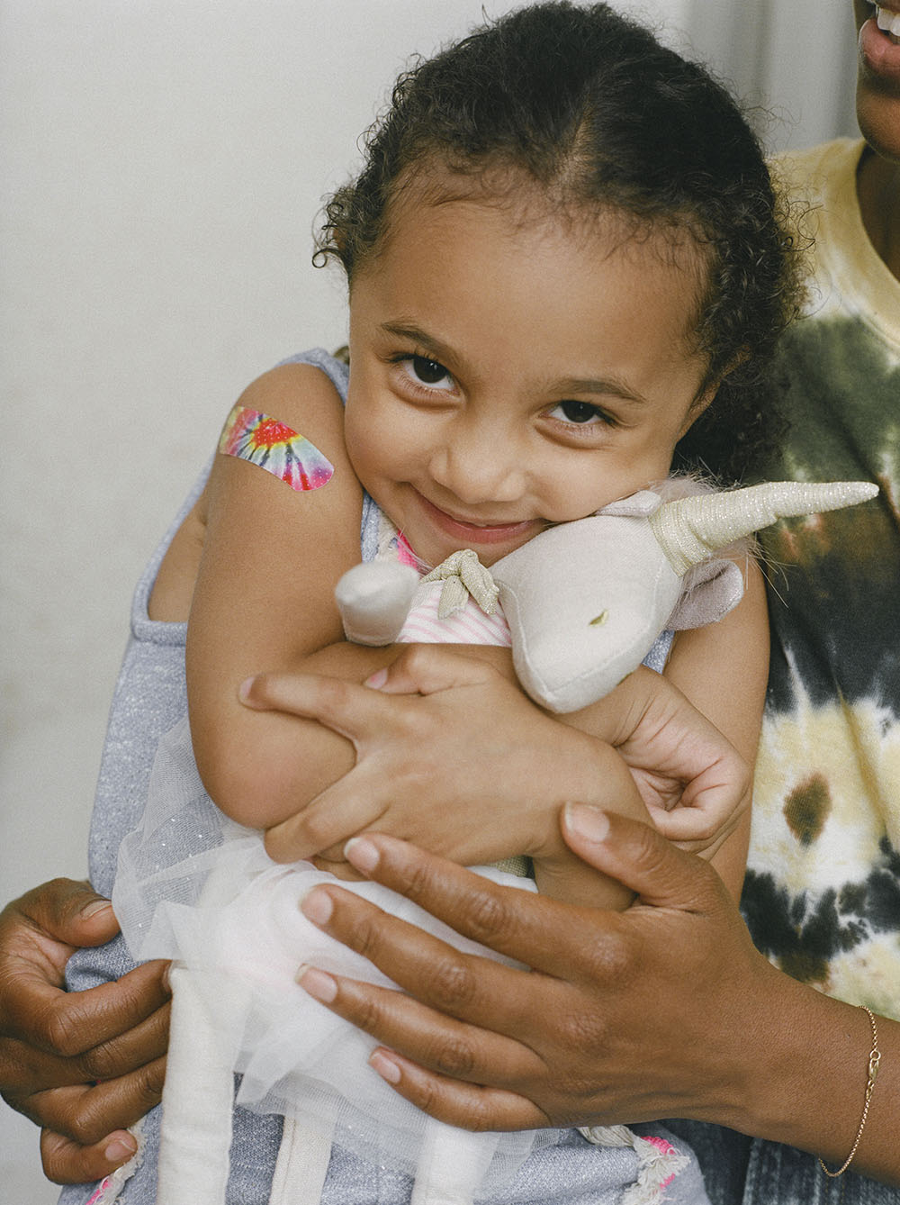
Now is the time to begin planning for World Immunization Week 2024 –
April 24-30, 2024
(this gives us Rotarians one additional time in the year to talk about polio vaccines as well as other vaccines!)

Since Rotary International launched a Program of Scale in Egypt to reduce cervical cancer, it would be appropriate for us to also promote HPV vaccine during World Immunization Week.

World Immunization Week, celebrated in the last week of April, aims to highlight the collective action needed to protect people from vaccine-preventable diseases.
The goal of World Immunization Week is for more children, adults – and their communities – to be protected from vaccine-preventable diseases, allowing them to live happier, healthier lives.
Promotional materials will be available soon. Google “World Immunization Week 2024”.

Note: This update is going out to those on Bob Roger’s previous list and all Zones 2627 DGs and DPPCs. Let me know if you no longer wish to receive these updates or if you have others that should be added. Email me: marnyeul@me.com
For those of you that send out copies or use this newsletter as a template for sending info to your Polio Warriors, I have added attachments in common formats to this email message.

